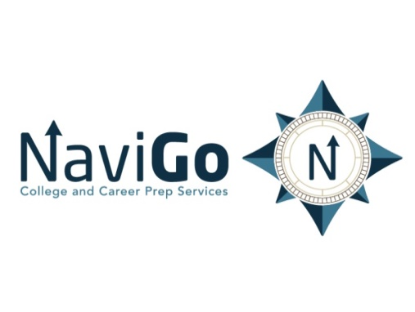

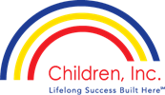

2018-19 ACE and Ryle High School Pilot

NaviGo Coaching Contract Proposal

Tim Hanner

Founder/Senior Director

NaviGo College and Career Prep Services

A Division of Children Inc

August 16, 2018

Executive Summary

Objective
The objective of this proposal is to outline a proposal for services in a contract between NaviGo College and Career Prep Services (a division of Children, Inc) and ACE and Ryle High School. The terms of the contract are for one academic year starting in August 2018 until the end of the academic year in June 2019. NaviGo Prep is a provider of coaching training and licensing of NaviGo’s proprietary curriculum.

Goals
The goal of the contract is for ACE and Ryle High School High School to work with a select group of students to enhance college/career readiness and awareness, while impacting student-centered, student-empowered approaches to learning. A second goal of the contract is to assist the school in the development of a program that will expose students to a variety of skill trade programs as they exercise greater voice in their education.

Solutions
In order to expand the experiences for select groups of students while in high school - and to expand the opportunities for these students beyond high school, NaviGo proposes to provide the NaviGo curriculum and initial Coaches training, as well as on-going Coaches training throughout the 2018-19 school year, to building and district level administrators at Ace and Ryle High School. .

NaviGo Services Defined
NaviGo will provide the following services to ACE and to Ryle High School (via a pilot for NaviGo In-school coaching):

- Initial training for staff members/administrators from both schools to use the NaviGo curriculum;
- Assist in the creation of strategies to engage the students college and career readiness;
- On-going monthly meetings with Coaches at a mutually agreed upon time to plan with NaviGo Trainer;
- Provide monthly reminders regarding resources and benchmarks to each school via email;

- Focus each school on relationship building – individuals and group – via exploring students’ interests, passions and talents ;
- Assist each school to connect with to relevant business points of contact in relevant ways to enhance the coaching/learning experiences during NaviGo sessions

Also, assist school/district to:
- Determine how to subgroup students – based on interests, progress towards graduation, college and career plans, etc.
- Determine a schedule in order to meet with respective groups on a consistent basis.
- Determine a schedule in order to meet with individual students on a rotating basis.

2018-2019 ACE and Ryle High School NaviGo Scholars Budget
NaviGo Upfront and Ongoing Training
Initial training
- Training with staff/community members to serve as NaviGo Coaches at ACE and Ryle  - (discounted due to pilot within BC) |  |  |  |  |  |  |  |  | $2000.00  ($1000 x 2)  $1000.00
On-going training
- Monthly update training in with NaviGo Coaching Team at ACE and Ryle  - (discounted due to pilot within BC) |  |  |  |  |  |  |  |  | $3000.00 x 2  $6000.00  $4000.00
Curriculum License Fee  - @ $4.00 per student - based on total number of students - approximately 200 x $4.00  - (discounted due to pilot within BC) |  |  |  |  |  | $800.00  $0.00
Totals  Training/PD (initial and on-going)  Curriculum and License Fee  Total Price of Services |  |  |  |  |  | $8000.00 - $5000.00  $800.00 - $0  $8800.00 - $5000.00

The signatures below signify agreement to the NaviGo-Boone County Schools (ACE and Ryle High School) contract proposal:

Boone County District Representative: Date

_________________________________________ __________

Title:

NaviGo College and Career Prep Services Representative Date
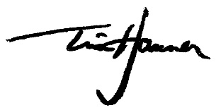 August 16, 2018
______________________________________ __________

Title: Senior Director

