John Hardin SBDM Council
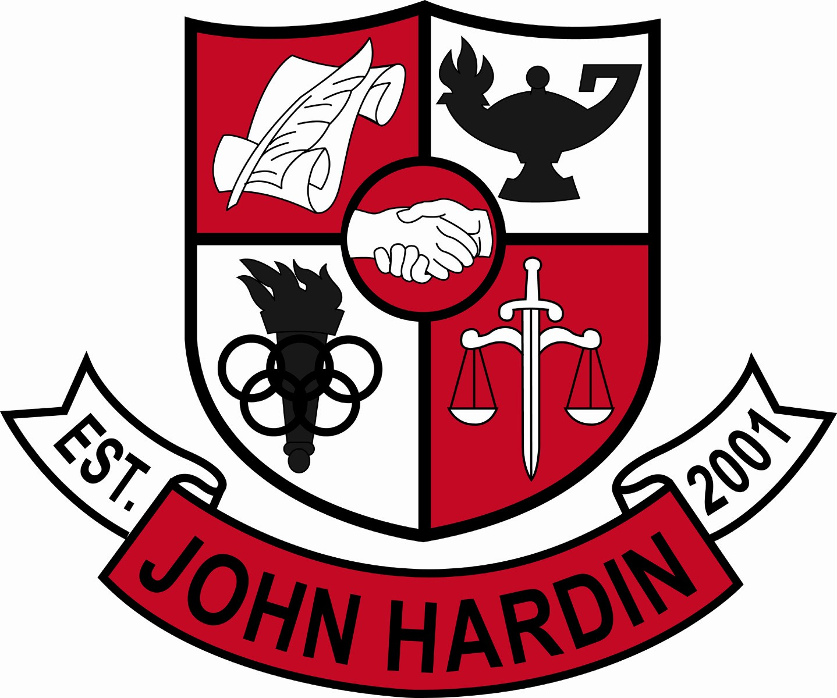
Meeting Minutes

January 15, 2015
4:00 p.m.

- Call to Order at 4:02 p.m.
Members present: Patrick Avery, Alex Shearer, Stacey Moore, Jana Haws, Geraldine Rodgers, Erica Pearson and Lynne Gibson.
Members absent: Pauline Crittenden
Visitors present: Phyllis Westfall
- Approval of Agenda ORDER #14-15/0022
The council approved the agenda as written.
Motion: Avery Second: Moore
Avery - Yes
Crittenden – Absent
Gibson – Yes
Haws – Yes
Moore – Yes
Pearson - Yes
Rodgers - Yes
Shearer - Yes
- Approval of Minutes ORDER #14-15/0023 The council approved the minutes as written.
Motion: Moore Second: Avery
Avery - Yes
Crittenden – Absent
Gibson – Yes
Haws – Yes
Moore – Yes
Pearson - Yes
Rodgers - Yes
Shearer - Yes
- Principal’s Update
- Standards Based Grading – Suggested that a committee be formed to research the benefits to John Hardin students. Mr. Avery and Ms. Rodgers will take the lead of forming the committee
- Showcases – February 2nd is the John Hardin Academic Showcase for incoming freshmen; January 29th is the EC³ showcase for all middle-schoolers in the county, public and private schools.
- Scheduling – counselors met with each department member during their planning today to prepare them for helping students with scheduling
- Student Achievements - Numerous John Hardin students will be recognized at the board meeting tonight; purchasing bulletin boards for the commons to display student names who are college and/or career ready and student acceptance letters for college or military; banners will be created at the end of each year for students carrying a 4.0 for the previous year; 3.5-3.9 and 3.0-3.4
- Financial Report ORDER #14-15/0025
The council reviewed and accepted the financial report.
Motion: Avery Second: Moore
Avery - Yes
Crittenden – Absent
Gibson – Yes
Haws – Yes
Moore – Yes
Pearson - Yes
Rodgers - Yes
Shearer - Yes
- Arts/Humanities Credit ORDER #14-15/0024
The council approved awarding Arts and Humanities credit for the class, Dance Technique. The class would include, but is not limited to, colorguard and winterguard members.
Motion: Shearer Second: Moore
Avery - Yes
Crittenden – Absent
Gibson – Yes
Haws – Yes
Moore – Yes
Pearson - Yes
Rodgers - Yes
Shearer - Yes
- Personnel
Vacancies: Currently have a few coaching assistant positions open
Hired: Maggie Vogel, Office Clerk; and Chris Wise, Asst. Baseball Coach
- Questions and Concerns from Council
- Discussed the possibility of awarding some sort of incentive for students receiving Distinquished or Profecient for On-Demand. Maybe a test grade for the next year or additional point or two to their final English grade the next year.
- Agenda Items for Next Meeting
- On-Demand points
- Adjourn
The meeting was adjourned at 4:56 p.m. The motion was made by Mr. Shearer and seconded by Ms. Moore

