Superintendent Report
August 24, 2022

Opening Day/Back to School Events/Start of School
On Monday, August 15, we held opening day activities for staff. I believe this was a success as positive feedback was received. During the 2 ½ hours we were together I was able to share my beliefs/expectations and cast vision for the year with Our word of the year being CONNECT. This word was chosen because it is important for me to connect with all of our staff and important for all of us to connect with one another in support of our students and families and to also connect WITH our students and families. Special thanks to Compass Municipal Advisors for providing breakfast and Bellevue Education Foundation for providing lunch.

Here is a picture of our puzzle after we were ALL CONNECTED… (Note to self… Next time I will make sure there is a way to identify the TOP of the puzzle piece… Live and Learn, right?)
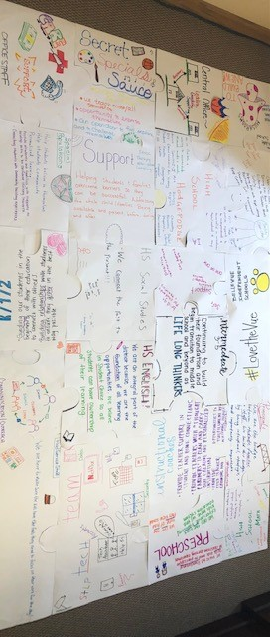

The Back to School Events on the evening of August 15 were well attended. Much appreciation to our staff for making the events so welcoming for our families. Also, special thanks to our board members for grilling hot dogs.

On Tuesday, August 16 a great event was held in partnership with the Sam Hubbard foundation and Crayons to Computers. This provided backpacks and school supplies to all students in attendance. It was also well attended and provided me an additional opportunity to meet and greet with our families.

The first three days of school have been smooth and I credit that to the hard work of our principals and school and district staff. It has been wonderful visiting the schools and experiencing a walking district. I look forward to a fantastic 2022-2023 school year.

Board Items
- Tax Rates will be approved. This is taking the 4% increase.
- Supt. Goals are up for your approval. No changes have been made since presented at the work session.
- Approval of adding additional days for the Grandview secretary position is found in the revised classified salary scale. This was asked for by Mrs. Rabe and I believe it is needed and request your approval.

City Development/IRB
On August 10 Bellevue City Council approved a contract that set forth plans for a huge development along the river. In my early conversations with Mayor Cleves and City Administrator Warnock they will be asking for support from the district (in terms of tax relief) to see this project through. Steve Wolnitzek and I are working on this with KDE to determine an appropriate rate in order to be proactive when the discussions are ready to be held. I will provide more updates as this unfolds.

Construction Update
Construction Meetings continue to take place on Tuesdays at 11:00. Ehmet will be at the board meeting to update the progress and share items that will take some time due to supply chain issues. They aren’t major, but they are holding up the project for completion.

Grandview Facility Funds
The district has received 12,726,200 for renovations/construction at Grandview. The funds must be spent by December 31, 2026. While we work through the plans for use of those funds it was suggested to invest them into a US Treasury to earn additional interest. Ms. Wright and I had meetings with Compass Municipal Advisors and Wes Banco to determine the best route while these funds are just sitting in the bank. We are still awaiting additional information and for that reason there is not an agenda item listed, but I may ask for one to be added at the meeting if we have gathered all the necessary information.

Meetings Held/Attended
- July 25- Administrative Team Meeting. These will be held monthly
- July 26-29- School and District Administrator Retreat in Louisville along with the KASA conference.
- August 1- Attended new teacher orientation
- August 2-4- Attended various professional learning events with teachers
- August 8- Compass Municipal Advisors and met with Candace Gibson and Jim Seward to establish a new Staff Hub which will be located on our website and serve as a “one stop shop” for staff to access all the items they will need.
- August 9- Review of Emergency Management Plans
- August 10-11- Attended Kindergarten Jump Start and BHS professional learning events.
- August 16- Gatekeeper Training

Upcoming Meetings
- August 22- Begins the weekly administrators’ meetings. 8:30-9:30 each Monday
- August 24- NKCES Board of Directors Meeting. As a reminder, I am serving as president of NKCES Board of Directors for the 22-23 school year. On this day I will be out of the district.
- August 25- River Cities Network Meeting @Gateway 10:30-12:00
- September 6- KSBA Regional Meeting at Receptions. 5:30 PM

Hubbard Painting
This painting has been restored and is back in our possession. I will bring it to the meeting to share and discuss where you’d like to see it placed.

As always, please let me know if you have any questions or concerns

Respectfully submitted,

Misty Middleton
Superintendent

