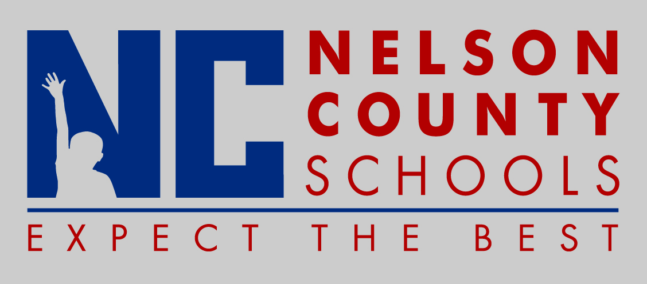

THIS IS AN INFORMATION PAPER

TO: Members of the Nelson County Board of Education

FROM: Kimberly Brown, Director of Secondary Education

CC: Anthony Orr, Superintendent

DATE: April 13, 2017

RE: Perkins Grant Application School Year 2017/2018

Discussion

The 2017/2018 Perkins Grant is now being written for Nelson County and Thomas Nelson High Schools. The amount of the grant is about $ 25,000.00. This funding will be shared between both high schools to enhance their Agriculture, Business and Family and Consumer Science Programs. This year’s grant will be initiated through the Grant Management Application and Planning System or GMAP Program. Areas of focus include:

- Curriculum materials,
- Various Work Ready Assessments,
- Professional Learning,
- Work Based Learning Opportunities, and
- Support for the English II End of Course Assessment.

Final approval is scheduled for the April Nelson County Board of Education meeting.

