SCHOOL REPORT TO GALLATIN CO. BOARD OF EDUCATION
Gallatin County Middle School
Curt Bieger, Principal

SPECIAL EVENTS:
Testing completed 5/6-5/10.
5/15- 8th grade trip to UK.
Field Day 5/16
5/17- 8th grade Toyota Trip
5/17- 7th Grade Thomas More Trip
5/17- 8th grade banquet
5/20- 6th grade YMCA trip
5/20- 8th grade vocational camp
5/21- 6th and 7th grade picnic
5/22- 8th grade picnic
5/23- Awards and 9th grade Moving Up.
PROFESSIONAL DEVELOPMENT ACTIVITIES:
5/7- Mr. Bieger attended Focus Group for TPGES

SCHOOL IMPROVEMENT PLAN I & I:

Subject | Beginning  Year Mean | On or Above  Grade Level  Mean | Below  Grade  Level Mean | Middle of Year Mean | On or  Above  Grade Level  Mean | Below  Grade  Level Mean | End of Year  Mean | On or Above Grade  Level Mean | Below  Grade Level  Mean
Reading
6 | 213 | 36.5 | 63.5 | 215 | 30.4 | 69.6 | 217 | 34.3 | 65.7
7 | 217 | 40.3 | 59.7 | 218 | 41.7 | 58.3 | 220 | 42.1 | 57.8
8 | 220 | 51.3 | 48.7 | 221 | 55.9 | 44.1 | 223 | 44.9 | 55.1
Math
6 | 220 | 26.7 | 73.3 | 223 | 28.8 | 71.2 | 226 | 26.7 | 73.3
7 | 226 | 24.8 | 75.2 | 228 | 30.0 | 70 | 231 | 38.3 | 61.7
8 | 230 | 42.9 | 57.1 | 233 | 35.5 | 64.5 | 235 | 45.29 | 54.71
Lang. Art
6 | 212 | 32 | 68 | 215 | 25.7 | 74.3 | 217 | 23.2 | 76.8
7 | 216 | 31.8 | 68.2 | 217 | 35.7 | 64.3 | 219 | 34.0 | 66
8 | 219 | 41.1 | 58.9 | 220 | 41.5 | 58.5 | 222 | 35.34 | 64.66

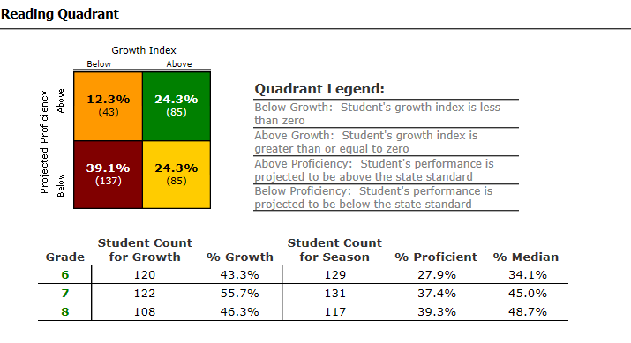

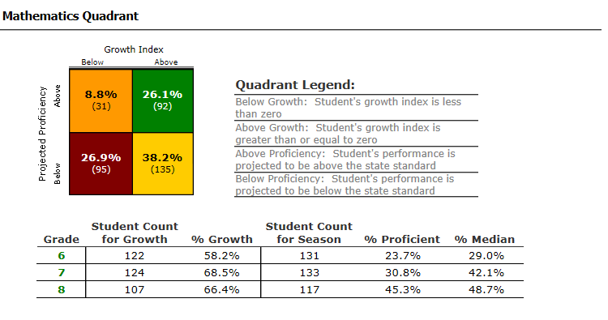
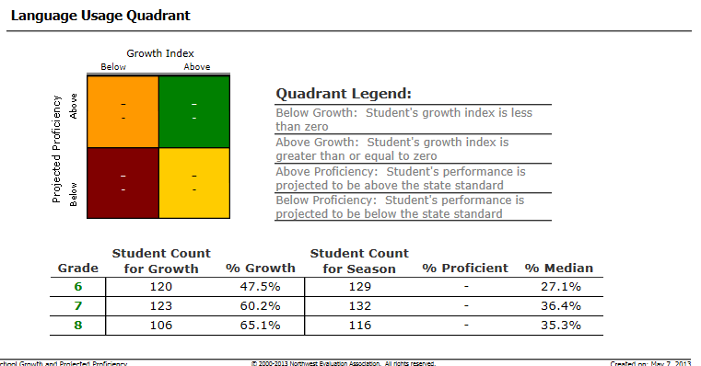

FACULTY MEETINGS AND DISCUSSION- Program reviews
OTHER RELEVANT INFORMATION:

SBDM MONTHLY AGENDA AND MINUTES ATTACHED TO EACH REPORT
Attached

