THIS IS AN INFORMATION PAPER

TO: Hardin County Board Of Education

FROM: The PAC

DATE: May 12, 2022

SUBJECT: PAC NEWS
BART’S BLOG – MAY 2022
This fall, we’ll open our 21st season at the PAC with a new spin on a tale as old as time.
Disney’s Beauty & the Beast has been on my wish list for a long time, and if anything good came out of COVID, it’s been that it has given the PAC’s design team the time needed to prepare for such a mammoth undertaking.
I spent the better part of two years researching and developing my approach to this classic story. First, I read the original fairytale and studied the Cocteau silent film and, of course, the classic Disney cartoon upon which the musical is based. I then compared them to numerous stage versions, which confirmed my biggest issue with most stage adaptions. To put it bluntly, I find it difficult to accept a six-foot-tall candlestick. However, given my long history with puppets, the solution to the problem presented itself pretty quickly. All the enchanted objects will be near the actual size and be performed by the castle servants, who are now just a shadow of their former selves.
Because of the number of puppets required, it was determined that half would be built here at the PAC, and the rest turned over to our friends in North Carolina who designed and built the puppets for our production of Little Mermaid five years ago.
That decision, in turn, influenced our approach to costumes and make-up, which have continued to evolve over the last year. For example, since the enchantment placed upon the castle includes the spell on the Beats, he will be masked. This performer will have to discover how to emote wearing a mask, much like the puppeteers have to learn how to bring their inanimate puppets to life.
Once these plans were in place, I needed to create a world that would complement my choices without impediment. For this, I turned to Indiana scenic designer Troy Trinkle with whom we’ve worked on numerous occasions – Based upon a newly built set he has for rent. I crafted a rough scale model to practice combining the elements he’s made in different configurations to represent the numerous locations required by the script.
Beauty & the Beast is shaping to be the biggest production the PAC has ever attempted. But we can’t do it alone. Auditions are in July, and there are fantastic roles for students and adults – professionals and amateurs. We also need help behind the scenes, so if you shy away from the spotlight but have a strong back come help us bring this show to life by volunteering backstage!
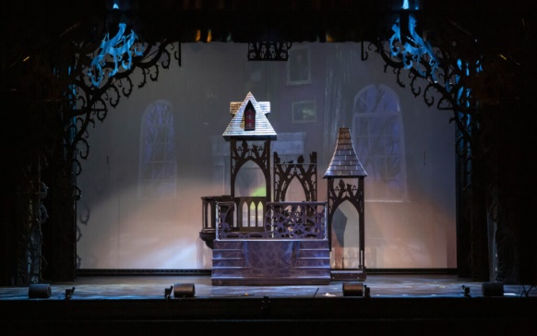
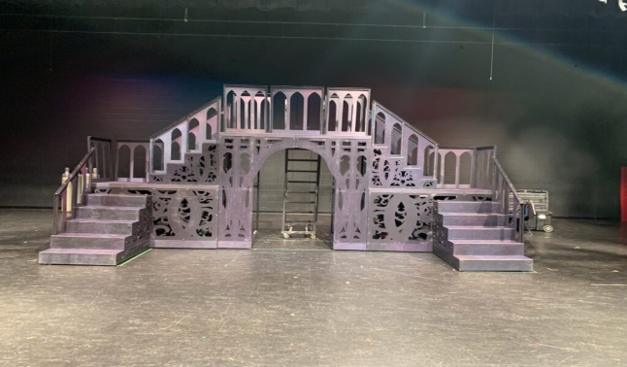
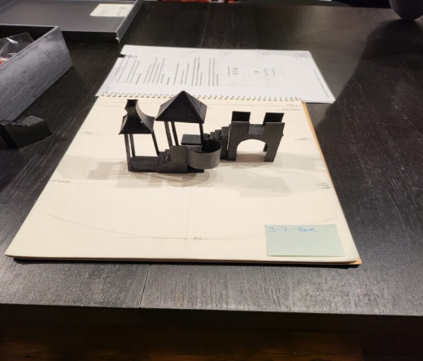
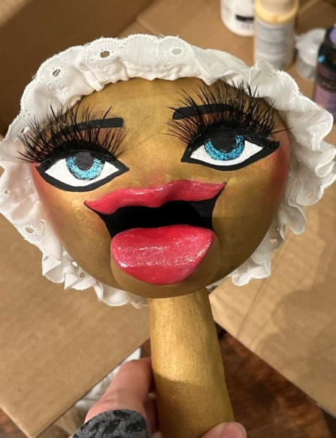
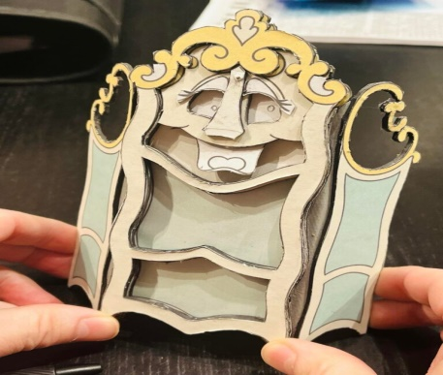

April Audience Survey Winners
Congratulations to DEANNA REED, KELLY GRAHAM & JOSH LOOTEN – each a lucky winner of a $20 PAC gift certificate for completing an April Audience Survey.
The PAC Spotlight
This month The PAC Spotlight shines on John Hardin student and PAC aide, Trey “T.J.” Goodman, and Allegro Dance Theatre’s Carol Zagar.
TJ, what do you want to do when you grow up?
TJ: Be an actor.
Carol, what Do You Do For A Living?
CAROL: Dance school administrator/instructor at Allegro Dance Theatre
Why is the PAC important to you?
TJ: I have learned how to use many tools and work with my hands during my PAC experiences. I have benefitted from the PAC because I have learned many life skills and gained many memorable moments.
CAROL: It is the performing space for my Allegro Dance Theatre students, the Youth Theatre of Hardin County students, and the Heartland Winds – three organizations I dearly love.
Why should the PAC be important to others?
TJ: The PAC should be important to others because of the positive impact its shows can bring to people. The PAC is a place where people can relax and enjoy themselves, which I value very much.
CAROL: Whether listening to a song, watching a ballet, or seeing a musical or play, we all learn so much about ourselves and our relationships. Theatre is so important to our society and kids of all ages. During the last show we did, a teacher shared that she found one of her students crying at the end of the musical. When asked why the little girl said she just didn’t want it to be over!
Learn more about TJ and Carol and all the other PAC Spotlight Ambassadors we’ve recognized over the years.

NOW SHOWING – MAY 2022
May 2 | Bluegrass Middle School Band Concert. 7:30 PM. POC Joshua Mitchell All seats reserved through the PAC at www.thepac.net (Look for tickets to be available at least 2 weeks prior to event date.)
May 3 | West Hardin Middle School Band Concert. 7 PM. POC Laura Hedges. All seats reserved through the PAC at www.thepac.net (Look for tickets to be available at least 2 weeks prior to event date.)
May 5 | Studio One-Eleven Dance Recital. 6:30 PM POC Katie Bennett. All seats reserved through the PAC at www.thepac.net (Look for tickets to be available at least 2 weeks prior to event date.)
May 10 | Abound Credit Union’s 71st Annual Meeting and Financial Education Expo. Doors open at 5 PM, Meeting to begin at 5:30 PM. POC Kayla Rohlff
May 11 | East Hardin Middle School Band Concert. 7 PM POC Vanessa Lee. All seats reserved through the PAC at www.thepac.net. (Look for tickets to be available at least 2 weeks prior to event date.)
May 12 | John Hardin High School Choir Concert.7 PM. POC Phyllis Westfall 270-769-8906. All seats reserved through the PAC at www.thepac.net. (Look for tickets to be available at least 2 weeks prior to event date.)
May 14 | North Hardin High School Choral Concert. 3 PM. POC Cassie Lucas 270-369-3167. All seats reserved through the PAC at www.thepac.net. (Look for tickets to be available at least 2 weeks prior to event date.)
May 16 | Central Hardin Band Concert. 7 PM. POC Trevor Ervin. All seats reserved through the PAC at www.thepac.net. (Look for tickets to be available at least 2 weeks prior to event date.)
May 19 | Hardin County Schools Board of Education Meeting. 6 PM. POC Kaycie Pawley 270-769-8817.
May 21 | The Dance Centre of Elizabethtown’s Spring Recitals. Saturday, 1 & 4 PM. POC Sherry Barnard 270-765-5464. All seats reserved through the PAC at www.thepac.net. (Look for tickets to be available 2 weeks prior to event date.)
May 22 | Heather Lawson Music Recital. 3 & 4:30 PM. POC Heather Lawson. All seats reserved through the PAC at www.thepac.net. (Look for tickets to be available at least 2 weeks prior to event date.)
May 27 -29 | Allegro Dance Theatre Spring Recitals Friday, 7 PM. Saturday, 3PM. Sunday, 3 PM. POC Carol Zagar 270-352-1333. All seats reserved through the PAC at www.thepac.net. (Look for tickets to be available at least 2 weeks prior to event date.)

COMING SOON – JUNE 2022
June 1,3, 5 | Center Stage Dance Studio’s Spring Recitals. Recitals, Wed, Friday at 7 PM & Sunday at 3 PM. POC Yvonne Groves 270-769-5505. All seats reserved through the PAC at www.thepac.net (Look for tickets to be available at least 2 weeks prior to event date.)
June 9 | Allegro Dance Theatre’s Musical Theatre Camp production. 7:30 PM. POC Carol Zagar 270-352-1333. All seats reserved through the PAC at www.thepac.net (Look for tickets to be available at least 2 weeks prior to event date.)
June 12 | Dance Center of Elizabethtown Musical Theatre ANNIE FOR KIDS. 3 PM POC Sherry Barnard 270–765-5464. All seats reserved through the PAC at www.thepac.net (Look for tickets to be available at least 2 weeks prior to event date.)

IN REVIEW – APRIL 2022
On April 15, THE PAC PRESENTED Kentucky Shakespeare’s JULIUS CAESAR to a student audience 336 of and a public audience of 50.
On April 19, 43 elementary and 44 middle and high school Gifted and Talent HCS students participated in a Musical Theatre Intensive.
On April 21, 58 students with Central Hardin High School Band under the direction of Trevor Ervin presented a PRISM concert before an audience of 211.
On April 24, Buffalo Productions presented Glen Rice Family & Friends Concert Series to an audience of 190.
On April 27 & 28, 20 students with the Elizabethtown High School Theatre Guild under the direction of EPAC’s Carmen Caldera-Brzoska presented “1984” before a student audience of 225 and public audiences totaling 220.
On April 29 & 30, 48 students participated in auditions for Youth Theatre of Hardin County’s production of THE LITTLE MERMAID.
Total Served in April: 496 HCS Students, 812 Non-HCS Students, 75 Adults, and 621 Audience Members.
Total Served to date: 11,889 Students (9,065 HCS, 2,824 Non-HCS) 1,339 Adult Participants & 13,216 Public Audiences.

