Communication Updates- May 2023
Candace Gibson- Communications and Outreach Coordinator

NEWSLETTER
Newsletter interactions continue to stay higher with Smore than Mailchimp. The most interesting thing I’ve noticed about the increase in views is that we consistently have more email views than subscribers. This indicates that people are not only reading the newsletter via email, but are passing it along to others.

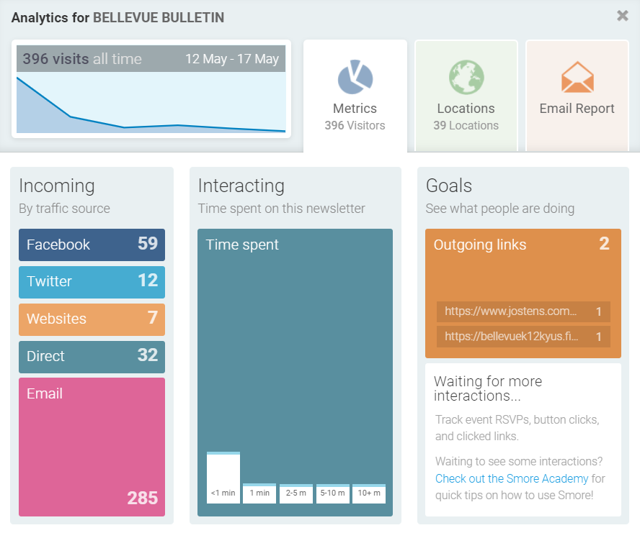

SOCIAL MEDIA
Facebook user reach was slightly lower this month (2,500 less), but the number of times people engaged with our posts was higher (1,000 more)! Content over the past month has shifted from a prioritization of classroom images to information about end of year activities. April-May benefits from a higher number of announcement posts, and many people turn to Facebook for last minute questions/changes.
Our numbers on Twitter have taken a sharp decline in recent months, despite steady communication. The timing of this decline can be directly tied to decisions made by Twitter’s new owner. With the introduction of paid “verified” accounts, the algorithm now deprioritizes account that do not pay $8/month for the “blue check.” Our Twitter audience is mostly education professionals/colleagues, so this change does not affect our ability to effectively communicate with BISD families.
FACEBOOK MONTHLY IMPACT
Total post reach this month | 12,865
Total post engagement (likes, comments, etc) | 9,120
Number of posts this month | 52
New followers; new page likes | +19; +10
Total shares | 142
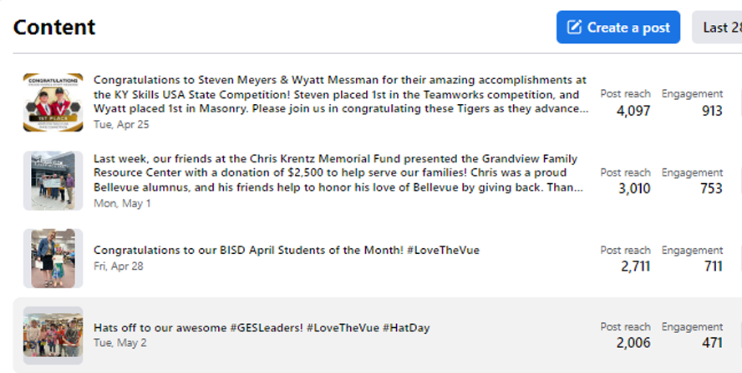

ADDITIONAL DESIGNS/INFORMATION
The influx of design needs for end-of-year events shifted my attention away from the new website information on the Mission & Vision, Portrait of a Bellevue Graduate, etc. Once graduation is complete, those projects will become my top priority.
In preparation for my departure, I am creating detailed schedules for weekly, monthly, and yearly projects. I will transfer ownership of all previous designs and templates over to my replacement, and will leave detailed notes about our current branding and messaging. In addition, I am reaching out to all current subscription services to inquire about transferring ownership.
On a personal note, I am so grateful to the board and to my colleagues for trusting me to be the voice of this district for the past four years. It has truly been the most rewarding and most challenging work I have ever done. I look forward to seeing what will happen when these responsibilities are transferred to someone who can bring a new perspective and a fresh set of eyes to the work that has been done. And most of all, I will continue to support Bellevue Independent Schools as a parent and BEF board member, and I will always Love The Vue.
Thank you.

