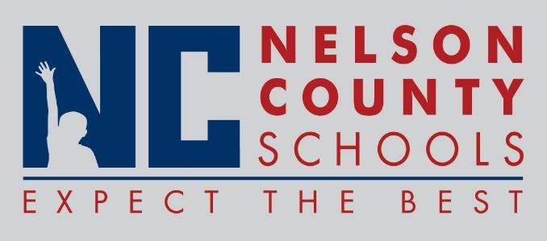

Decision Paper
To: | Nelson County Board of Education
From: | Tim Beck, Director of Student Support
cc: | Dr. Anthony Orr, Superintendent
Date: | June 21, 2016
Re: | Policy Updates for 2016-2017

RECOMMENDATION: Approve the below listed policy updates for 2016-2017 as written for their second reading.

01.0 Definitions
01.61 Records Management
02.14 Evaluation
03.11 Hiring (Certified)
03.21 Hiring (Classified)
03.111 Medical Examination (Certified)
03.211 Medical Examination (Classified)
03.112 Certification and Records (Certified)
03.121 Salaries (Certified)
03.221 Salaries (Classified)
03.1231 Personal Leave (Certified)
03.2231 Personal Leave (Classified)
03.126 Planning Time
03.1321 Use of School Property (Certified)
03.2321 Use of School Property (Classified)
03.14 Health & Safety (Certified)
03.24 Health & Safety (Classified)
03.273 Retirement (Classified)
03.18 Evaluation
03.222 Holidays and Vacations
03.5 Paraprofessionals
04.0 Finance Officer Qualifications
05.11 Alterations of Buildings and Grounds
06.23 Driver and Substitute Driver Training
08.1312 Home/Hospital Instruction
08.133 Extended School Services
08.3 School Calendar
09.11 School Attendance Areas
09.122 Attendance Requirements
09.1231 Dismissal from School
09.12311 Release of Students to Divorced, Separated or Single Parents
09.14 Student Records
09.227 Child Abuse
09.124 Tuition
09.313 Eligibility (Athletics)
09.36 School-Related Student Trips
09.422 Bullying/Hazing
09.438 Student Discipline Code

RECOMMENDED MOTION: I move that the Nelson County Board of Education Approve the listed policy updates for 2016-2017.

