THIS IS A DECISION PAPER.

To: Members of the Hardin County Board Of Education
From: Nannette S. Johnston, Superintendent
Date: December 17, 2015
Subject: Nonresident Contract Students for 2016-2017

INFORMATION:
Each year the Board approves the signing of nonresident contracts with other school districts. The Kentucky Department of Education recommends that boards of education approve the signing of nonresident contracts with other districts by January 1 of each year. Listed are the districts and the number of nonresident students for which contracts were approved for the 2015-2016 school year.

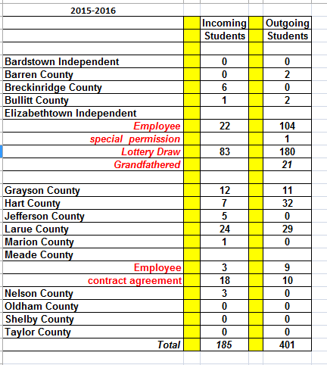

RECOMMENDATION:
Approve the signing of nonresident student contracts with the above districts for the 2016-2017school year.

MOTION:
I move that we approve the signing of nonresident student contracts for the 2016-2017 school year with the districts listed.

