John Hardin SBDM Council
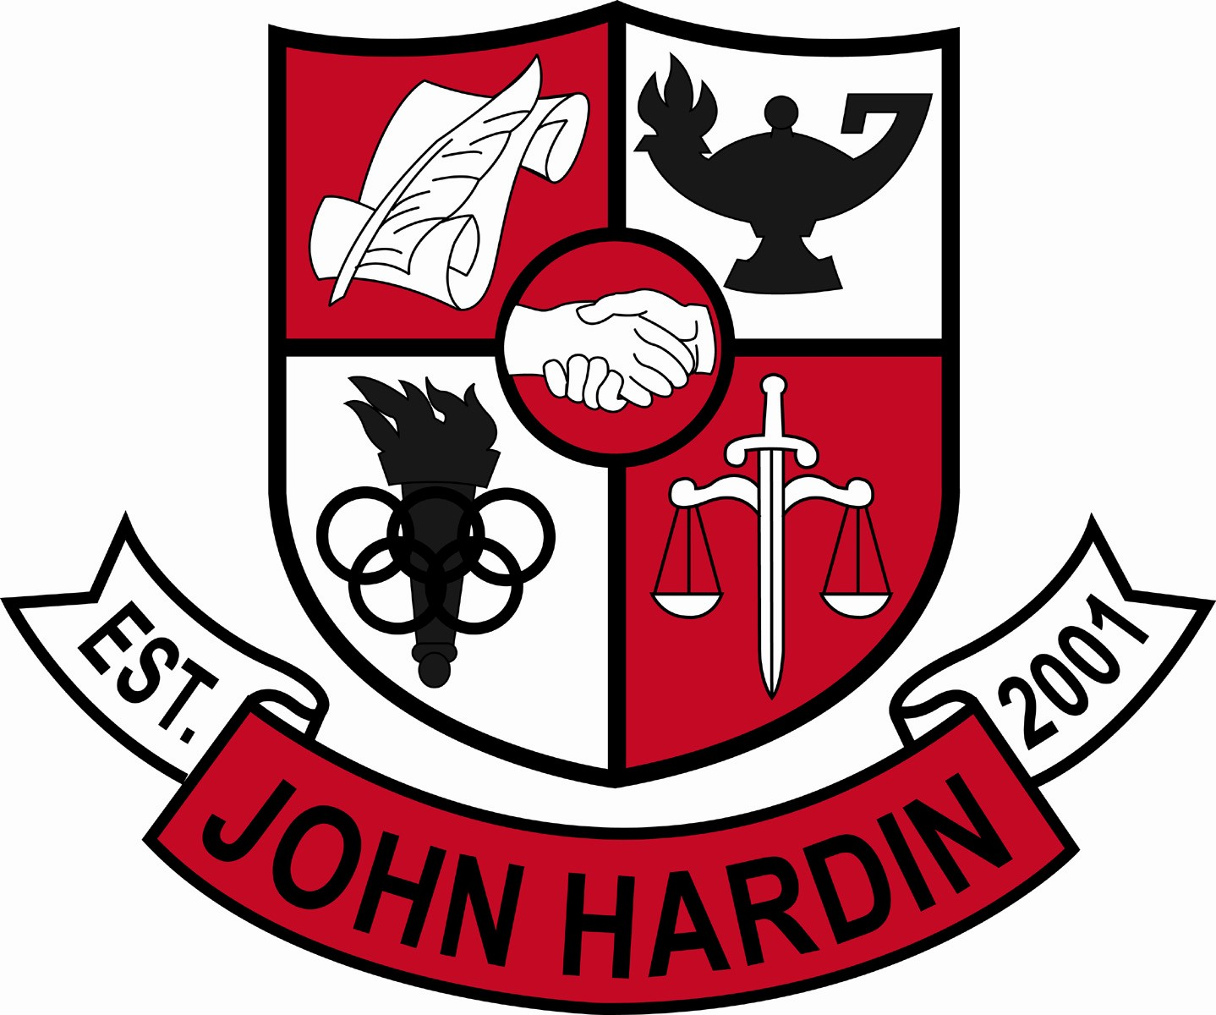
Meeting Minutes

February 13, 2014
4:00 p.m.

- Call to Order at 4:00 p.m.
Members present: Patrick Avery, Jana Haws, Stacey Moore, Alex Shearer, Pauline Crittenden and Lynne Gibson
Visitors present: Peggy Snow, Heather Brown, Eddie Wilkerson, and Laura Simpson
- Approval of Agenda ORDER #13-14/0031
The council approved the agenda as written.
Motion: Moore Second: Avery
Avery - Yes
Crittenden – Yes
Gibson – Yes
Haws – Yes
Moore – Yes
Shearer - Yes
- Approval of Minutes ORDER #13-14/0032
The council approved the minutes as written.
Motion: Avery Second: Moore
Avery - Yes
Crittenden – Yes
Gibson – Yes
Haws – Yes
Moore – Yes
Shearer - Yes
- PLC Reports
English (Moore) – Working on summer reading requirements for ALL grade levels.
World Language (H. Brown) – will report on Item 7
- Principal’s Update
- Scheduling - students have completed schedule requests; core area teachers put in the next logical/appropriate class on PL Day; CTE classes were put in and caused issues with electives, those have been removed; Middle school schedules will be entered soon; Ms. Gibson wants numbers by March 7th
- Revised Dates/Calendar – 2nd Trimester will end Feb. 28th; EOC Testing dates are Biology on the 27th and US History on the 28th; Math dept would like their test to be paper/pencil instead of on the computer; maybe the 10-15 seniors it would involve could take the computerized version so as not to interfere with graduation. Make up Snow Days are now Feb. 14, 17, Mar 24, and May 2; May 20 will be the PL Day for staff. As of this meeting, June 2nd is the last day for students.
- Testing Plan – everyone will get the plan info so everyone knows what’s going on -not all are involved. Mar. 4 is ACT; 9th and 10th will discuss PLAN results; still working on a plan for Seniors
- MMD District Change – NHE, BGMS, & JHHS will be the hub for the district for MMD. Our district has to combine location to meet standards. Our location will have one teacher, two assistants and one IEP assistant. Those that don’t want to leave their home school have the option of signing the student out of special ed.
- Title I Funding – two teachers are currently being paid out of Title I funds; we are in the red by $945.61 on those salaries.
- Student Achievements - DECA region winners were shared. They will compete at State. JHHS had more than any other area school.
- Financial Report ORDER #13-14/0033
The council reviewed and accepted the financial report for January.
Motion: Moore Second: Avery
Avery - Yes
Crittenden – Yes
Gibson – Yes
Haws – Yes
Moore – Yes
Shearer – Yes
- World Language
PLC Report – spoke about student growth in the PGES to find out requirements for WL. Already doing all requirements.
The council previously approved an Arts and Humanities credit for AP Language students. The WL Department is asking that credit be retroactive to include this school year.
World Language –Arts/Humanities Credit ORDER #13-14/0034
The council approves allowing A/H credit to students completing AP World Language for the 2013-14 school year and beyond.
Motion: Shearer Second: Moore
Avery - Yes
Crittenden – Yes
Gibson – Yes
Haws – Yes
Moore – Yes
Shearer – Yes
- YSC Action Plan ORDER #13-14/0035
The Action Plan is due March 1st. The format has changed; streamlined for ease of input as well as understanding. Six categories are covered in the plan. The council approved the Action Plan as presented.
Motion: Moore Second: Shearer
Avery - Yes
Crittenden – Yes
Gibson – Yes
Haws – Absent
Moore – Yes
Shearer – Yes

- Staffing Allocation for 2014-15 ORDER #13-14/0036
The council approved the receipt of the staffing allocation for 2014-15. Discussion followed the acceptance; nothing can be decided until our scheduling numbers can be presented.
Motion: Shearer Second: Avery
Avery - Yes
Crittenden – Yes
Gibson – Yes
Haws – Absent
Moore – Yes
Shearer – Yes
- Personnel
Hired: Justin Maddock for head girls soccer coach; Paul Underdonk for asst. tennis; Wallace King for Freshmen Baseball (90%); Douglas Branson for 3rd shift custodian
- Questions and Concerns from Council
- None
- Agenda Items for Next Meeting
Staffing Allocations
- Adjourn
The meeting was adjourned at 6:01 p.m. The motion was made by Ms. Moore and seconded by Mr. Shearer

