Regular Meeting Boone County Board of Education
February 14, 2019 7:30 PM
Ralph Rush Professional Development Center
99 Center Street
Florence, Kentucky 41042

I. CALL TO ORDER

The Regular meeting of the Boone County Schools Board of Education February 14, 2019 was called to order by Chairperson Karen Byrd at the Ralph Rush Staff Development Center.
Attendance Taken at 8:02 PM: The meeting was called to order late due to the completion of an Expulsion Hearing before the meeting.

Present Board Members:
Dr. Maria Brown
Ms. Karen Byrd
Mr. Matt McIntire
Mrs. Julia Pile

Claire Parsons attended as Board Attorney
Karen Evans, Board Secretary, recorded the minutes.

Mr. Eric McArtor represented the district at the board meeting, Dr. Poe was attending a conference.

II. NATIONAL ANTHEM
The National Anthem was presented by students of Camp Ernst Middle School.

III. PLEDGE TO THE FLAG
The Pledge to the Flag was led by a student from Collins Elementary School.

IV. STUDENT BOARD MEMBER REPRESENTATIVE REPORT
Anna Impellitteri gave the Student Board Member Representative report. Anna introduced two Advisory Council Members to the board, John Warten of BHS and Brayden Hughes of CHS. Anna updated the board on the Councils activities involving Wellness Wednesday and the Positive Post-it Notes messages given to the elementary students.

V. GOOD NEWS
V.A. The board recognized and congratulated the February 2019 Break the Mold Award Recipient, Mr. Michael Johnson, Head Custodian at Burlington Elementary.

V.B. The board recognized and congratulated Mr. Tim Schlotman, Boone County High School Principal, for being awarded the Kentucky Music Education Association Administrator of the Year.

V.C. English Learner Newcomer Academy (ELNA) Partners Recognition. A video presentation was given to the board and Dr. Delahunty spoke to the board about the program. Christy Eastwood -County Extension Agent for 4-H Youth Development and Jerry Brown -Boone County Extension Manager were recognized for their partnership in the program.

V.D. Family Resource and Youth Service Center Recognition. The board thanked the resource coordinators for all the work they do for the students of Boone County.

High Schools:
Boone County
Ben Brown
Conner
Laura Mosqueda
Ryle:
Carrie Tribbe
Middle Schools:
Camp Ernst
Kristen Kaliin
Ockerman
Sierra Miller
R.A. Jones
Renee Wooten
Elementary:
Burlington
Jennifer Hater
Collins
Kathy Oehler
Florence
Lindsay Chappell
Goodridge
Stephanie Ganns
Kelly
Shelly Hoxmeier
New Haven
Jennifer McGraw

Ockerman
Leslie Harney
Stephens
Rebecca Folz
Yealey
Cheryl Burns-Kraft

V.E. Recognition of the Boone County Education Foundation Grant Recipients. Jim Claxton, president of the Boone County Education Foundation and members of the foundation presented certificates to the recipients. The board congratulated the grant award winners for their innovations and dedication to our students.
High Schools:
Conner Ms. Jessica Covert Hydroponic Garden Supplies $2,228
Grant Writers: Sarah Gill, Kendall Belisle, Trinity Marlar and Nicole Alig
Cooper Ms. Rachael Burriss Professional Artwork Printer $851

Middle Schools:
Ballyshannon Ms. Tia Wood Makey Makey Stem Packs $1,400
Conner Mr. Patrick Wallace Parrot Mambo Drone $1,460
RA Jones Ms. Mary Sargent Leader Recognition Program $1,000

Elementary Schools:
Collins Ms. Kelly Hahlbeck Ozobots and Dash/Dots $1,550
Erpenbeck Ms. Jessica Pass Courtyard Paddock $3,037
Florence Ms. Jennifer Payne Virtual Reality $2,500
Kelly Ms. Karla Hall Wildlife Habitat $1,399
Longbranch Ms. Stephanie Stambaugh Zones of Regulation $3,250
Mann Ms. Anne Oney Project Programming Alive! $2,279
New Haven Ms. Jennifer Melvin CASEL Pilot Program $1,530
North Pointe Ms. Elizabeth Kirby Complex Needs Board Book $540
North Pointe Ms. Stephanie Knauer Multiple Math Programs $2,000
Ockerman Ms. Ruth Palmer Monster Genetics $257
Stephens Ms. Melissa Huff Appalachian Basket Weaving $605
Thornwilde Mr. Tim Mitchell Ukelele $1,386
Yealey Ms. Julia Deevers-Rich PLTW Pre-K-5 Launch $2,000
Yealey Ms. Wendi Belk Outdoor Pre-K Gross Motor Fun $502

V.F. Recognition of the Student Presenters during the District Principal Meeting and the video participants.
Olivia Rockwell, Lucas Sanders, Isaac Brown, Cole Freemen and Zeene Thompson of Ballyshannon were recognized for the Social Emotional Learning Video. Video was presented.

V.G. The board recognized the 2019 February Sportsmanship Award Recipients.
The February 2019 Sportsmanship Award Recipients.
Boone County High School - Kara Strong
Conner High School - Owen Baynum
Ryle High School - Ian Dennis
Cooper High School - Josh Baker
V.H. Men of Boone Program Recognition.
The Men of Boone were recognized for their dedicated community volunteering and each year volunteering at the Honor Run Half Marathon. Certificates were presented to those in attendance.

Yazan Orabi, Kevin Le, Emmanuel Bikoli, Patrick Medovich, Tevin Merritt, John Mark Shutt, Devin Schwabe, Matthew Rice, Jake Woods, Jerry Garcia, John Garcia, Connor Gleis, Aaron Begley, Matthew Cordas, Greg McMillan, Jesse East, Michael Roedersheimer, Chris Bonham, Ethan Huffman, Drew Muench and Tyler Walton.

- Representative Ed Massey, State Representative 66th District, updated the board on education legislation and discussed SB 3, SB 8 and discussed other safety bills. Mr. Massey reviewed the points of the bills that are relevant to the board. Rep. Massey thanked Mrs. Byrd for testifying for the House Committee on School Board Legislation. Rep. Massey announced that his heart will always be in education and he looks forward to working in Frankfort for education.

VI. RECOMMENDED ACTION - CONSENT AGENDA
Eric McArtor, Deputy Superintendent, recommended the board approve Consent Agenda items A- YY, as presented.

- A motion was made by Matt McIntire, seconded by Maria Brown, to approve the consent agenda items A – YY, as presented. Karen Byrd, Maria Brown, Matt McIntire, and Julia Pile voted, “aye.” MOTION: The motion passed 4-0.

VI.A. Minutes of the regular board meeting of January 10, 2019.
The board approved the minutes of the regular board meeting of January 10, 2019 , as presented.
VI.B. January 10, 2019 Special Board Meeting Expulsion Hearing Meeting Minutes
The board approve the Special Board Meeting Expulsion Hearing meeting minutes of January 10, 2019.
VI.C. Bill List
VI.D. Treasurer's Report –report by Mrs. Linda Schild.
VI.E. Leaves of Absence
The following persons submitted leave of absence requests were approved:
Recommended by Principal/Supervisor for approval:
Burch, Shane, Router @ Transportation 1/4/2019 – 1/21/2019
Cobb, Mark, Bus Driver @ Transportation 12/19/2018 – 1/16/2019
Dragan, Dee, Staff Support @ Camp Ernst MS 2/7/2019 – 3/14/2019
Embry Walker, Nedra, Bus Driver @ Transportation 1/3/2019 – 1/23/2019
Gilliam, Jean, Café Worker @ Boone County HS 2/25/2019 – 3/11/2019
Johnson, Joanna, Teacher @ Ryle HS 2/28/2019 – 4/15/2019
Mathews, Jordan, Teacher @ RA Jones MS 1/3/2019 – 3/15/2019
McAleese, Randi, Counselor @ RA Jones MS 7/30/2018 – 9/11/2018
Seaton, Allyson, Teacher @ Ryle HS 1/7/2019 – 2/6/2019
Schroeder, Debra, Teacher @ Yealey ES 3/21/2019 – 3/28/2019
Testory, Nichole, Teacher @ Ryle HS 1/3/2019 – 2/23/2019
Not Recommended by Principal/Supervisor for approval:
Nothing to Report
Amended Leaves:
Andrew, Joann, Transportation Aide @ Transportation 1/18/2019 – 2/11/2019
Brown, Chelsea, Admin Assistant @ Central Office 2/4/2019 – 3/11/2019
Couch, Mike, Maintenance @ Maintenance 10/22 /2018 – 1/10/2019
Hall, Cynthia, Bus Driver @ Transportation 10/15/2018 - 2/13/2019
Herkner, Jenifer, Para Ed @ North Pointe ES 9/21/2018 – 12/7/2018 and 12/19/2018 – 1/14/2019
McGlasson, Kathleen, Para Ed@ Stephens ES11/26/2018 – 3/11/2019
Payne, Steven, Custodian @ Transportation 1/10/2019 – 02/13/2019
Stewart, Donna, Café Worker @ Erpenbeck ES 11/5/2018 -2/11/2019
Vallari, Izetta, Nurse @ Ryle HS 9/18/2018 – 2/1/2019
Vannarsdall, Robert, Custodian @ Camp Ernst MS 10/23/2018 – 3/5/2019
Cancelled Leaves:
Franklin, Rebecca, Counselor @ Stephens ES 2/1/2019 - 2/11/2019
Jeffries, Melissa, Teacher @ Yealey ES 11/19/2018 – 12/14/2018
Oliverio, Steve, Teacher @ Ryle HS 11/15/2018 – EOY

VI.F. Ockerman Elementary School Copier Lease Agreement
The board approved the Ockerman Elementary School Lease Agreement with Waltz Business Solutions, as presented.
VI.G. Gasoline and Diesel Contract Renewal
The board approved the Gasoline and Diesel Contract Renewal with Lykins Oil, as presented.
VI.H. Declaration as Surplus: Text Books
The board approved the Declaration as Surplus: Text Books from Conner High School, as presented.
VI.I. Ignite Institute: Furniture Award
The board approved the Ignite Institute: Furniture Award to two vendors Tom Sexton & Associates and JW Associates, as presented.
VI.J. Yealey Elementary School Chrome Book Lease
The board approved the Yealey Elementary School Chrome Book Lease with TEQLease, Inc., as presented.
VI.K. Declaration as Surplus: Equipment
The board approved the Declaration as Surplus: Equipment from Florence Elementary School, as presented.
VI.L. Declaration as Surplus: Technology Equipment
The board approved the Declaration as Surplus: Technology Equipment from the Warehouse, as presented.
VI.M. Executive Charter - Conner Middle School Archery
The board approved the agreement between Executive Charters and Conner Middle School Archery for transportation, as presented.
VI.N. Revised BG-1 for Paving 2019 BG#19-141
The board approved the Revised BG-1 for Paving 2019 BG#19-141, as presented.
VI.O. Memorandum of Agreement between Discovery Education and Florence Elementary School
The board approved the Memorandum of Agreement between Discovery Education online streaming plus product and Florence Elementary School, as presented.
VI.P. Revised BG-1 for Conner Middle School-HVAC Upgrades-Phase 2 BG#16-172
The board approved the Revised BG-1 for Conner Middle School-HVAC Upgrades-Phase 2 BG#16-172, as presented.
VI.Q. Music Theatre International Production Contract for Guys & Dolls for Cooper High School
The board approved the Music Theatre International Production Contract for Guys & Dolls for Cooper High School, as presented.
VI.R. Music Theatre International Production Contract for Willy Wonka Jr. for Cooper High School
The board approved the Music Theatre International Production Contract for Willy Wonka Jr. for Cooper High School, as presented.
VI.S. Facility Use Agreement - Erpenbeck Elementary and Florence United Methodist Church
The board approved the Facility Use Agreement between Erpenbeck Elementary and Florence United Methodist Church, as presented
VI.T. Bid Award and revised BG-1 for Conner Middle School Flooring BG#19-139
The board approved the Bid Award and revised BG-1 for Conner Middle School Flooring BG#19-13. Bid opening for project is February 13 at 2pm and bid awarded to the lowest bid of Axis Interior Systems, as presented.
VI.U. Bidding Documents for LSS Renovations BG#19-104
The board approved the Bidding Documents for LSS Renovations BG#19-104. These drawings will be hand carried to the board meeting, as presented.
VI.V. Bidding Documents and BC3 for Parking Lot Expansions BG#19-140
The board approved the Bidding Documents and BC3 for Parking Lot Expansions BG#19-140. These drawings will be hand delivered to the Board meeting, as presented.
VI.W. Bidding Documents and BC3 for North Point Roof Project BG#19-143
The board approved the Bidding Documents and BC3 for North Point Roof Project BG#19-143. These drawings will be hand delivered to the Board meeting, as presented.
VI.X. Music Theatre International Production Contract for Bugsy Malone Jr. for Cooper High School
The board approved the Music Theatre International Production Contract for Bugsy Malone Jr. for Cooper High School, as presented.
VI.Y. Schoolhouse Photos Agreement with Mann Elementary
The board approved the Schoolhouse Photos Agreement with Mann Elementary, as presented.
VI.Z. Lifetouch Agreement with Florence Elementary
The board approved the Lifetouch Agreement with Florence Elementary, as presented.
VI.AA. KHSAA Contract for Athletic Contests
The board approved the KHSAA Contract for Athletic Contests with Cooper High School Volleyball, as presented.
VI.BB. Executive Charter - Longbranch Elementary to COSI
The board approved the agreement with Executive Charter and Longbranch Elementary to COSI, as presented.
VI.CC. Queen City Transportation - Erpenbeck Elementary to Frankfort
The board approved the agreement with Queen City Transportation and Erpenbeck Elementary to Frankfort, as presented.
VI.DD. Cooper High School Banquet at Receptions, Inc
The board approved the contract between Receptions, Inc. and Cooper High School Cheerleading, as presented
VI.EE. Schematic Design Drawings for Steeplechase Elementary BF#19-078
The board approved the Schematic Design Drawings for Steeplechase Elementary BF#19-078. Documents will be available to view at board meeting, as presented.
VI.FF. Change Order #1-Gray Middle School-MEP Improvements
The board approved the Change Order #1-Gray Middle School-MEP Improvements in the amount of $52,810, as presented.
VI.GG. Instructional Time Adjustment for Elementary Schools for the 2019-2020 School Year
The board approved the Instructional Time Adjustment for Elementary Schools for the 2019-2020 School Year, as presented.
VI.HH. Miller Transportation - Robotics to Huntsville, AL
The board approved the agreement between Miller Transportation and District Robotics Teams to Huntsville AL, as presented.
VI.II. Miller Transportation - Robotics to Wright State University
The board approved the agreement between Miller Transportation and District Robotics Team to Wright State University, as presented.
VI.JJ. Lakefront Lines-Burlington Elementary to Frankfort
The board approved the agreement between Lakefront Lines and Burlington Elementary for transportation to Frankfort, as presented.
VI.KK. Change Order #2 - Ignite BG#17-279
The board approved the Change Order #2-Ignite BG#17-279 in the amount of $2,078,711, as presented.
VI.LL. Revised BG-1 for Parking Lot Expansions BG#19-140
The board approved the Revision of BG-1 for Parking Lot Expansion BG#19-140, as presented.
VI.MM. Field Trips
The board approved the Field Trip requests, as presented.
- All travel by commercial carrier is due to schedule/cost.

School | Date Of Trip | Location | Reason
Burlington Elementary | April 16, 2019 | Frankfort | Educational
Conner Middle School | March 15, 2019 | Louisville | Archery Tournament
Conner Middle School | May 3-4, 2019 | Pigeon Forge, TN | Music Performance
Cooper High School | July 16-21, 2019 | Washington DC | Leadership Conference
Cooper High School | March 21-24, 2019 | Chicago, IL | National Student Council Leadership Conference
District Robotics Team | March 16-19, 2019 | Huntsville, AL | Regional Competition
District Robotics Team | March 7-9, 2019 | Wright State University | Regional Competition
Erpenbeck Elementary | April 3, 2019 | Frankfort | Educational
Longbranch Elementary | April 18, 2019 | Columbus, OH | Educational
Ryle High School | March 6-10, 2019 | Lexington | Possible State Basketball Games (Boys)
Ryle High School | March 13-17, 2019 | Lexington | Possible State Basketball Games (Girls)

VI.NN. Croswell Motorcoach- CMS to Pigeon Forge, TN
The board approved the agreement of Croswell Motorcoach and CMS to Pigeon Forge, TN, as presented.
VI.OO. SSG Managed Facility BB&T Arena Agreement
The board approved the agreement between SSG Managed Facility BB&T and Boone County Schools for graduation dates, as presented.
VI.PP. Memorandum of Agreement Between Khan Academy and Boone County Schools
The board approved the Memorandum of Agreement Between Khan Academy and Boone County Schools, as presented.
VI.QQ. Dual Credit Memorandum of Agreement Between Kentucky State University and Conner High School
The board approved the Dual Credit Memorandum of Agreement Between Kentucky State University and Conner High School, as presented.
VI.RR. Bus Request-City of Florence-Independence Day Celebration
The board approved the Bus Request from the City of Florence for Independence Day Celebration, as presented.
VI.SS. Bus Request - City of Florence - The Great American Cleanup
The board approved the Bus Request from the City of Florence for The Great American Cleanup, as presented.
VI.TT. Facility Use Agreement-Erpenbeck Elementary and Dirt Dawgs Baseball Team
The board approved the Facility Use Agreement between Erpenbeck Elementary and Dirt Dawgs Baseball Team, as presented.
VI.UU. Facility Use Agreement-Erpenbeck Elementary and Ky. Xplosion
The board approved the Facility Use Agreement between Erpenbeck Elementary and Ky. Xplosion, as presented.
VI.VV. InterAlliance Agreement with Cooper High School for Tech Olympics
The board approved the InterAlliance Agreement with Cooper High School to attend the Tech Olympics, as presented.
VI.WW. Speaker's Agreement Between the Parson's Company and the Boone County School-Youth Mental Health Summit
The board approved the Speaker's Agreement Between the Parson's Company and the Boone County School-Youth Mental Health Summit 2019, as presented.
VI.XX. SWIS Suite License Agreement for Thornwilde Elementary
The board approved the SWIS Suite License Agreement for Thornwilde Elementary, as presented.
VI.YY. Revised BG-1 for Ignite Institute BG#17-279
The board approved the Revised BG-1 for Ignite Institute BG#17-279, as presented.

VII. RECOMMENDED ACTION - OLD BUSINESS
VII.A. No Old Business

VIII. RECOMMENDED ACTION - NEW BUSINESS

VIII.A. Request for an Emergency Day for Longbranch ES
Mr. Eric McArtor, Deputy Superintendent, recommended the board to approve the Request for an Emergency Day for Longbranch ES, as presented.

- A motion was made by Maria Brown, seconded by Julia Pile, to approve the Request for an Emergency Day for Longbranch Elementary, as presented. Matt McIntire, Karen Byrd, Maria Brown, and Julia Pile voted, “aye” MOTION: The motion passed 4-0.

Mr. McArtor, explained this is for the day there was no water at the school.

Karen Byrd, Chairperson, noted for the record, the board would be going in a different order due to needed discussion on item VIII. D. The MOU of Understanding between Kenton County School District and Boone County School District Regarding the Ignite Institute was then moved along with B. Ignite Institute Positions and rearranged from the order.

VIII.C. 2019-2020 School Year Allocation Formulas
Mr. Eric McArtor, Deputy Superintendent, recommended the board to approve the 2019-2020 Allocation Formulas, as presented.

- A motion was made by Matt McIntire, seconded by Maria Brown, to approve the 2019-2020 Allocation Formulas, as presented. Matt McIntire, Karen Byrd, Maria Brown, and Julia Pile voted, “aye” MOTION: The motion passed 4-0.

VIII.D. Memorandum of Understanding between Kenton County School District and Boone County School District Regarding the Ignite Institute
Mr. Eric McArtor, Deputy Superintendent, recommended the board to approve the Memorandum of Understanding between Kenton County School District and Boone County School District Regarding the Ignite Institute, as presented.

- Clarification from Claire Parsons, Board Attorney that there must be a 1st and 2nd then the board can discuss and if they get their questions answered then can vote Nay or Aye on D.

- A motion was made by Matt McIntire, seconded by Maria Brown, to approve the Memorandum of Understanding between Kenton County School District and Boone County School District Regarding the Ignite Institute, as presented.
Matt McIntire, Karen Byrd, Maria Brown, and Julia Pile did not vote “aye”. Karen Byrd announced the motion died. 0-4 Nay.

The board discussed in length many questions that they each presented to Dr. Detwiler, Linda Schild, Bill Hogan and Jenny Watson. The Boone County Administrators answered the questions on Ignite, the board agreed that they would like more information and a Special Board Meeting was set tentatively for Feb. 19th at 5:30 pm to have their questions fully answered and the MOU would be brought for a vote again at the Special Meeting. Mrs. Byrd asked the Board Secretary to arrange for the meeting and send the notices.

VIII.E. 2019-2020 Boone County Schools District Comprehensive Plan
Mr. Eric McArtor, Deputy Superintendent, recommended the board to approve the 2019-2020 Boone County Schools District Comprehensive Plan, as presented.

- A motion was made by Matt McIntire, seconded by Maria Brown, to approve the 2019-2020 Boone County Schools District Comprehensive Plan, as presented. Matt McIntire, Karen Byrd, Maria Brown, and Julia Pile voted, “aye” MOTION: The motion passed 4-0.

VIII.B. Ignite Institute Positions
Karen Byrd, Chairperson discussed Item B and the board agreed to Table the Ignite Institute Positions item until the Special Board Meeting, as presented.

- A motion was made by Julia Pile, seconded by Maria Brown, to table Item VIII.B. Ignite Institute Positions and bring it back at the Special Board Meeting scheduled, as presented. Matt McIntire, Karen Byrd, Maria Brown, and Julia Pile voted, “aye” MOTION: The motion passed 4-0.

IX. SUPERINTENDENT'S REPORT
Mrs. Jenny Watson, LSS Assistant Superintendent, gave a full report with a power point presentation on the Comprehensive District Improvement Plan, as follows. Mrs. Watson covered the required goals, key core work process, timeline and where to find all the information on the Boone website.

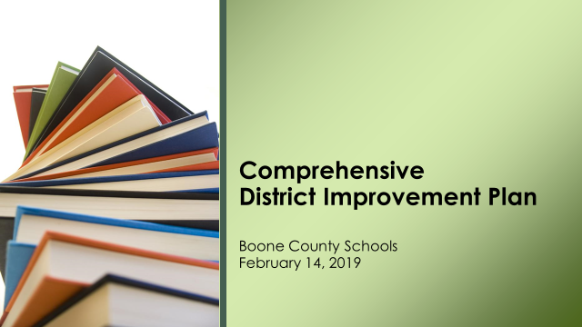

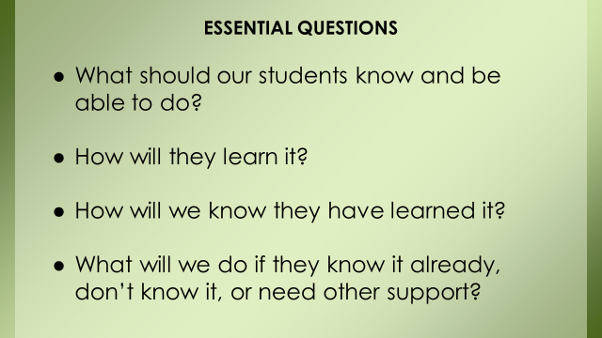

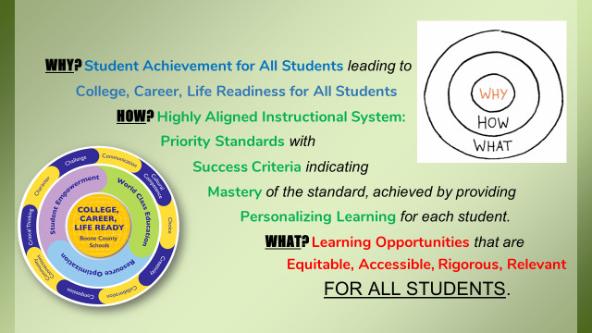

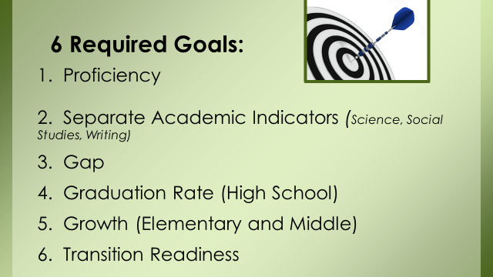

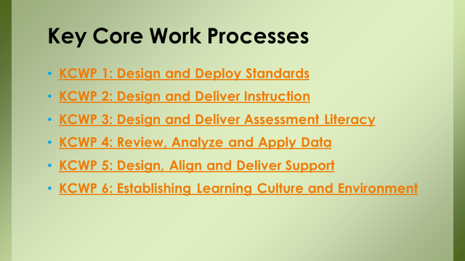

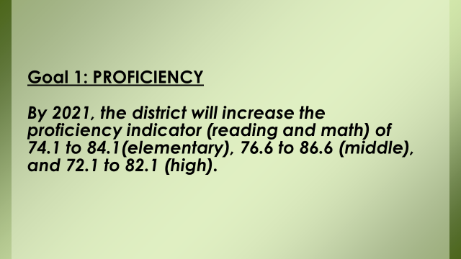

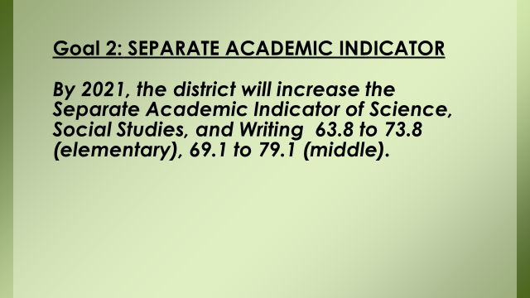

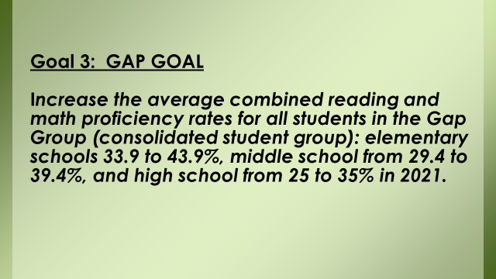

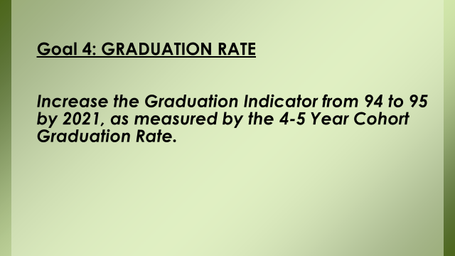

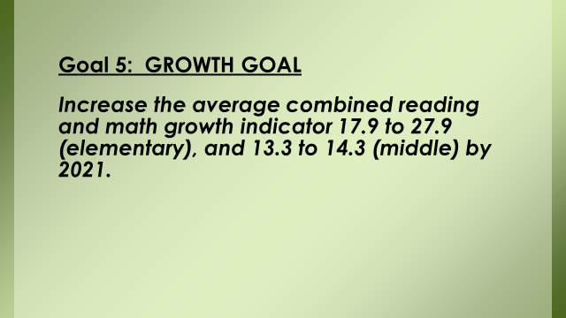

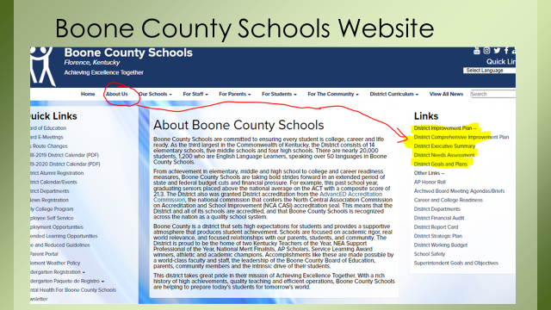
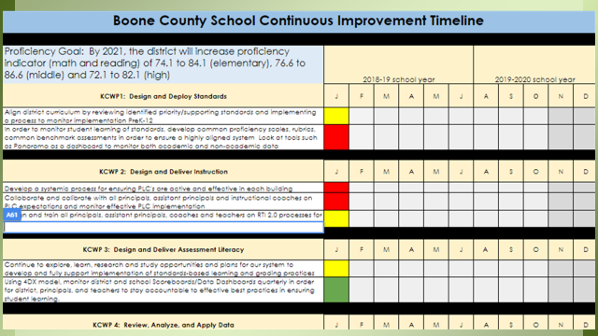

X. INFORMATION, PROPOSALS, COMMUNICATIONS
X.A. Human Resource Actions
X.B. Worker's Compensation Claims
X.C. Overtime Report
X.D. Construction Status Report
X.E. Energy Management Report
X.F. Grand National Blvd. Connector Road from Richwood Road to Chambers Road - Judge Gary Moore Memo of Action

- Julia Pile reminded everyone the Rotary Club Teacher of the Year applications are available and due March 8, 2019. Mrs. Pile attended the Show Cases of Learning Boone County High School and commented on the successful showcase. Mrs. Pile reported that she presented at the PSEA National Title I Conference by the US Dept. of Ed and Maryland Dept. Of Ed. which centered on Section 116 Parent Engagement polices and implementing family and community engagement. Mrs. Pile reported the conference was good and she learned a lot about Title I.
- Karen Byrd announced the KSBA Conference will be held Feb. 22, 23, 2019.

XI. AUDIENCE OF CITIZENS
No one addressed the board.

XII. CLOSED EXECUTIVE SESSION PER KRS 61.810
XII.A. No closed session

XIII. ADJOURN

7. A motion was made by Maria Brown, seconded by Matt McIntire, to adjourn the meeting. Karen Byrd, Maria Brown, Julia Brown and Matt McIntire voted, “aye” MOTION: The motion passed 4-0.

Meeting was adjourned at approximately 10:11 pm

_____________________________________
Karen Byrd /Chairperson

_________________________________
Karen Evans/Secretary

