John Hardin SBDM Council
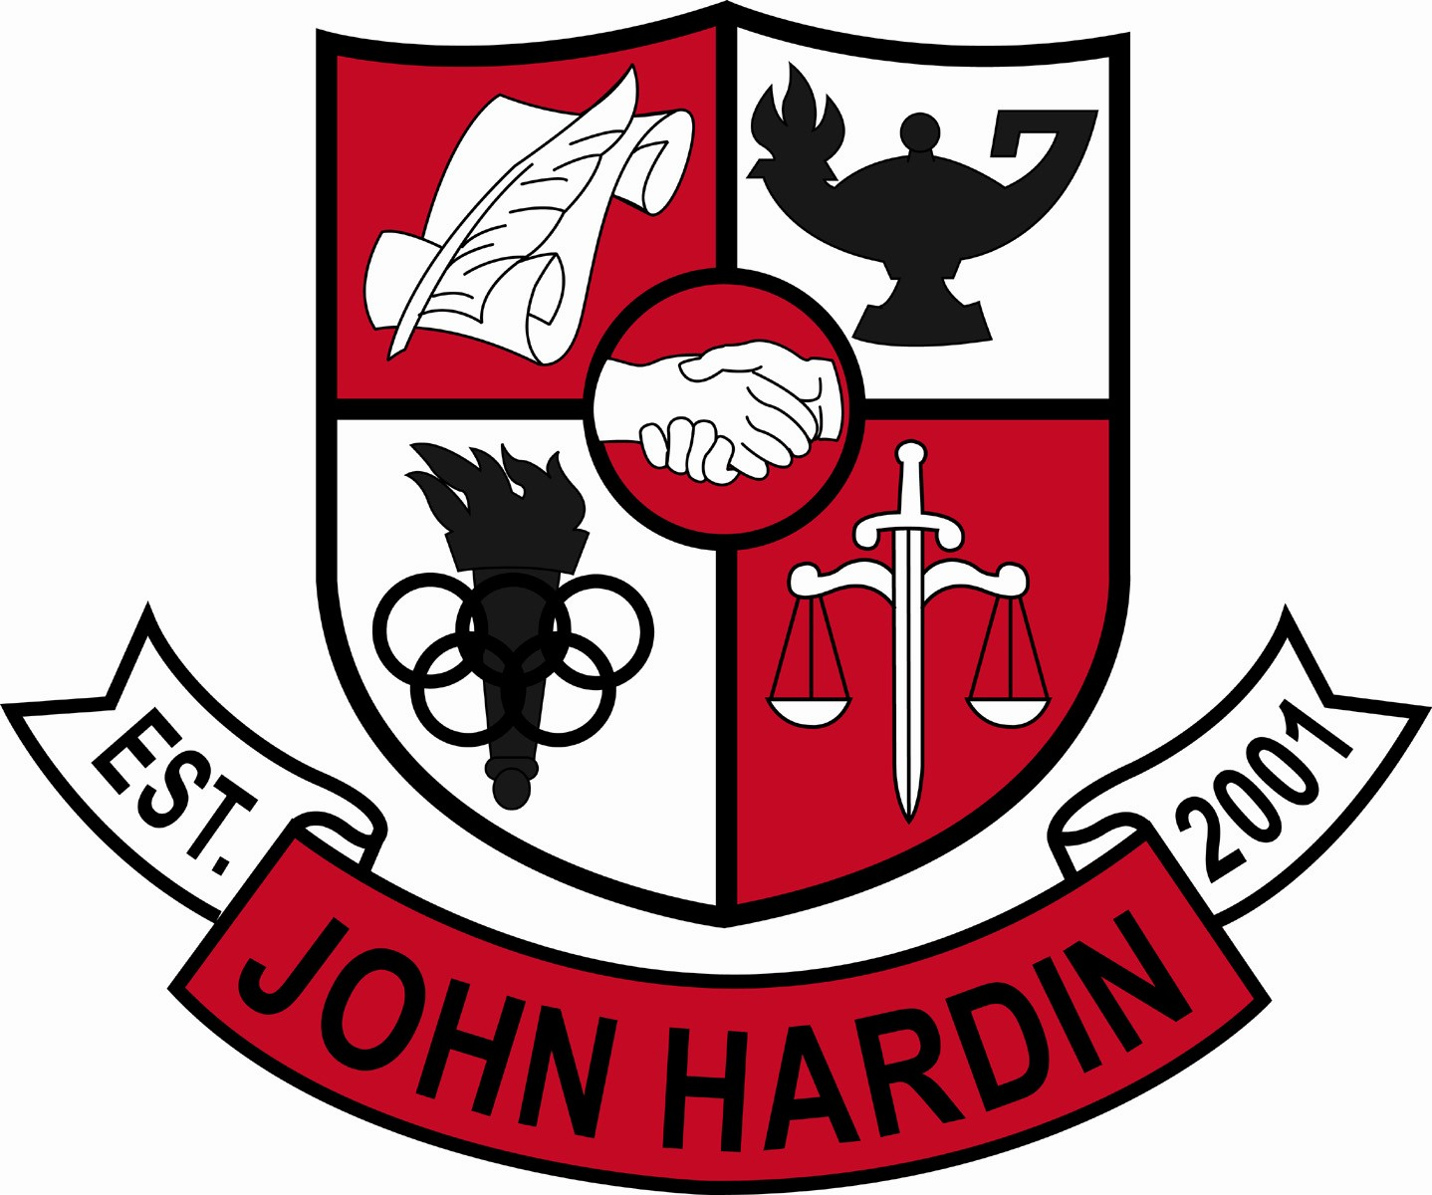
Meeting Minutes

January 16, 2014
4:00 p.m.

- Call to Order at 4:01 p.m.
Members present: Patrick Avery, Jana Haws, Stacey Moore, Alex Shearer Pauline Crittenden and Lynne Gibson
Visitors present: Greg Gumm, Angela Lewis, Jo Million and Vasi Wilk
- Approval of Agenda ORDER #13-14/0028
The council approved the agenda as written.
Motion: Avery Second: Moore
Avery - Yes
Crittenden – Yes
Gibson – Yes
Haws – Yes
Moore – Yes
Shearer - Yes
- Approval of Minutes ORDER #13-14/0029
The council approved the minutes as written.
Motion: Moore Second: Shearer
Avery - Yes
Crittenden – Yes
Gibson – Yes
Haws – Yes
Moore – Yes
Shearer - Yes
- PLC Reports
PE (Gumm) – Meet on Mondays, discuss what was covered in the IL meetings; reaching out to parents when students miss a lot of class time (grade drops to 76 or below) – it costs them 5 points each absence. Test students on the physical fitness test as well as a writing assignment.
CTE (Lewis and Million) – hosting a career fair for Bluegrass 8th graders and our freshmen, to give exposure of offerings; focus of PLCs is to make sure students and parents understand the pathway. KOSSA coming up (online this year) so will review during enrichment; STAR Competition will be held at JHHS on the 25th of January, six schools with 102 participants will be here.
- Principal’s Update
- EC³ Program Update - LEAD 100 will be offered in the business department. It’s a leadership class linked to WKU for dual credit; part of their Honors Academy. All three high schools will offer it for a trimester but EC³ will have it as an all year course and will require community service. Students who sign up for work ethic certification will be required to take LEAD 100. Personal Finance will be offered in the business department as well.
- Scheduling – counselors went to BGMS today to start the process; Academic Showcase is the 27th. Feb. 3rd (PL Day) core teachers will work on inputting student schedules
- Power Hour – committee met to discuss curriculum after March testing; the committee doesn’t see an academic need for continuing, so Feb. 26th will be the last Wednesday for Power Hour. Time could be spent doing productive work in the core classes rather than “making up” things to do in Power Hour
- New Highland Partnership – 27 seniors go to NHE on Tuesdays and Thursdays during 1st, 2nd & 4th blocks working one on one with students; making a huge impact. Still haven’t heard anything from BGMS about working with their students…
- Student Achievements - A large number of our students will be recognized at the HCS Board Meeting this month (Brittany Tooker for Gilda Award; KYA students, chapter and advisor; All State Chorus; JROTC Rifle Team; Football team and coaches)
- Financial Report ORDER #13-14/0030
The council reviewed and accepted the financial report for December.
Motion: Moore Second: Avery
Avery - Yes
Crittenden – Yes
Gibson – Yes
Haws – Yes
Moore – Yes
Shearer – Yes
- Personnel
Vacancies: Excel Asst.; Asst. Tennis Coach; Freshmen Volleyball Coach; Girls Soccer Head Coach; 90% Freshmen Baseball Coach; 10% Asst. Baseball/10% Freshmen Baseball Coach
Working on setting up interviews for Excel assistant, tennis, girls soccer and baseball
- Questions and Concerns from Council
- Graphing Calculators are going down quickly, buying more batteries. Have found out students are exchanging their batteries out of their personal devices with the graphing calculators. Looking for suggestions.
- Agenda Items for Next Meeting
None
- Adjourn
The meeting was adjourned at 5:24 p.m. The motion was made by Ms. Crittenden and seconded by Ms. Moore

