John Hardin SBDM Council
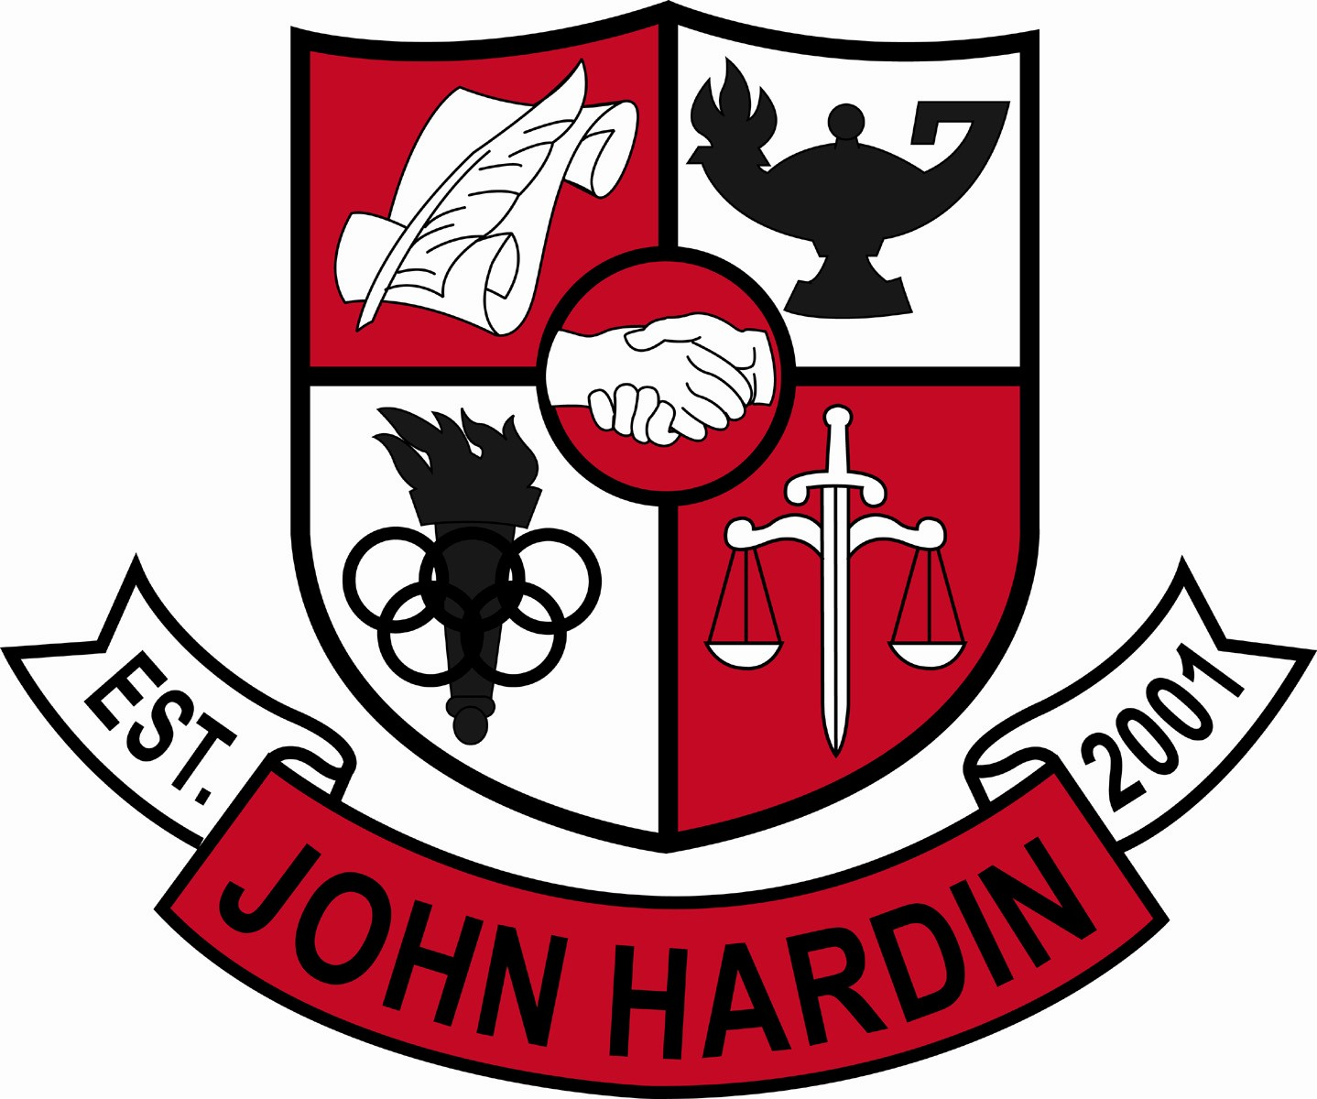
Meeting Minutes

March 10, 2016
4:00 p.m.

- Call to Order at 4:07 pm
Members present: Mark Wells, Alex Shearer, Aurora Selbe, Stacey Moore, and Jan O’Daniel
Members absent: Kelly Smith
Visitors: Michael Moritz and Mark Kopp
- Approval of Agenda ORDER #15-16/0058
The council approved the agenda as written.
Motion: Shearer Second: O’Daniel
Selbe – Yes
O’Daniel – Yes
Shearer– Yes
Wells – Yes
Moore - Yes
- Approval of Minutes ORDER #15-16/0059
The council approved the minutes as written.
Motion: Shearer Second: O’Daniel
O’Daniel – Yes
Selbe– Yes
Wells – Yes
Moore – Yes
Shearer – Yes
- Good News Report
  - FCCLA Region 5 STAR Events – John Hardin will be represented by Rebecca Smith, Destinea Holcomb, Kendrick Thomas, Kaitlyn Humphrey, Reyna Shelby and Madison Smith at state FCCLA. These students were 1st place winners at Region 5 FCCLA.
  - Wrestlers – Seven State Qualifiers; Rickey Garcia, Brody Haverstick, Chase Wallace, Trent Johnson, Warren Tucker, Stephen Kaiser and Trevon Wright.
  - National German Exam – Kevin Young placed second in the state in his test. Kavonte Jones and Rachel Rohrer received achievement awards.
  - Art Contest- Third place in painting - Elainae Thomas, First place in drawing – Madison Gengler, Third place in drawing – Daeshionna Kimbrough, Second place in sculpture- Kayla Jones, Third place in sculpture – Leah Foster. Madison Gengler will compete at the state contest in May.
  - Girls Basketball Team – The team placed 2nd in districts and advanced to Regions for the first time in the school’s history. The girls’basketball team will have a banner hung in the gym.
  - KUNA – John Hardin received the Delegation of Excellence Award, Outstanding Speaker – Kavonte Jones, Outstanding Ambassador –Jack Parvin, and Outstanding International Court of Justice Advocate – Matthew Mitchell.
  - Robotics - John Hardin 2886A received the highest honor for VEX Robotics Competition, the KY State VEX Robotics Excellence Award.
- Public Comment
  - No comments from visitors.
- Principal’s Update
  - ACT - Students took a practice exam in the Fall, data was analyzed, and the students were paired one on one with teachers to discuss results, strategies and to provide encouragement.
  - Sophomore Practice Act – Students took the exam on March 2nd. Mr. Corley and Mrs. Wright will breakdown the data. This information is used to schedule students and for power hour.
- PBIS Committee
Mr. Moritz explained the Positive Behavior Intervention System and presented data. .
- Financial Report ORDER#15-16/0060
The Financial Report for February was reviewed and accepted
Motion: Selbe Second: Moore
Shearer – Yes
Wells – Yes
Moore – Yes
Selbe – Yes
O’Daniel - Yes
- Dress Code Amendment
The amendment will be discussed at a later date by the Dress Code Committee to determine if it will be added for the next year.
- Needs List
The list was reviewed and accepted with the addition of blinds for the library media center.
- OCR Report
The results were discussed and accepted.
- Personnel
Hired;
Vacancies: Custodian; Golf Coach; Tennis Coach 10 % Stipend
- New Business
- Agenda Items for Next Meeting
  - Scheduling
- Adjourn
The meeting was adjourned at 4:50 p.m. The motion was made by Mr. Shearer and seconded by Ms. Selbe

