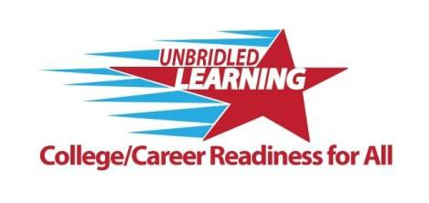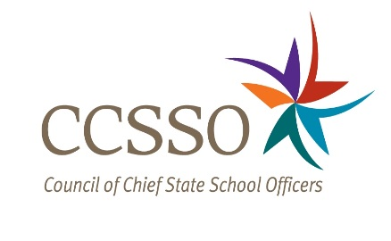

Kentucky Innovation Lab Network

2015-2016

LETTER OF COMMITMENT

The Kentucky Innovation Lab Network (KYILN) is a partnership between a local school district and the Kentucky Department of Education to transform education systems and accelerate College and Career Ready Outcomes through State-Local Plans of Action

Introduction
This Letter of Commitment (LOC) establishes a partnership between the Kentucky Department of Education (KDE) and the Nelson County Schools to benchmark, design, and implement practices and plans of action that can help accelerate districts and the state towards ensuring that all students graduate from high school, college and career ready (CCR). This letter of commitment is based on Kentucky’s participation in the Council of Chief State School Officers (CCSSO) Innovation Lab Network (ILN) and the state’s ongoing commitment to work with a set of peer states and with a group of leading districts within each state that are advancing new models of learning that can best prepare all students for success in the 21st Century.

. Background and Beliefs
This LOC is based on the several shared beliefs across the Kentucky ILN districts/partnerships:

  - We are in a moment of great opportunity in education reform, anchored in our belief that the core goal of our education systems is to realize “college- and career-readiness” for all students.
  - The Kentucky Academic Standards (KAS) are an historic opportunity and critical foundation for this work.
  - Building on the foundation of the (KAS), there is growing consensus and evidence that college- and career-readiness requires mastery of rigorous knowledge, skills, and dispositions, and that these are mutually reinforcing. Mastery of content knowledge is essential in multiple disciplines, including English/Language Arts, mathematics, science, social studies, the arts, and beyond. Key college- and career-readiness skills include, but are not limited to, the ability to think critically and solve problems, communicate effectively, work collaboratively, and be self-directed in the learning process. Dispositions refer to capacities or habits of mind, some of which are not easily measured, but they constitute important underpinnings for student success. These categories and concepts will continue to evolve as experience and evidence mature.
  - Our goal is for all students to graduate from high school with knowledge, skills, and dispositions necessary to enter and succeed in college or career training without remediation in either pathway, and to be prepared for citizenship. We believe that the core knowledge, skills, promote strong civic engagement.
  - Achieving college- and career-readiness at scale will require significant change in policy and practice, new models of learning, integrated strategies from early learning to and through high school graduation, and movement to learning systems that are resilient and continuously improve over time.
  - Based on the work of the KDE, CCSSO, KYILN and other partnerships, we believe that education systems designed to support every student to college- and career-readiness will share several critical attributes, including a focus on world class knowledge and skills,
performance based learning, personalized learning, anytime/anywhere learning, student agency, and comprehensive systems of support.
  - To transform our education systems along these lines, KDE and leading districts -- must advance plans of actions and/or a specific reform agenda that promote(s) comprehensive, transformative changes in policy, practice, and structures.

Mutual Commitments
Through this partnership, KDE (both directly and through its partners) will provide to each district in the KYILN ongoing technical assistance, supports and continued coordination to advance the innovation reform agenda established in this document. KDE will further commit to supporting identification, evaluation, and dissemination of best practices—to KYILN districts and more broadly. In exchange, participating KYILN districts, by completing this letter of agreement, agree to participate actively in the KYILN, work with its fellow KYILN districts, KDE and other partners to design and take specific actions to accelerate movement toward CCR outcomes for all students. More specific commitments include:

- Definition. Each KYILN district will support the current Kentucky definition of “college and career readiness” adopted by KDE and expand its use to include skills and dispositions.

- Participation/Shared Activities. Each district will establish and maintain a designated point of contact at the district level with continuing leadership from and involvement of the superintendent. Superintendents and or his/her designee will be present on bi-weekly calls in which districts will share their innovative approaches and also hear about other innovative approaches from outside the KYILN. The nature and degree of each district involvement will vary as KDE leadership engages in activities, such as meeting with key policy and community stakeholders. This work includes a commitment by each KYILN district to participate in activities which will assist KDE, in its work with CCSSO ILN, to drive policy aligned to innovative strategies resulting in increased college and career readiness outcomes.

- Annual Report. Each participating district will develop an action plan and submit an annual report of innovation work that highlights 2-3 district specific policies and/or practices for implementation. This may include new models of teaching and learning intended to advance CCR--especially deeper learning outcomes rooted in strong student voice and ownership. The focus of these reports should emphasize approaches that move toward vastly improved levels of student learning and success through re-designed systems.

- Research and Evaluation. Each participating district will agree to participate in the CCSSO ILN and KYILN’s research agenda, which includes participation in data collections, providing documentation, for purposes of quality control review, of how the KYILN is functioning and learning together as a network. To support development of a transferrable knowledge base, KYILN districts will agree to use a common language or taxonomy, and to report data in consistent ways for the purposes of cross-district and –state ILN activities. All data sharing will fully comply with federal and state privacy laws.

- Support. KDE will provide each participating district with continuing support and technical assistance to advance reforms consistent with this document, which includes matching funding for professional development opportunities when available upon successful execution of this agreement. KDE will provide, within available resources, technical assistance, coordinated joint activities, KYILN convenings for multi-district support and

peer-state communications, etc. The information contained in this document may also be used to solicit additional funding for ongoing KYILN support and services to participating districts.

KYILN Signing Statement
Each KYILN district has agreed to enter into an agreement with KDE with its own context and priorities in an action plan. Accordingly, Kentucky’s plan stresses the following few points:

  - Personalized Learning Pathways
  - Six key attributes of next generation learning systems
- Expansion of CCR to include assessing skills and dispositions

Within the framework of the information outlined in this letter of commitment, and, in referencing the priorities above, please identify 2-3 points of action for the district level plan.

- Non-Traditional Instructional Days
- World Readiness Certification (work ready program, including soft-skills training for students)
- Roll-out of Literacy/Math Design Collaboratives and Project Based Learning district wide

Agreement
KDE and KYILN districts agree to the principles and commitments described above, and agree to work together in good faith to advance both collective and district commitments. This agreement is effective from date from the date of the signature with the intent that this work will be sustained and scaled over the longer term. It is mutually understood that this agreement in no way restricts the district from participating in similar activities with other organizations.
Amendments to the innovation priorities may be made at any time by agreement of the parties and KYILN districts may terminate the agreement through written notice. Early termination may result in the loss of supports outlined above.

Required Signatories

Kentucky Innovation Lab Network, KDE Designee Date:

8/18/15

KYILN Participating District, Superintendent/Designee Date:

To return the Letter of Commitment, please either scan and email it to beth.peterson@education.ky.gov or mail to:

Kentucky Department of Education
Division of Innovation and Partner Engagement
c/o Beth Peterson
500 Mero St., 8th Floor CPT
Frankfort, KY 40601

