Regular Meeting Boone County Board of Education
April 18, 2019 7:30 PM
Ralph Rush Professional Development Center
99 Center Street
Florence, Kentucky 41042

I. CALL TO ORDER

The Regular meeting of the Boone County Schools Board of Education April 18, 2019 was called to order by Chairperson Karen Byrd at the Ralph Rush Staff Development Center.
Attendance Taken at 7:30 PM:

Present Board Members:
Dr. Maria Brown - attended at 8:09 pm due to traffic issues.
Ms. Karen Byrd
Mr. Troy Fryman
Mr. Matt McIntire
Mrs. Julia Pile

Gerry Dusing attended as Board Attorney
Karen Evans, Board Secretary, recorded the minutes.

II. PLEDGE TO THE FLAG
The Pledge to the Flag was led New Haven Elementary Students.

III. STUDENT BOARD MEMBER REPRESENTATIVE REPORT
Anna Impellitteri gave the Student Board Member Representative report. Anna reported on the Lex Based Prichard Committee Survey Social Emotional Learning which will be helpful when talking to students.

IV. GOOD NEWS
- The board recognized and congratulated the 2019 April Break the Mold Winner, Ms. Alison Sutton, Social Studies Teacher, Boone County High School.
- Beth Koch, Enrichment Teacher, Boone County Makerspace and District Robotics Coordinator, was recognized for applying and receiving a $25,000 grant from NASA KY to support the FIRST LEGO League program.
- Karen Byrd congratulated and welcomed Troy Fryman for being appointed as a board member by the Departed of Education.

V. RECOMMENDED ACTION - CONSENT AGENDA
Dr. Randy Poe, Superintendent, recommend the Consent Agenda items A - SS for Board approval, as presented.

- A motion was made by Matt McIntire, seconded by Julia Pile, recommended the Consent Agenda items A-SS for Board approval, as presented. Karen Byrd, Maria Brown, Matt McIntire, Julia Pile, and Troy Fryman removed himself from A & B because he was he was not at the meeting. voted, “aye.”
MOTION: The motion passed 5-0.

V.A. Minutes of the regular board meeting of March 14, 2019
The board approved the minutes of the regular board meeting of March 14, 2019, as presented.
V.B. Special Board Workshop March 19, 2019 FOCUS Book Study
The board approved the Special Board Workshop March 19, 2019 FOCUS Book Study, as presented.
V.C. Bill List
V.D. Treasurer's Report given by Mrs. Linda Schild.

V.E. Leaves of Absence
The following leaves of absence requests were board approved:
Recommended by Principal/Supervisor for approval:
Bailey, Sarah, Teacher @ New Haven ES 4/16/2019 – 5/15/2019
Deno, Janice, Bus Aide @ Transportation 3/14/2019 – EOY
Dotson, Deborah, Bus Driver @ Transportation 1/22/2019 – EOY
Harms, Tonia, Staff Support @ Thornwilde ES 3/4/2019 -3/22/2019
McMillian, Wayne, Bus Driver @ Transportation 3/27/2019 – EOY
Thompson, Olivia, Teacher @ Stephens ES 3/27/2019 – 5/13/2019
Not Recommended by Principal/Supervisor for approval:
Amended Leaves:
Hall, Cynthia, Bus Driver @ Transportation 10/15/2018 – 4/15/2019
McGlasson, Kathleen, Para @ Stephens ES 11/26/2018 – 3/14/2019
Menning, Leo, Bus Driver @ Transportation 10/19/2018 – 3/26/2019
Payne, Samantha, Teacher @ Mann ES 1/3/2019 – 4/18/2019
Vannarsdall, Robert, Custodian @ Camp Ernst MS 10/23/2018 – 4/17/2019
Cancelled Leaves:
Andrew, JoAnn, Transportation Aide @ Transportation 2/7/2019 – 3/15/2019
Brown, Chelsea, Admin Assistant @ District Office 2/4/2019 – 3/11/2019

V.F. Bid Award and Revised BG-1 for Jones Middle/Collins Elementary Underground Electric BG#19-144
The board approved the Bid Award to Woeste Builder, Inc. and Revised BG-1 for Jones Middle/Collins Elementary Underground Electric BG#19-144, as presented.
V.G. Bid Award and revised BG-1 for Paving 2019 BG#19-141
The board approved the bid awards to Paul Michels and Riegler Blacktop and revised BG-1 for Paving 2019, as presented.
V.H. Bid Award and revised BG-1 for Parking Lot Expansions BG#19-140
The board approved the bid award and revised BG-1 for Parking Lot expansions to Len Riegler Blacktop, Inc., as presented. The bid was opened on Thursday April 4 at 2:00pm.
V.I. Bid Award and Revised BG-1 for LSS Renovations BG#19-104
The board approved the bid award to Century Construction INC. and revised BG-1 for LSS renovations, as presented.
V.J. Bid Award and revised BG-1 for North Pointe Roof BG#19-143
The board approved the bid award to R & B Contractors in the amount of $361,515.00 and revised BG-1 for North Pointe Roof BG # 19-143, as presented. The bid was opened on Thursday, April 4 at 2:30pm.
V.K. Revised BG-1 for Preschool Playgrounds BG#19-145
The board approved the revised BG-1 for preschool playgrounds, as presented.
V.L. Design Development Drawings BG-2 and BG-3 for Steeplechase Elementary School BG#19-078
The board approved the Design Development Drawings BG-2 and BG-3 for Steeplechase Elementary School BG#19-078, as presented.
V.M. Bidding Documents, BG-2 and BG-3 for Boone County Schools Access Controls BG#19-194
The board approved the Bidding Documents, BG-2 and BG-3 for Boone County Schools Access Controls BG#19-194, as presented.
V.N. Camp Erpenbeck with Boone County Parks
The board approved the contract with Boone County Parks to host Camp Erpenbeck, as presented.
V.O. School Network Wiring Upgrade Needs
The board approved the school network wiring upgrade needs, as presented.
V.P. Student Accident Insurance
The board approved the student accident insurance, as presented.
V.Q. Declaration as Surplus: Text Books
The board approved the declaration as surplus text books, as presented.
V.R. Boone County School District and Brilliant Performance Group Contract
The board approved the Boone County School District and Brilliant Performance Group contract, as presented.
V.S. Ockerman Elementary and Schoolhouse Photos Agreement
The board approved the Ockerman Elementary and Schoolhouse Photos agreement, as presented.
V.T. Queen City Transportation- Ryle High School Soccer
The board approved Queen City Transportation for Ryle High School soccer, as presented.
V.U. Bus Request- Boone County Parks and Boone County Conservation District
The board approved the bus request for Boone County Parks and Boone County Conservation District, as presented.
V.V. Samuel French Play Agreement with Cooper High School
The board approved the Samuel French Play Agreement with Cooper High School, as presented.
V.W. YMCA of Greater Cincinnati/RC Durr Branch Contract with Florence Elementary
The board approved the YMCA of Greater Cincinnati/RC Durr Branch contract with Florence Elementary, as presented.
V.X. Dramatists Play Service, Inc., agreement with Cooper High School
The board approved the Dramatists Play Service, Inc. agreement with Cooper High School, as presented.
V.Y. Bid Award for Burlington Elementary Asbestos Abatement BG#19-105
The board approved the bid award for Burlington Elementary Asbestos Abatement BG#19-105, as presented.
V.Z. Longbranch Elementary- Agreement with Boosterthon for Fun Run
The board approved the Longbranch Elementary agreement with Boosterthon for Fun Run, as presented.
V.AA. Facility Use Agreement- Boone County High School with OH-KY All Star Game
The board approved the facility use agreement for Boone County High School with OH-KY All Star game, as presented.
V.BB. Declaration as Surplus: Technology Equipment
The board approved the declaration as surplus for technology equipment, as presented.
V.CC. Alternative Funding Program fro FRYSC
The board approved the Alternative Funding Program fro FRYSC, as presented.
V.DD. Memorandum of Agreement between Franklincovey Client Sales Inc. and Burlington Elementary School
The board approved the Memorandum of Agreement between Franklincovey Client Sales Inc. and Burlington Elementary School, as presented.
V.EE. Field Trips
The board approved the following field trip requests, as presented.
School | Date Of Trip | Location | Reason
Cooper High School | July 9-14, 2019* | Washington DC | Leadership Conference
Cooper High School | April 26-30, 2019 | Orlando, FL | Culinary Cook Around the World Competition
Cooper High School | June 29-July 5, 2019 | Anaheim, CA | FCCLA National Leadership Conference
Ryle High School | September 6-7, 2019 | Owensboro | Soccer Tournament
Ryle High School | June 6-8, 2019 | Lexington | Possible State Baseball Games
Ryle High School | June 6-8, 2019 | Lexington | Possible State Softball Games
Ryle High School | May 30-June 1, 2019 | Lexington | Possible State Tennis Games
Ryle High School | April 30, 2019 | Bowling Green | Archery State Tournament
- All travel by commercial carrier is due to schedule/cost.
- *change of date

V.FF. Non-resident Contracts for Students who reside in BCS but attend other school districts
The board approved the Non-resident Contracts for Students who reside in BCS but attend other school districts, as presented.
V.GG. Memorandum of Agreement with Smekens Education Solutions, Inc and Stephens Elementary School
The board approved the Memorandum of Agreement with Smekens Education Solutions, Inc and Stephens Elementary School, as presented.
V.HH. Memorandum of Agreement between Northern Kentucky University and Florence Elementary School
The board approved the Memorandum of Agreement between Northern Kentucky University and Florence Elementary School, as presented.
V.II. Memorandum of Agreement- Midway University
The board approved the Memorandum of Agreement with Midway University, as presented.
V.JJ. Boone County High School Copier Lease and Maintenance Agreement
The board approved the Boone County High School Copier Lease and Maintenance Agreement, as presented.
V.KK. SLN Spring Leadership Conference
The board approved the SLN Spring Leadership Conference for Dr. Randy Poe to attend in Montgomery, Alabama, April 24-26, 2019, as presented.
V.LL. Executive Charter- Ryle High School to Bowling Green
The board approved the Executive Charter for Ryle High School to Bowling Green, as presented.
V.MM. Camp Yealey with Boone County Parks
The board approved Camp Yealey with Boone County Parks, as presented.
V.NN. Memorandum of Understanding Between the Boone County Schools & Be Well Counseling
The board approved the Memorandum of Understanding Between the Boone County Schools & Be Well Counseling, as presented.
V.OO. Memorandum of Understanding Between the Boone County Schools and Holly Hill Child & Family Solutions
The board approved Memorandum of Understanding Between the Boone County Schools and Holly Hill Child & Family Solutions, as presented.

V.PP. Renewal of Financial Auditor Services
The board approved the Renewal of Financial Auditor Services for the period of July 1, 2019 through June 20, 2020, as presented.
V.QQ. Indemia Contract
The board approved the Indemia Contract, as presented.
V.RR. Approval of School Fees, Admissions, Fees, Transcript Fees and Meal prices for 2019-2020 school year.
The board approved the School Fees, Admissions, Fees, Transcript Fees and Meal prices for 2019-2020 school year, as presented.
V.SS. Executive Charter to Conner Prairie for Stephens Elementary School
The board approved the Executive Charter to Conner Prairie for Stephens Elementary School, as presented.

VI. RECOMMENDED ACTION - OLD BUSINESS
VI.A. No Old Business

VII. SUPERINTENDENT'S REPORT
(beol
District CSI Plan and RA Jones Improvement Priorities Review was led by Dr. Jim Detwiler, Deputy Superintendent CAO and Mrs. Jenny Watson, LSS Assistant Superintendent. The powerpoint was presented and the open discussion was presented by the team to the board, including Curriculum, Data Improved Decision, and System for Continuous Improvement (district turnaround model). Principals Lisa Resing and TW Loring, spoke on the support help from LSS and the challenges of their particular schools. Both discussed the necessities in order to sustain the needs of their students and thanked LSS for the continued support. Dr. Detwiler discussed the models of other turnaround schools and the proposed Office of Schools & System Improvements for the district.

Dr. Poe also discussed the meaning of a TSI school (Targeted Support and Improvement) and CSI (Comprehensive Support and Improvement), the plans in developing the system to improve student performance in the identified CSI, TSI group, as well as, addressing all achievement gaps. Dr. Poe discussed the research based turnaround models and the highly recommended system from the state. The district is a TSI district and we must have a plan. How it is designed is up to the board, the plan must be approved by KDE, this is mandated. Dr. Poe spoke on what TSI means as a district - when it comes to Special Education we need to develop a system and develop a plan to improve student performance in the TSI identified group.

Dr. Poe discussed reconstitution of RA Jones and what this will mean for the school and staff. RA Jones will no longer have an SBDM the district will be the decision maker under the recommendations of the state. Dr. Poe spoke on the state audit and recommendations. He also spoke on the failure is in the system not the teachers and the system is what RA Jones is up against.

This meeting was an open meeting for discussion questions by the board members.

Paula McPeake, Parent Ambassador spoke on the Newcomer Academy and the impressive program and her thoughts on the program’s success and asked the board to leave the students in their respective schools.

Dr. Detwiler and Mrs. Watson covered the presentation as follows:

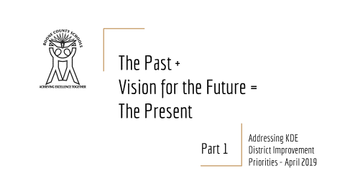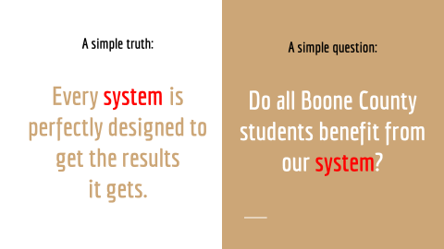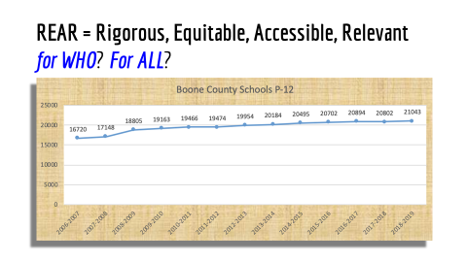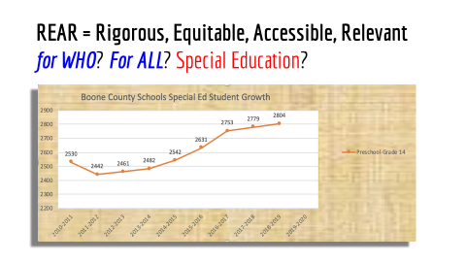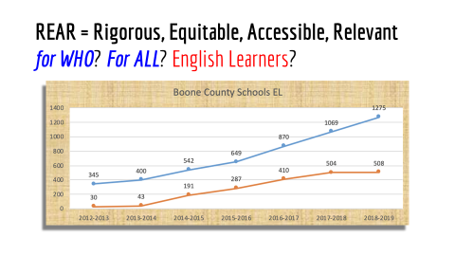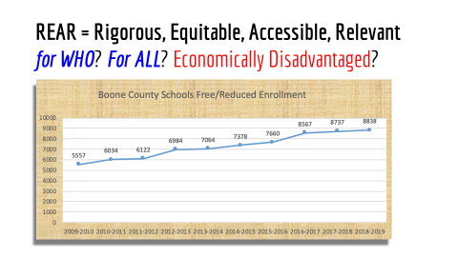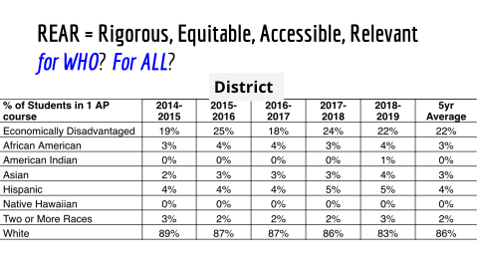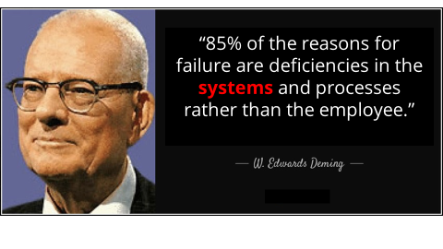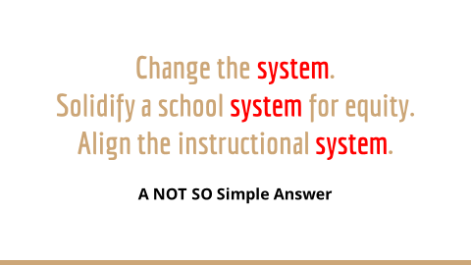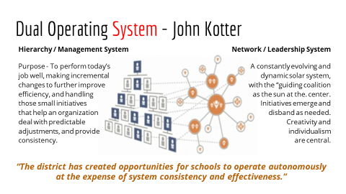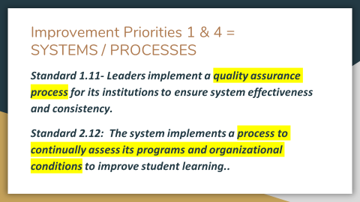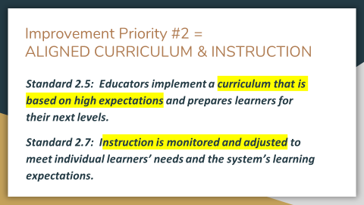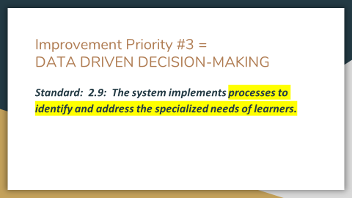
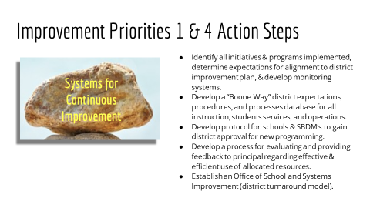
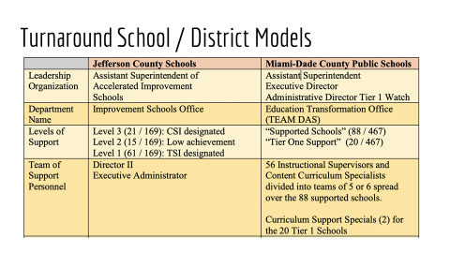
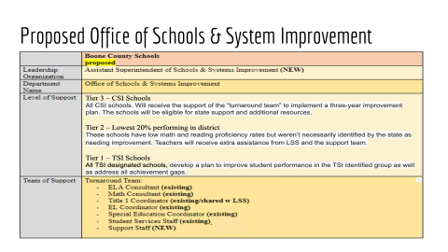
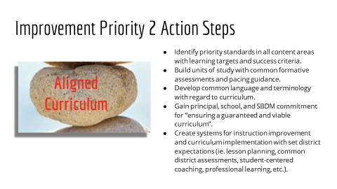
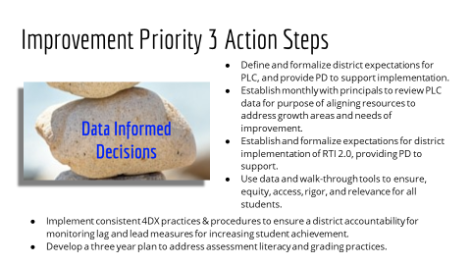
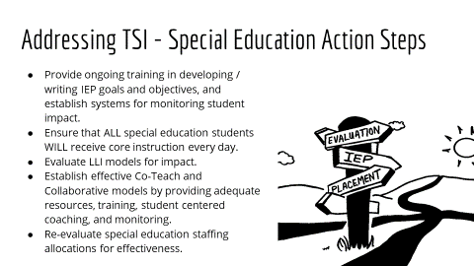
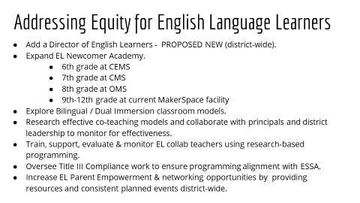
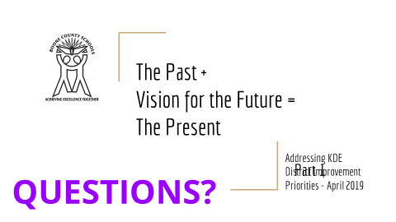
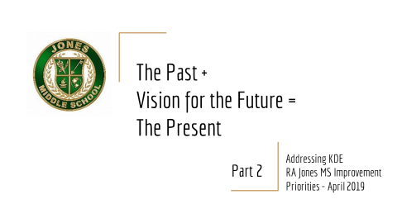
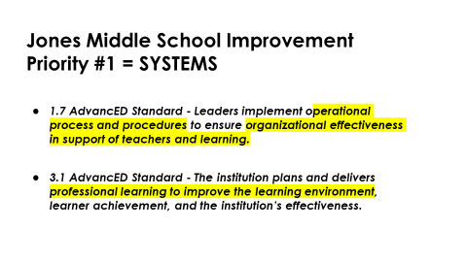
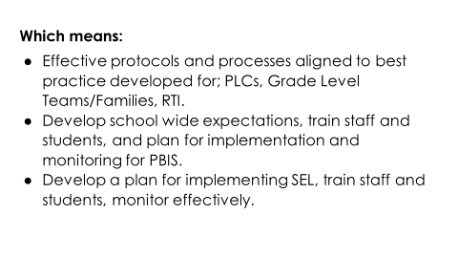
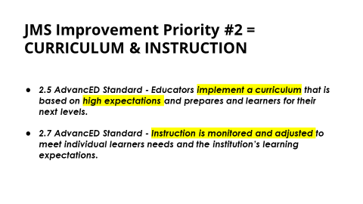
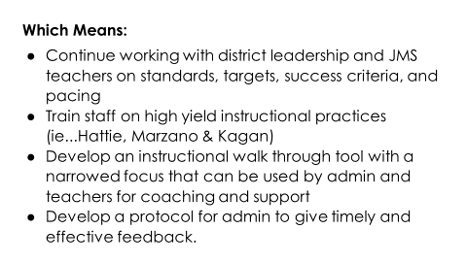
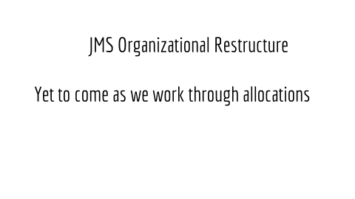
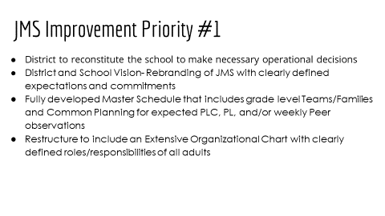
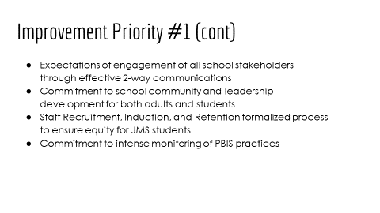
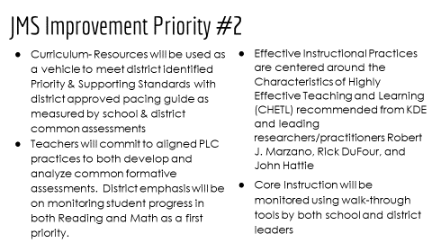
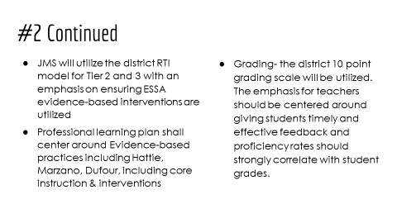
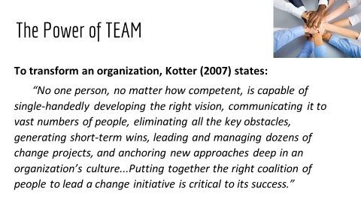
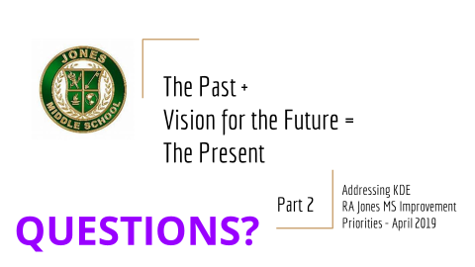

VIII. RECOMMENDED ACTION - NEW BUSINESS
VIII.A. Last Instructional Day for 2018-2019
Dr. Randy Poe, Superintendent, recommended the board to approve the last Instructional Day for 2018-2019 as May 24, 2019, as presented.
- A motion was made by Maria Brown, seconded by Julia Pile, to approve the last instructional day for 2018-19, as presented. Matt McIntire, Karen Byrd, Maria Brown, Julia Pile, and Troy Fryman voted, “aye” MOTION: The motion passed 5-0.

VIII.B. Plan for Addressing Identified District CSI/TSI Improvement Priorities
Dr. Randy Poe, Superintendent, recommended the board to approve the Plan for Addressing Identified District CSI/TSI Improvement Priorities, as presented.
- A motion was made by Matt McIntire, seconded by Maria Brown, to approve the Plan for Addressing Identified District CSI/TSI Improvement Priorities, as presented. Matt McIntire, Karen Byrd, Maria Brown, Julia Pile, and Troy Fryman voted, “aye” MOTION: The motion passed 5-0.

VIII.C. Plan for Addressing Identified RA Jones Middle School Improvement Priorities
Dr. Randy Poe, Superintendent, recommended the board to approve the Plan for Addressing Identified RA Jones Middle School Improvement Priorities, as presented.
- A motion was made by Maria Brown, seconded by Matt McIntire, to approve the Plan for Addressing Identified RA Jones Middle School Improvement Priorities, as presented. Matt McIntire, Karen Byrd, Maria Brown, Julia Pile, and Troy Fryman voted, “aye” MOTION: The motion passed 5-0

VIII.D. Updated TSI/CSI CSIPS Per KDE Revised Goals and Plans
Dr. Randy Poe, Superintendent, recommended the board to approve the updated TSI/CSI CSIPS per KDE revised goals and plans, as presented.
- A motion was made by Julia Pile, seconded by Matt McIntire, to approve the Updated TSI/CSI CSIPS Per KDE Revised Goals and Plans, as presented. Matt McIntire, Karen Byrd, Maria Brown, Julia Pile, and Troy Fryman voted, “aye” MOTION: The motion passed 5-0
VIII.E. Memorandum of Understanding Between Regional School District and Boone County School District Regarding the Ignite Institute
Dr. Randy Poe, Superintendent, recommended the board approve the Memorandum of Understanding Between Regional School District and Boone County School District Regarding the Ignite Institute, as presented.

- A motion was made by Maria Brown, seconded by Julia Pile, to approve the Memorandum of Understanding Between Regional School District and Boone County School District Regarding the Ignite Institute, as presented. Matt McIntire, Karen Byrd, Maria Brown, Julia Pile, and Troy Fryman voted, “aye” MOTION: The motion passed 5-0

IX. INFORMATION, PROPOSALS, COMMUNICATIONS
IX.A. Human Resource Actions
IX.B. Worker's Compensation Claims
IX.C. Overtime Report
IX.D. Construction Status Report
IX.E. Energy Management Report
IX.F. KSBIT Member Letter of Refund

X. AUDIENCE OF CITIZENS
(Brief summaries)
- Education Majors from the following Schools attended: NKU- Kristin Stanley, Damian Klein, Dustin Borwn, McKenna Burford, Deborah Lee, Maviem Soud, Ian Bahman, Haley Binkley, Alley Dennler, Dezy Owens, Jordan Eglian, Brianna Wright, Cole Ludwig, Mason Bulland. Shannon Kopser from University of the Cumberlands.
- Lenora Broome, Teacher at RA Jones, spoke to the board about the great school RA Jones is and the wonderful teachers that do so much for the students. She asked for the board to give Jones staff a chance to pick themselves up and for the board to be gentle in their decisions.
- Tammy Webb, RA Jones teacher, spoke the many reasons that she works and stays at RA Jones. She spoke on how she and the teachers support the students. She discussed that the teachers want and need the support and welcome the help.
- Dr. Poe stated that he agreed and discussed the details of reconstituting the school and this is state mandated and the board is here and willing to give support to our students and staff.
- Sharon Reynolds, RA Jones teacher, spoke on behalf of the students and staff and the reasons why she choose RA Jones for her teaching career. Mrs. Reynolds discussed the current system not being good and thanked the board for the support. She also invited the board to visit the school and see the students and staff. Ms. Reynolds also asked the timeline to be shared.
- Dr. Poe discussed the time frame and by law we must inform teachers by May 15th. Dr. Poe stated the board is committed to long term support for our students and staff.
- Matt McIntire asked that we continue the work on collaboration with the staff at RA Jones. Troy Fryman discussed the importance of planning to meet our goals and the collaboration efforts. Karen Byrd spoke on RA Jones being a school in her division, but also her families’ school. Ms. Byrd discussed her dedication to the students in the Florence area as well as all our students in the district. Ms. Byrd spoke on the strong commitment that the board has always had and will have for all of our schools -All means All.
- Dave Fleischer, gave a presentation and handout to the board members on the fund raising efforts for Ignite that he is currently working on along with the Business Partnership Guide. Mr. Fleischer discussed the Workforce Development at Ignite with Scholarship, Operational Costs Support, Endowments and Regional Initiatives.

XI. CLOSED EXECUTIVE SESSION PER KRS 61.810
XI.A. No closed session

XII. ADJOURN
- A motion was made by Maria Brown, seconded by Matt McIntire, to adjourn the meeting. Karen Byrd, Maria Brown, Julia Pile, Matt McIntire, and Troy Fryman voted, “aye” MOTION: The motion passed 5-0.

Meeting was adjourned at approximately 10:58pm.

_____________________________________
Karen Byrd /Chairperson

_________________________________
Karen Evans/Secretary

