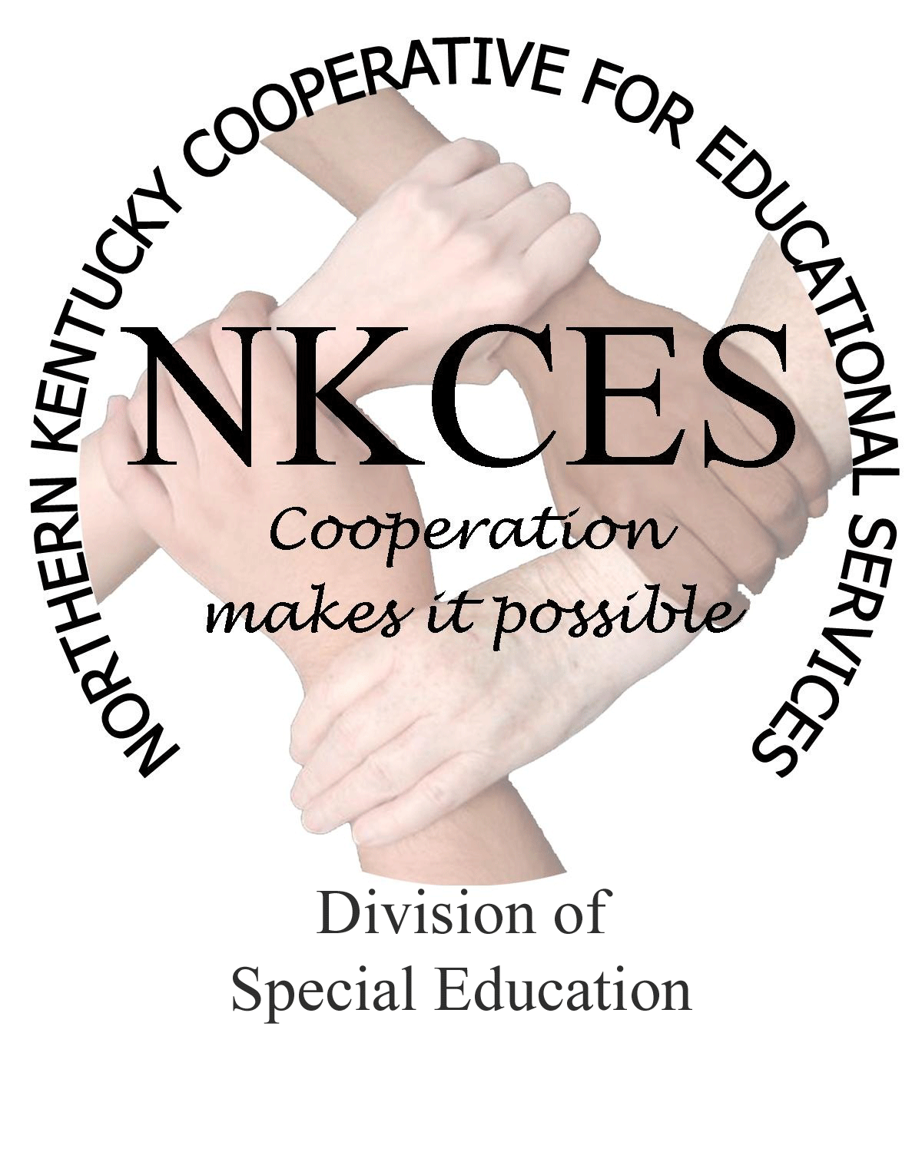
Northern Kentucky Cooperative for Educational Services, Inc.

Member Districts

Beechwood Independent • Bellevue Independent • Boone County • Campbell County

Covington Independent • Dayton Independent • Erlanger-Elsmere Independent

Ft. Thomas Independent • Kenton County • Ludlow Independent • Newport Independent

Pendleton County • Silver Grove Independent • Southgate Independent

Walton-Verona Independent • Williamstown Independent

June 9, 2014

Curtis Hall, Executive Director
NKCES
5516 E. Alexandria Dr.
Cold Spring, KY 4-176

Re: Superintendents Report

Dear Curtis:

May proved to be exciting and successful as we completed the district meetings and developed plans for the upcoming year. We are proud and excited to announce that we have experienced an outstanding year, have made many contacts, and developed educational relationships with principals and staff members. My staff and I are always amazed and grateful that we work with teachers and administrators that are vested with their students and desire nothing less than to provide every opportunity that will help their students meet success. We will have our 2013 – 2014 Year-End report prepared and ready for your review next month detailing and summarizing our work and accomplishments in our school districts.

In order to close out the school year, the staff has been busy this past month with many of the teachers and staff regarding follow-up trainings and any additional assistance they needed. Looking forward to 2014 – 2015, their calendars are already filled for July and August as schools request additional training and technical assistance. Also our summer trainings and summer institute scheduled for July 28th – 31st will be timely and pertinent to the request we have received. All of us are looking forward to presenting and overseeing these trainings to ensure teachers are exposed to the most up to date information, support, and trainings.

As you are aware, Jeanette Hodge, Literacy Consultant, retired as of June 1. I am in the process of interviewing for this position and have a few candidates that look very promising and look forward to the interviews. I am pleased to announce that we have filled the middle school and high school math consultant position, which has been posted since October 2013. I will provide a complete report to you next month with the names of new staff members along with details.

Please see the consultant’s report attached and feel free to contact me regarding any questions or concerns as I am always glad to assist you in any way possible. Enjoy your time off this summer and please note that each of us are looking forward to our continued success as we work to “Close the Gap” in our school districts in 2014 – 2015.

Sincerely,

Linda Alford
Regional Director of Special Education
NKCES

