Grandview Elementary
SBDM Board Report
May 24, 2023

MAP Assessments
Kindergarten through 5th grade Reading and Math Spring MAP assessments have been completed. Attached are two reports: One report shows Spring 2022 to Spring 2023 Growth Summary and the other shows 2022-2023 MAP Data Growth with percentile ranges.

Teacher Appreciation
Thank you to GES PTA, BEF and BISD for all our wonderful goodies! We had a great week of making us feel spoiled and very much appreciated.
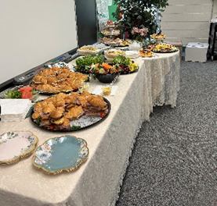

End of the year Celebrations
Preschool Graduation
Preschool graduation was ADORABLE! Thank you to the preschool staff, Tara Wittrock and Amy Staggs for all your hard work!

5th Grade Dance- May 15th
The GES PTA organized a glow themed 5th grade dance. We had a wonderful turnout and the students danced the entire time. Thank you to the PTA for organizing this and Jim Seward for his DJ skills!
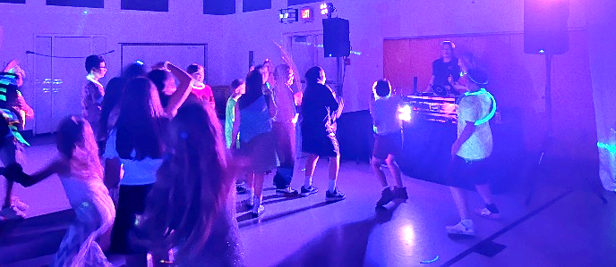

5th Grade Graduation
We had a great crowd at 5th grade graduation and parade! Thank you to John and Candace Gibson for the wonderful Send-off video.

Welcome Brandon Forshey as Grandview Elementary’s new Assistant Principal!
We look forward to getting started and preparing for the 2023-2024 school year.

Upcoming Dates
- May 18th 3rd-5th Grade Field Trip Newport Movies and Picnic at Sawyer Point
- May 22nd Field Day (May 23rd Rainout Date)
- May 23rd BHS Seniors walk through Grandview
- May 24th Future Day (8:30-11am) and Talent Show (12:30-1:45)
- May 25th Students’ Last Day
- May 26th Staff Closing Day
- June 5th- 30th Summer Learning

