Option Nine Program Proposal between
University of the Cumberlands and Spencer County Public Schools

Includes a residency or paraprofessional component which employs the person within the district for the duration of the program to gain work experience to supplement the expedited program and reduced coursework.
To enroll in the Option Nine program, a candidate must be employed full-time as a paraprofessional serving in an instructional assistant position in the district. The district will provide a mentor for each candidate enrolled in the Option Nine program at the University of the Cumberlands for the duration of the time the candidate is enrolled in the program. Option Nine candidates will be assigned mentors who are skilled in each of the subject areas the candidate will be responsible for teaching pursuant to the certification they are seeking.
The program will result in a bachelor's degree and initial certification within three (3) school years.
Utilizes experienced teachers employed by the district to provide coaching and mentoring to the candidates.
When selecting mentors, the district will give first preference to a teacher who demonstrates:
- Effective classroom management techniques that promote an environment conducive to learning;
- Best practices for delivery of instruction;
- Knowledge and use of multiple forms of assessment;
- Mastery of the content knowledge or subject matter in which the Option Nine candidate will receive certification;
- Aptitude and ability to contribute to the mentoring and development of a candidate enrolled in the Option Nine program; and
- Creation of a learning environment that values and builds upon the diverse backgrounds of students.
The mentoring teacher will have:
- A valid teaching certificate for the grade and subject in which the Option Nine candidate will receive certification;
- At least two (2) years of teaching experience; and
- Time available to provide adequate mentoring to the candidate.
- The school district will be responsible for compensating mentors for their time spent working with the candidate(s).
The mentoring teacher will be responsible for providing the Option Nine candidate with proper experience and counsel in planning and presenting effective learning experiences in the classroom for a minimum of 50 clock hours per year for the first two years. The district will be responsible for monitoring the hours and reporting those to the university.

Designed to meet the needs of the participating district and may include an emphasis in developing a teacher pipeline for the district's students, improving the numbers of underrepresented populations among the district's workforce, or focusing on increasing the number of teachers with certification areas that are in high demand.
The Option Nine program will focus on developing a teacher pipeline for students in Spencer County by getting instructional assistants with classroom experience certified to teach in the district though the partnership with the University of the Cumberlands. Only instructional assistants who show promise as a classroom teacher are eligible for the program. Candidates will be selected by the district and recommended to the university.
A school district shall ensure the availability of funding for each candidate employed within the district for the duration of the candidate's participation in the program.
The Spencer County Public Schools Board of Education approved the partnership agreement and board minutes are attached. The agreement includes the assurance that the candidate will be employed throughout the program. The agreement does not require the district to continue employing the candidate after the candidate has received initial certification. The agreement further states that if a district ends the partnership, they shall no longer accept new candidates but shall continue the partnership until the employed candidates complete the program or are no longer employed.
The program shall only include the EPP's existing undergraduate initial certification educator preparation programs approved by the EPSB.
Programs offered to candidates through the Option Nine program will include all University of the Cumberlands initial undergraduate certification programs in early childhood, elementary, middle, and high school approved by the EPSB.
An agreement between the Spencer County Public Schools and the University of the Cumberlands to collaborate on the expedited route program is attached.
An understanding that the program shall not negatively impact the accreditation of the EPP.
The program will not negatively impact the accreditation of the University of the Cumberlands as all program requirements will be met with each candidate participating in the Option Nine program. A planned program example is attached.
Contact information for the EPP leader and the district leader.
District University
Charles Abell
chuck.abell@spencer.kyschools.us
502-299-477-3250

Description of when the expedited route program is offered, the method of delivery and the certification areas included.
Courses will be offered in the Fall, Spring, and Summer terms. Courses will be offered in-seat and online. Certification areas included will be all early childhood, elementary, middle, and high school certification areas approved by EPSB.
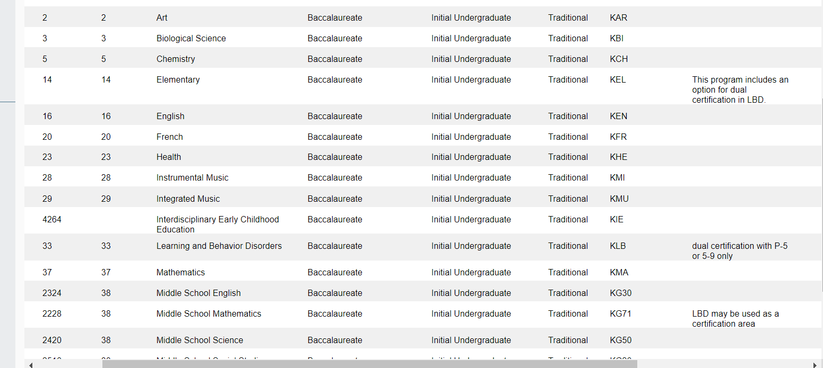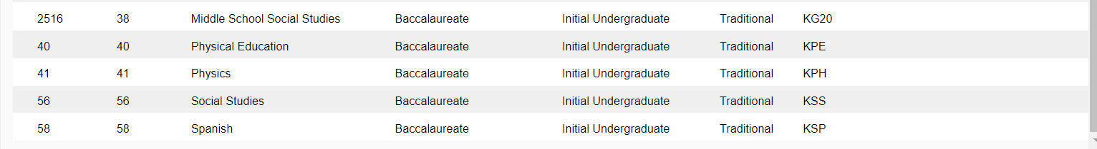
A process to maintain regular communication between the employing school and EPP to assist the resident as needed and address identified areas of improvement.
The mentoring teacher will submit evaluation documents and field hours documentation to the University of the Cumberlands each semester for the duration of the program. Two hundred twenty hours will be documented during the first two years of the program; 120 course-required hours and 100 district-required hours.
The University of the Cumberlands will designate a representative to serve as a liaison between the university and the district and school in which the Option Nine candidate is employed.
The university representative will work closely with the Option Nine candidate during the third year of the program, including a minimum of four observations of the candidate providing hands-on learning experiences in the classroom.
Explanation of how the program requirements contained in 16 KAR 9:110 Sections 2, 3 and 4 will be addressed.
Section 2. Residency
The district will provide a paid residency program with mentors for each candidate enrolled in the Option Nine program at the University of the Cumberlands for the duration of the time the candidate is enrolled in the program. The residency will allow the candidate to gain work experience in the grade spans and content areas in which the candidate will be seeking certification. Mentors skilled in each of the grade spans and subject areas the candidate will be responsible for teaching pursuant to the certification they are seeking will work with the candidates while enrolled in the program.
An Option Nine candidate shall not have responsibility for the supervision or instruction of students without the direct supervision of a certified educator.
Section 3. Field Experience
Option Nine candidates will complete the same field experience requirements as traditional students in 16 KAR 5:040. Specific field experiences to be completed in identified courses are included in syllabi. In addition to course-required hours, the Option Nine candidate will complete additional hours with the mentor teacher in the areas of planning and presenting effective learning experiences in the classroom for a minimum of 50 clock hours per year for the first two years. The district will be responsible for monitoring the hours and reporting hours to the university.
Clinical Experience-Undergraduate
Courses  (Knowledge Strands) | InTASC Standards |  |  |  |  |  |  |  |  |  | Clinical  Hours
 | 1 | 2 | 3 | 4 | 5 | 6 | 7 | 8 | 9 | 10 | Online
EDUC 235 Basic Concepts Concerning Education (CP,E) | X | X | X | X | X |  | X | X | X |  | 20
EDUC 130 Educational Technology | X | X |  | X | X | X | X | X
SPED 233 Survey of Individuals with Exceptionalities (CP, E, S) | X | X | X | X | X | X | X | X |  |  | 20
EDUC 237 Effective Teaching Practices (CP, S, E, CM) | X | X | X | X | X | X | X | X | X |  | 20
EDUC 331 Studies in Education: Special Topics in Literacy (CP, S, E, CM) | X | X | X | X | X | X | X | X | X | X | 30
EDUC 430 Classroom Management and Behavior (CP, S, E, CM) | X | X | X | X | X | X | X | X | X |  | 30
EDUC 432 Fundamentals of Secondary Education (CP, S, E, CM) | X | X | X | X | X | X | X | X | X
SPED 234 Special Education Instructional Programs (P-12) (CP, S, CM) | X |  | X | X |  |  | X |  | X
SPED 236 Special Education Programs for Adolescents with Mild Disabilities(5-12) (CP, S) | X | X | X | X | X | X | X | X
SPED 238 Special Education Early Childhood Programs (CP, S, E) | X | X | X | X | X | X | X | X
SPED 336 Educational Assessment and Prescriptive Programing of Individuals with Disabilities Part I (CP, S, E, CM) | X |  | X | X |  | X | X |  | X
SPED 337 Educational Assessment and Prescriptive Programing of Individuals with Disabilities Part II (CP, S, E, CM) | X |  | X | X |  | X | X |  | X
SPED 435 Special Education Methods and Materials (Mild Disabilities) (P-12)(CP, S, E, CM) | X | X | X | X | X | X | X | X
SPED 436 Special Education Methods and Materials (EBD) (P- 12 12) (CP, S, E, CM)  12) (CP, S, E, CM) | X | X | X | X | X | X | X | X
EDUC 332 Reading I (CP, S, E, CM) | X | X | X | X | X | X |  | X |  |  | 20
EDUC 338 Reading II (CP, S, E, CM) | X | X | X | X | X | X |  | X |  |  | 20
Courses  (Knowledge Strands) | InTASC Standards
 | 1 | 2 | 3 | 4 | 5 | 6 | 7 | 8 | 9 | 10
MATH 130 Concepts of Math for the Elementary and Middle School Teacher (CP, S, CM) |  |  |  | X
MATH 230 Concepts of Math for the Elementary and Middle School Teacher (CP, S, CM) |  |  |  | X
MATH 332 Math Methods P-5 (CP, S, CM) | X | X | X | X | X | X | X | X |  |  | 10
MATH 333 Middle School Math Methods (CP, S, CM) | X | X | X | X | X | X | X | X
ELEM 333 Children’s Literature (CP, S, E) | X | X |  | X | X |  | X | X | X
ELEM 334 P-5 Teaching of Social Studies (CP, S, E, CM) | X | X | X | X | X | X | X | X |  |  | 10
ELEM 339 P-5 Teaching of Science (CP, S, E, CM) | X | X | X | X | X | X | X | X |  |  | 10
ELMS 335 The Middle School (CP, S, E, CM) | X | X | X | X | X | X | X | X | X | X
ART 331 School Art | X | X |  | X | X |  |  | X | X |  | 10

Section 4. Student Teaching
The student teaching experience will meet all requirements of 16 KAR 5:040.
In the 3rd year of the program, the Option Nine candidate will be placed in a setting that is consistent with his or her planned certification content area and grade range.
A qualified cooperating teacher will be assigned to each Option Nine candidate. The cooperating teacher shall meet eligibility requirements and will be chosen by the university and the district representatives jointly.
Each Option Nine candidate will be trained in and adhere to the Professional Code of Ethics.
During the first 2 years of the residency, the candidate will complete a minimum of 200 clock hours of field experiences in a variety of primary through grade 12 school settings as outlined above.
The district and university will maintain electronic records of field hours and student teaching performance to confirm that all third-year residents meet the student teaching requirements.
A properly trained university supervisor will work closely with the Option Nine candidate during the third year of the program, including a minimum of four observations of the candidate providing hands-on learning experiences in the classroom. The university supervisor will be available to work with the candidate and school if problems arise related to student teaching.
All candidates shall meet the admission requirements established in 16 KAR 5:020.
Option Nine candidates will meet the admission requirements to an undergraduate, initial certification educator preparation program.[16 KAR 5:020, Section 1(2)]:
• A cumulative grade point average of 2.75 on a 4.0 scale; or a grade point average of 3.00 on a 4.0 scale on the last 30 hours of credit completed.
• Successful completion of one or a combination of the following assessments of basic knowledge:
ACT with a composite score of 22 or the corresponding minimum scores:
▪ Reading: 20
▪ Writing or English: 18
▪ Math: 19
Praxis Core Academic Skills for Educators (CASE):
▪ Reading (5713): 156
▪ Writing (5723): 162
▪ Mathematics (5733): 150

