John Hardin SBDM Council
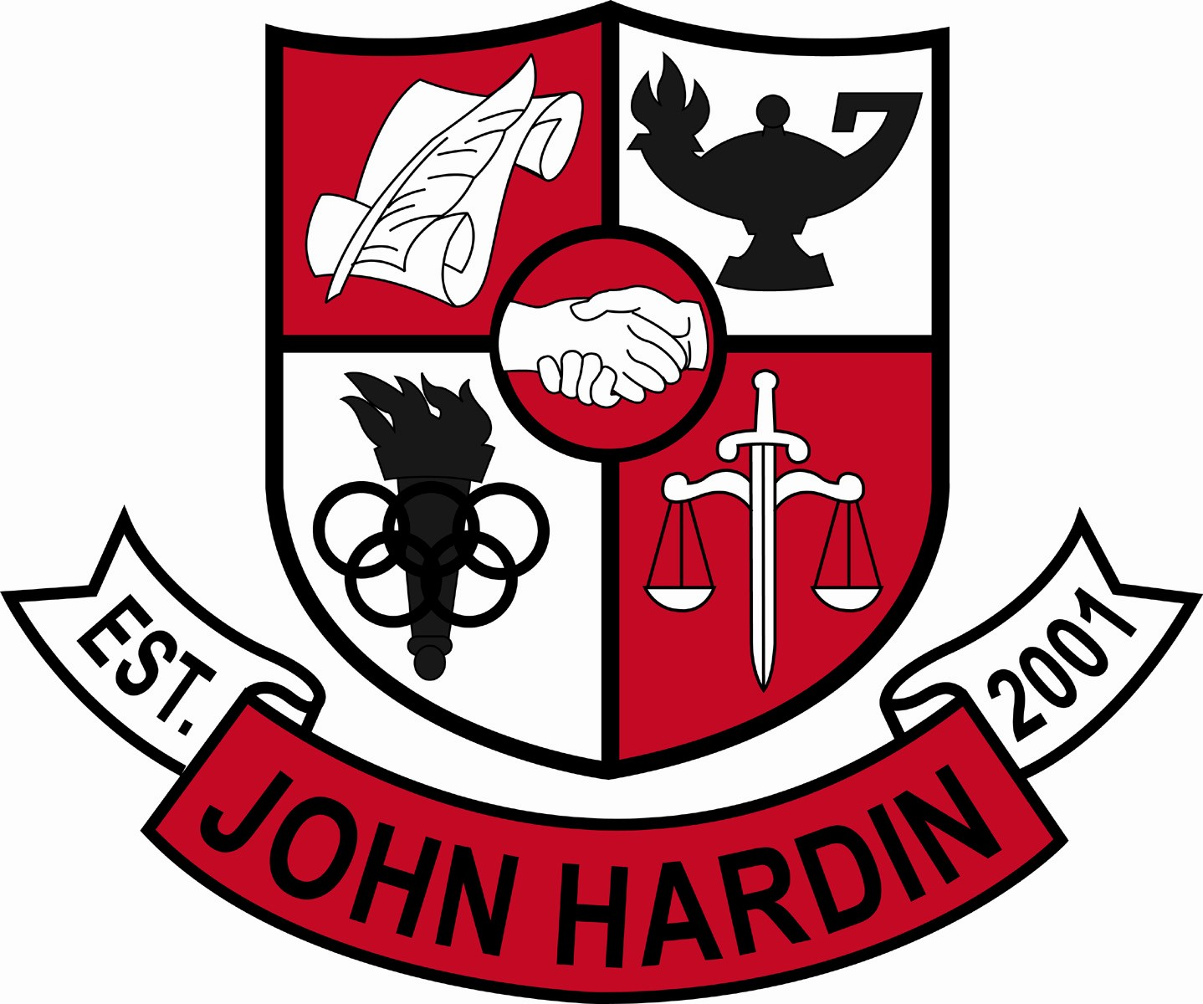
Meeting Minutes

October 15, 2015
4:00 p.m.

- Call to Order at 4:06 p.m.
Members present: Mark Wells, Alex Shearer, Aurora Selbe, Stacey Moore, and Jan O’Daniel
Members absent: Kelly Smith
Visitors: Mark Kopp, Donna Bumper, and Brahim Benmoussa
- Approval of Agenda ORDER #15-16/0020
The council approved the agenda as written.
Motion: Shearer Second: O’Daniel
Selbe – Yes
Moore – Yes
Wells - Yes
- Approval of Minutes ORDER #15-16/0021
The council approved the minutes as written.
Motion: O’Daniel Second: Shearer
Selbe – Yes
Moore - Yes
Wells - Yes
- Principal’s Update
- Mr. Wells went over the test score analysis, discussed moving novice in math, and language and mechanic scores in the future. Next step, midterms and finals are generated by administration from a teacher made test bank.
- Honors biology classes will be added.
- Financial Report ORDER #15-16/0022
The Financial Report for Sept was reviewed and accepted.
Motion: O’Daniel Second: Selbe
Shearer – Yes
Moore – Yes
Wells - Yes
- Personnel
Hired: Adrienne Gearheart for English; Carmen Johnson for Boys Cheer; Deron Bell for Girls Cheer; Chris Appleman for Asst. Baseball ($500 stipend); David Bell for Asst. Baseball ($50 Stipend); Jason Fischer for Asst. Archery;
Vacancies: Asst. Band Dir #3; Asst Girls Basketball; Freshmen Softball Coach; Asst . Wrestling Coach; Freshmen Wrestling Coach
- Questions and Concerns from Council
- Teacher accountability for posting grades in Infinite Campus for Dual Credit Classes? Mr. Kopp said there is no issue between ECTC and John Hardin that would prevent the posting of grades. Mr. Wells has addressed this with the individual teachers.
- The doors of the school are locked at 4 pm.
- When will the students receive their practice ACT scores? Mr. Wells said the scores will be given to students during the next power hour.
- Can On-Demand scores be added to report cards? Mr. Wells will research the possibility of adding these scores.
- Discussed the possibilityof changing the name of Honors US History.
- Senior trip? Mr. Wells explained why the senior trip was cancelled.
- Agenda Items for Next Meeting
- Committee representatives will speak
- CSIP
- Adjourn
The meeting was adjourned at 5:04 p.m. The motion was made by Ms. Selbe and seconded by Ms. O’Daniel.

