John Hardin SBDM Council
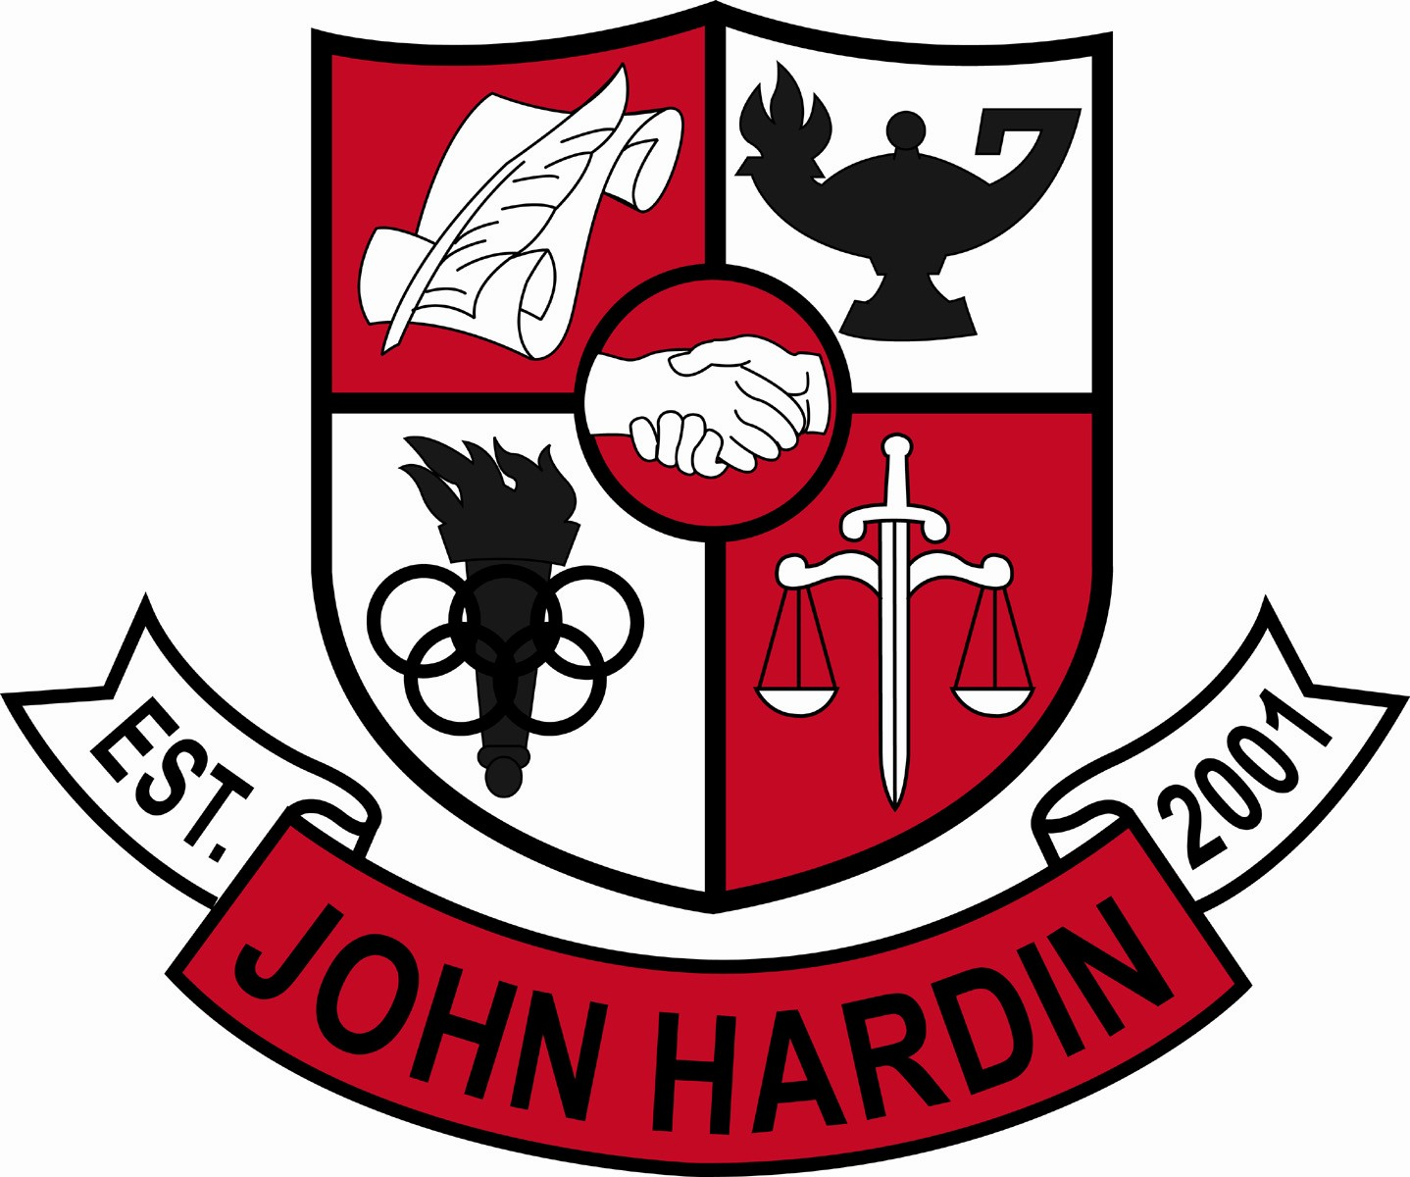
Meeting Minutes

June 2016

A meeting was not held in the month of June. Minutes from May’s SBDM meeting will be approved in July.

