Board Workshop Mid-Year Review Meeting Boone County Board of Education
February 06, 2020 6:30 PM
Ralph Rush Professional Development Center
99 Center Street
Florence, Kentucky 41042
I. CALL TO ORDER
The Special Board Meeting Workshop Mid-Year Review meeting of the Boone County Schools Board of Education of February 6, 2020 was called to order by Chairperson Matt McIntire the Ralph Rush Staff Development Center.

Attendance Taken at: 6:30 PM
Present Board Members:
Dr. Maria Brown
Ms. Karen Byrd
Mr. Troy Fryman
Mr. Matt McIntire
Mrs. Julia Pile
Karen Evans, Board Secretary
II. PLEDGE TO THE FLAG
The Pledge to the Flag was led by Mr. Matt McIntire, Chairperson.
III. DISTRICT MID YEAR REVIEW
The Mid-Year District Review was given by Dr. Jim Detwiler, Deputy Superintendent CAO, Mrs. Jenny Watson, Assistant Superintendent of Learning Support and Dr. Jason Radford, Assistant Superintendent Office of School and System Improvement. Dr. Detwiler led the powerpoint presentation with a continuing of pervious workshops and the discussion of equity and accessibility and what a quality learning environment would look like…his discussion of what the district is doing, tried and where we need to get there. The board members joined their clusters for each area and had a one-on-one discussion with each principal in the cluster. The board members reported on the clusters learning opportunities and needs. The following powerpoint was discussed at length.

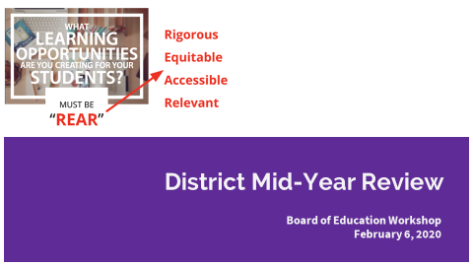

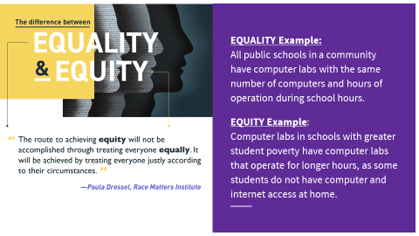

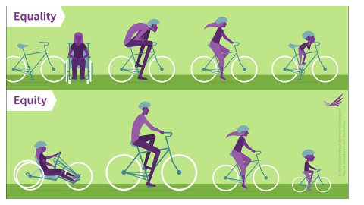
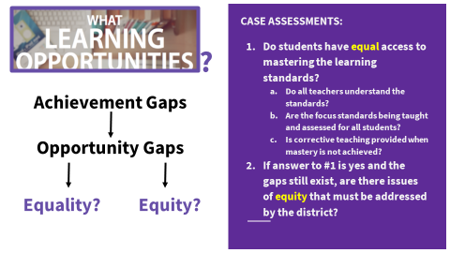

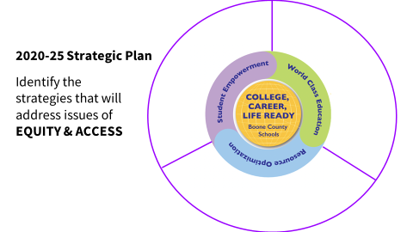

Discussion and presentation by Dr. Jason Radford…..

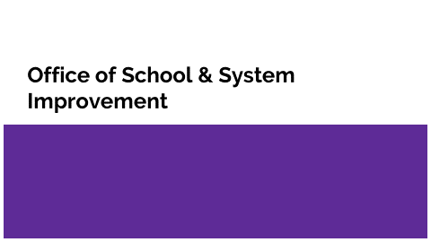

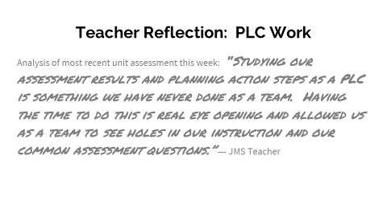

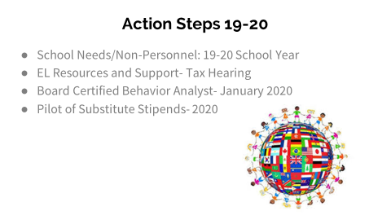
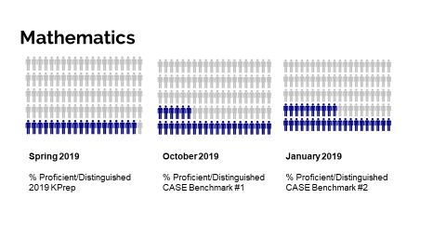

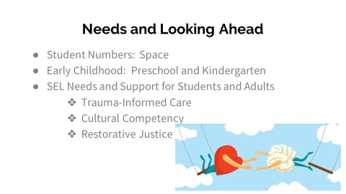

IV. ADJOURN

- A motion was made by Dr. Maria Brown, seconded by Julia Pile, to adjourn the meeting. Karen Byrd, Maria Brown, Julia Brown, Troy Fryman and Matt McIntire voted, “aye” MOTION: The motion passed 5-0.

Meeting was adjourned at approximately 7:38 pm.

____________________________________

Matt McIntire /Chairperson

_____________________________________
Karen Evans/Secretary

