Program Reviews
A Program Review is a systematic method that schools use to analyze components of their instructional programs. Currently, there are three Program Review areas:
- Arts and Humanities,
- Practical Living/Career Studies and
- Writing.
Program Reviews fall under Next-Generation Instructional Programs and Supports in the accountability model. These program reviews will count 23 % of a school’s overall accountability score. The remaining 77 % will come from current KPREP Next-Generation Learners components (achievement, gap, growth, graduation rate and college/career-readiness). The overall score, once program review data has been integrated, will be used to set the new percentile cuts for summer 2014 targets.

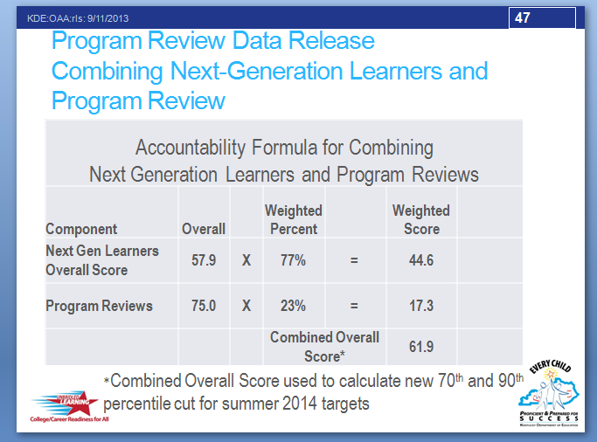
A program review requires that a school gathers evidence about how it integrates the subjects across its curricula and whether the school provides students with high-quality learning opportunities. The components that schools will look at are curriculum and instruction, formative and summative assessments, professional development, and leadership support and monitoring.
There are four identical components across all three program reviews. Those standards are:
- Curriculum and Instruction,
- Formative and Summative Assessment,
- Professional Development,
- Leadership support and monitoring

Further, each standard is organized with demonstrators, and each demonstrator has a number of characteristics. A rubric guides the scoring. Characteristic scores range from 0-3.

Details about scoring are below:

- For each standard, its characteristic scores are averaged.
- The characteristic scores range from 0-3 (0 – Non-Existent, 1 – Needs Improvement, 2 – Proficient, and 3 – Distinguished)
- For a total score, the four standard scores are added resulting in a single number ranging between 0-12 for each Program Review
- Below 8 is Needs Improvement, 8-10.7 is Proficient and 10.8 or higher is Distinguished.
- Statewide, data show arts and humanities, practical living/career studies and writing programs earned an overall score of 7 total points each which indicates the majority of programs need improvement.

Once scores are received, the school uses that information to improve its programs. The SBDM will be responsible for receiving the findings of the Program Review team(s) and making policy decisions based upon those findings.

