Special Workshop Meeting Strategic Plan Reflection and Boone2020 Update Boone County Board of Education
September 19, 2019 6:30 PM
Ralph Rush Professional Development Center
99 Center Street
Florence, Kentucky 41042

I. CALL TO ORDER

The Special Workshop Meeting Strategic Plan Reflection and #Boone 2020 meeting of the Boone County Schools Board of Education September 19, 2019 was called to order by Chairperson Karen Byrd at the Ralph Rush Staff Development Center.
Attendance Taken at 6:30 PM:

Present Board Members:
Ms. Karen Byrd
Mr. Troy Fryman
Mr. Matt McIntire
Mrs. Julia Pile

Absent Board Members:
Dr. Maria Brown

II. PLEDGE TO THE FLAG
The Pledge to the Flag was led by Ms. Karen Byrd, Chairperson.

III. STRATEGIC PLAN REFLECTION & #BOONE2020 UPDATE

Dr. Detwiler, Deputy Superintendent COA, presented a detailed PowerPoint to the board: Fully Focused and Committed: Where We’ve Been and Where We Are Headed. The presentation was open for questions from the board and those in attendance. See below.

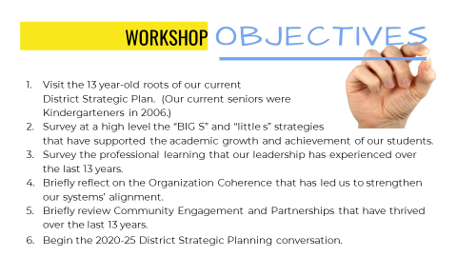

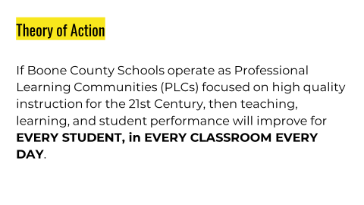

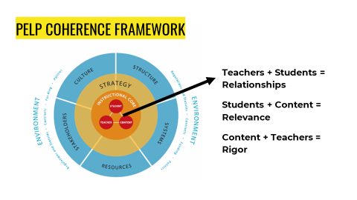

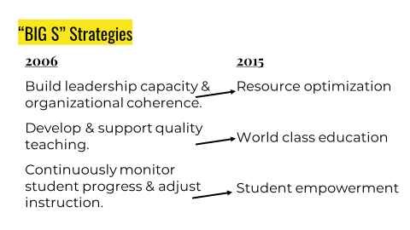

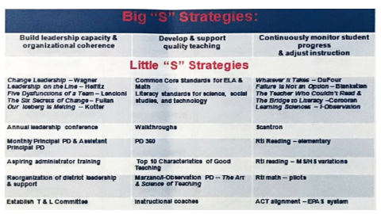

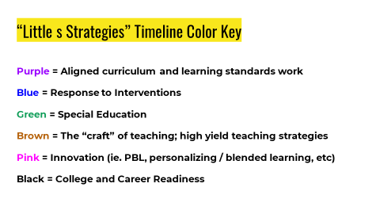

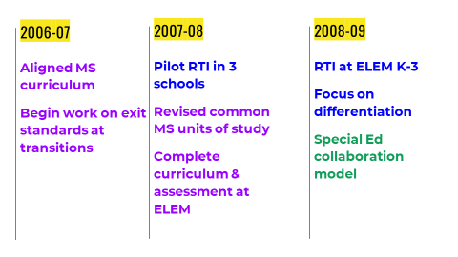

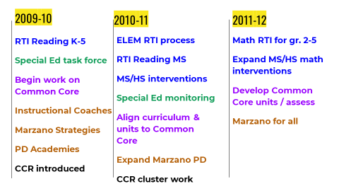
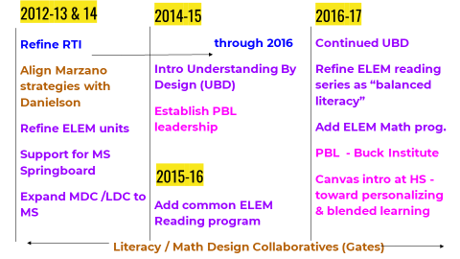

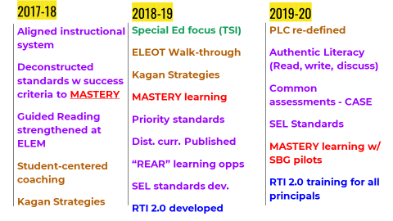

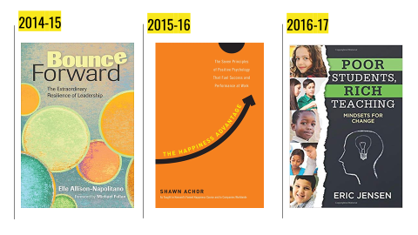

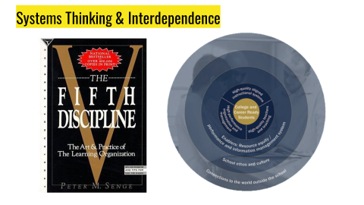

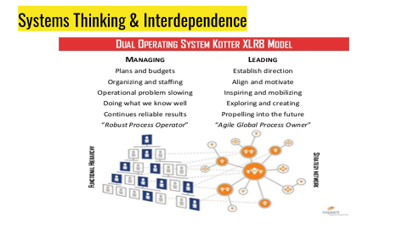

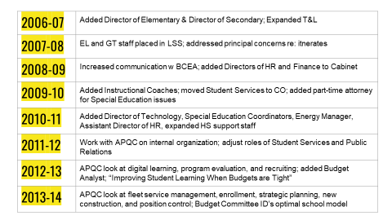
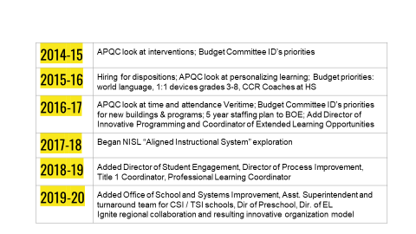

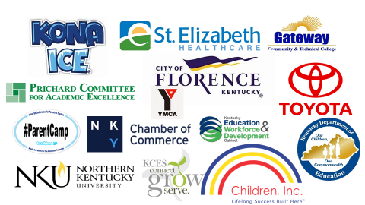

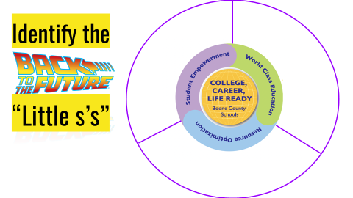

IV. ADJOURN

- A motion was made by Troy Fryman, seconded by Matt McIntire, to adjourn the meeting. Karen Byrd, Troy Fryman, Julia Brown and Matt McIntire voted, “aye” MOTION: The motion passed 4-0.

Meeting was adjourned at approximately 8:33 pm

_____________________________________
Karen Byrd Chairperson

_____________________________________
Karen Evans/Secretary

