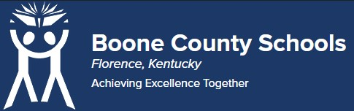
Boone County Board of Education Members
Dr. Maria Brown, Board Chair Mrs. Julia Pile, Vice Chair
Ms. Karen Byrd Mr. Jesse Parks
Mr. Keith Collins Mr. Matthew Turner, Superintendent

Board Memo

DATE: 8/24/2021

AGENDA ITEM DETAILS:

School/Department
Learning Support Services Product Vendor or Grant Issuer Translate Live

Product or Grant Name
ILA Pro

Date/Term (Beginning and End Dates/Year)
8/30/2021 - no end date

APPLICABLE BOARD POLICY:
Community Relations 10.5/ 08.13451 Title I Parent/Community and Family Engagement Policy/ 08.13452 ESL

DESCRIBE USE OF CONTRACT/PURCHASE/AGREEMENT
Service included for the life of the device. The dual sided ILA pro allows any two people to easily and instantly have a realtime, natural back and forth conversation no matter what language or method they use to communicate. Simple approach the device, or connect remotely via the web, schoose your language/accent and start communicating. Customers can speak, spell out loud or type and results are immediately displayed and/or voiced to both people in their native language - preventing confusion and increasing sales potential. For our use
- it enables school-home communication in any of our district buildings, and between families and transportation dispatchers. For additional building security and family equity of access, families will be able to use their smart phones to communicate to office personnel while outside of the building (at the doorbell).

FUNDING FOR PURCHASES AND OTHER REQUESTS:

Total Cost
$94,950.00

Funding Source
ARP ESSR

*If more than one funding source, list below along with amount or percent for each source
Click or tap here to enter text.

IF THIS IS A GRANT, ENTER AMOUNT TO BE AWARDED: $94,950.00

RECOMMENDATION:
I recommend the Board to approve this agreement as presented. Jenny Watson, Assistant Superintendent

CONTACT PERSON: (submitter)
Dr.Geniene Piche

