John Hardin SBDM Council
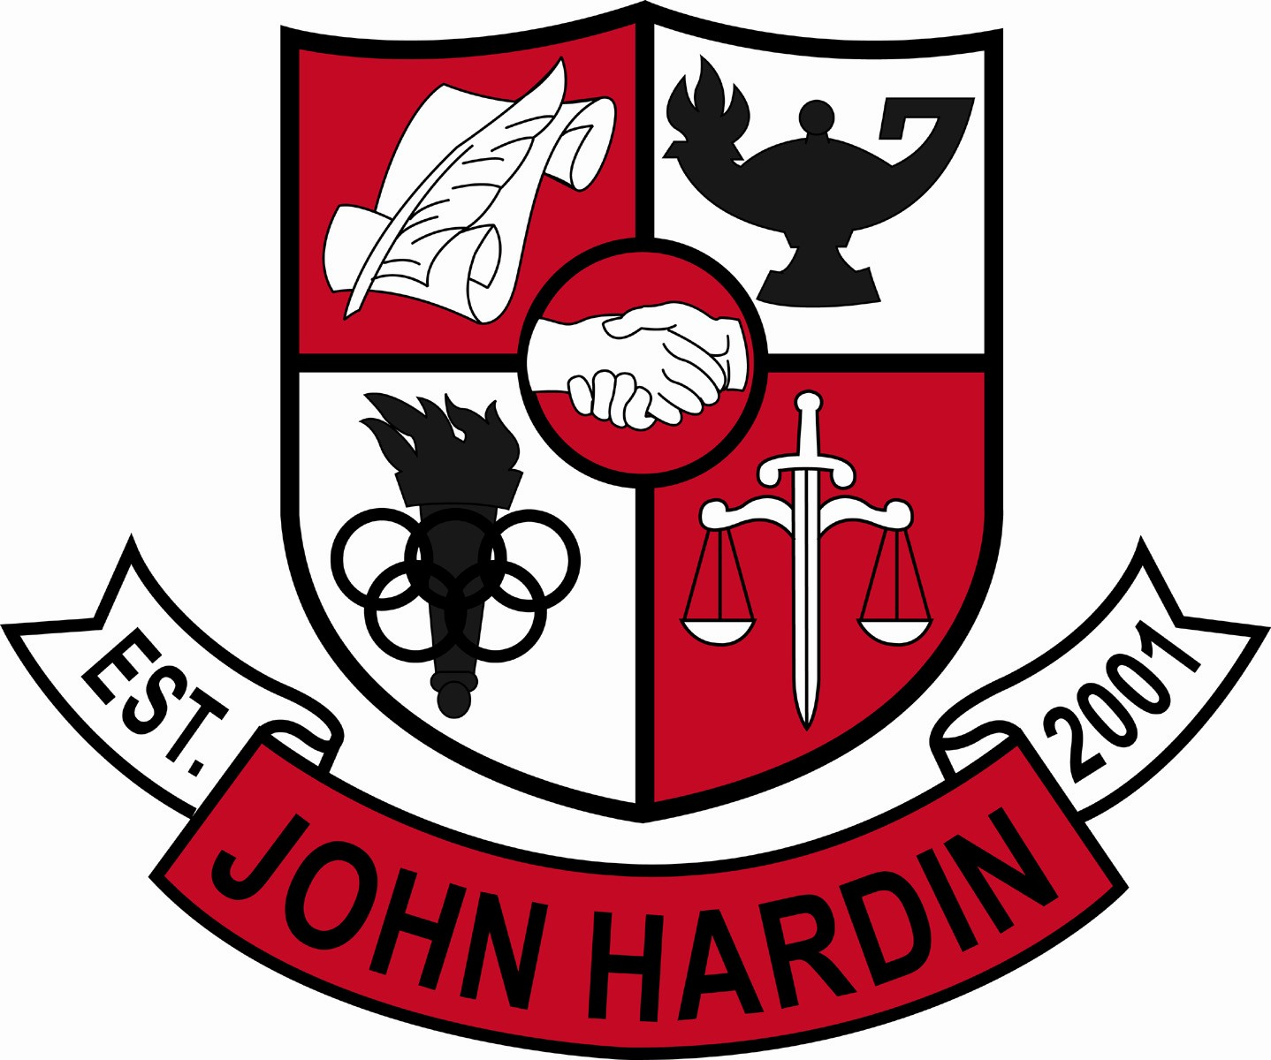
Meeting Minutes

April 10, 2014
4:00 p.m.

- Call to Order at 4:00 p.m.
Members present: Patrick Avery, Jana Haws, Stacey Moore, Alex Shearer, and Lynne Gibson. Absent: Pauline Crittenden
Visitors present: Phyllis Westfall, Jessica Forrest and Kris Hodge for PLC reporting.
- Approval of Agenda ORDER #13-14/0042
The council approved the agenda as written.
Motion: Avery Second: Moore
Avery - Yes
Crittenden – Absent
Gibson – Yes
Haws – Yes
Moore – Yes
Shearer - Yes
- Approval of Minutes ORDER #13-14/0043
The council approved the minutes as written.
Motion: Shearer Second: Moore
Avery - Yes
Crittenden – Absent
Gibson – Yes
Haws – Yes
Moore – Yes
Shearer - Yes
- PLC Reports
Fine Arts (Westfall) – Choir competed at Festival; Band’s competition is coming up; Choir is doing a Disney Review performance the last week of school. Art classes are doing the backdrops/scenery; 14 Students entered the Rotary Art Competition – several won or placed; Band is working with Middle School Director on recruiting; all areas have been helping students with GSA Applications
Social Studies (Forrest) – EOC Testing went well (100% passed), waiting on special ed results; held an ice cream social for testers for a job well done; group is working on making sure we are offering what students need
Science (Hodge) – council members received a copy of the Science Dept brochure used for open houses; group is working on aligning freshmen classes to prepare for biology and chemistry
Math (Shearer) – currently using Math/Carnegie lab 4 days a week; with the improvements showing the department is hoping power hour stays the same for a few years to get a real picture of what’s working

- Principal’s Update
- Scheduling - the council members were given a “first draft” of the schedule for 2014-15 school year for review/questions
- Review OCR Survey – copies of the survey from the Office of Civil Rights were shared with the council; the results showed our students “like being here.”
- Student Achievements - Preliminary ACT Scores were shared with the council
- Financial Report ORDER #13-14/0044
The council reviewed and accepted the financial report for March.
Motion: Shearer Second: Avery
Avery - Yes
Crittenden – Absent
Gibson – Yes
Haws – Yes
Moore – Yes
Shearer – Yes
- PD Plan for 2014-15 ORDER #13-14/0041
The council was emailed the plan on 3/25/14 and responded electronically to the Professional Development plan presented by Ms. Gibson.
Motion was made by Moore and seconded by Shearer.
Gibson, Crittenden and Avery confirmed.
Haws did not respond to the email.
- Room Use for 2014-15 ORDER #13-14/0045
Ms. Gibson presented a plan for classroom use for 2014-15. Due to technology issues, several labs will be moved around. The council approves as submitted but understand it is subject to change
Motion: Avery Second: Shearer
Avery - Yes
Crittenden – Absent
Gibson – Yes
Haws – Yes
Moore – Yes
Shearer – Yes
- Needs List for 2014-15 ORDER #13-14/0046
The council approved the Needs list as submitted.
Motion: Moore Second: Avery
Avery - Yes
Crittenden – Absent
Gibson – Yes
Haws – Yes
Moore – Yes
Shearer – Yes
- Personnel
Hired: Hired Adam Cobb for Asst. Football Coach; Kelly Fisher for 9th grade coach; Leslie Freeman-Wright for Cheer Coach
Vacancies: Boys Basketball Coach; Golf Coach; Freshmen Volleyball Coach; 10% Baseball Coach; Freshmen Football Coach; Girls Cheer Coaches; Wrestling Coach; Asst. Wrestling Coach 50%

- Questions and Concerns from Council
- Will John Hardin council be attending/representing at the April 24th appreciation dinner at Nolin RECC?
- Agenda Items for Next Meeting
- None were discussed
- Adjourn
The meeting was adjourned at 5:00 p.m. The motion was made by Ms. Moore and seconded by Ms. Haws

