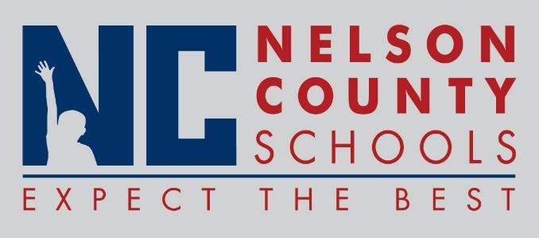

Information Paper
To: | Nelson County Board of Education
From: | Bob Morris Executive Director of Student Support
cc: | Tom Brown
Date: | Oct 17, 2017
Re: | Personnel Notifications

New Hires: Penny Bradley Teacher FH
Jean Young Spch Path Dis
Latinna Lyons Math BMS
Marcus Brown PE OKH
JoJo Kemp IAIII OKH
Kellie Reynolds Nurse NCHS
Julie Craig Nurse OKH
Michelle Ball Sec FH
Katrina Haydon Sec OKH
Liz Sutton IA II BES

Transfers:
Reinstatements: None
One Year Certification:
Classified Subs:
Certified Substitute:
Student Workers: None
Non-Renewals:
Resignation: Kellie Riggs Teacher Bos
Dylan Lambert Teacher NCHS
Retirements:
Reprimands/Terminations: None

