Regular Meeting Boone County Board of Education
March 12, 2020 7:30 PM
Ralph Rush Professional Development Center
99 Center Street
Florence, Kentucky 41042
I. CALL TO ORDER
The Regular meeting of the Boone County Schools Board of Education March 12, 2020 was called to order by Chairperson Matt McIntire at the Ralph Rush Staff Development Center.

Attendance Taken at : 7:30 PM
Present Board Members:
Dr. Maria Brown
Ms. Karen Byrd
Mr. Troy Fryman
Mr. Matt McIntire
Mrs. Julia Pile
Gerry Dusing, Board Attorney
Karen Evans, Board Secretary
Michelle Ashley, attended for cross training duties.
II. NATIONAL ANTHEM
Students were asked to not attend due to Social Distancing and the Cov19 Virus.
III. PLEDGE TO THE FLAG
The Pledge to the Flag was led by Mr. Matt McIntire, Chairperson.
IV. STUDENT BOARD MEMBER REPRESENTATIVE REPORT
Students were asked to not attend due to Social Distancing and the Cov19 Virus.

V. GOOD NEWS
A. Due to Governor Beshear's State of Emergency due to the Corona Virus Outbreak there was no one present for good news, the board will reschedule the awards at a later board meeting.
VI. RECOMMENDED ACTION - CONSENT AGENDA
Dr. Randy Poe, Superintendent, recommended Consent Agenda items A- AAA for Board approval, as presented.
- A motion was made by Julia Pile, seconded by Troy Fryman, to approve the consent agenda items A-AAA, as presented. Matt McIntire, Dr. Maria Brown, Karen Byrd, Troy Fryman and Julia Pile voted, “aye” MOTION: The motion passed 5-0.

A. Minutes of the regular board meeting of the February 13, 2020 Board Meeting.
The board approved the minutes of the regular board meeting of February 13, 2020, as presented.
B. Minutes of the February 6th, 2020 Superintendent Charge Discussion Workshop.
The board approved the Minutes of the February 6th, 2020 Superintendent Charge Meeting Workshop, as presented.
C. Minutes of the February 6th, 2020 Mid-Year Review Board Workshop at 6:30 pm Board of Education.
The board approved the Minutes of the February 6th, 2020 Mid-Year Review Board Workshop at 6:30 pm Board of Education, as presented.
D. Minutes of the February 13th, 2020 Special Board Meeting of the Joint Meeting with the Superintendent Search Committee and the Board of Education 6:30 pm.
The board approved the Minutes of the Special Board Meeting of the February 13th, 2020 Joint Meeting with the Superintendent Search Committee and the Board of Education at 6:30 pm, as presented.
E. Bill List
F. Treasurer's Report was given by Mrs. Linda Schild.
G. Leaves of Absence
The following persons have submitted leave of absence requests for board approval:
Recommended by Principal/Supervisor for approval:
Boggs, Brandy, Teacher @ Florence ES 3/16/2020 – 4/3/2020
Drew, Vickie, Teacher @ Ockerman ES 2/28/2020 – 4/3/2020
Foster, Emily, Para Ed @ Ockerman ES 3/6/2020 – 4/3/2020
Foust, Allyson, Teacher @ Ockerman ES 4/27/2020 – EOY
Harvey, Sarah, Teacher @ Longbranch ES 5/11/2020 – EOY
Honaker, Erica, Teacher @ Ryle HS 2/18/2020 – 4/1/2020
Messmer, Kimberly, Teacher @ Ockerman ES 4/13/2020 – 5/20/2020
Stanimaw, Lori, Para Ed @ Ryle HS 3/5/2020 – 3/20/2020
Standley, Tiffany, Teacher @ RA Jones MS 4/13/2020 – EOY
Not Recommended by Principal/Supervisor for approval:
None
Amended Leaves:
Bouwie, Erica, School Psychologist @ Longbranch ES 2/4/2020 – 3/13/2020
Crooker, Mary Ann, Transportation Aide @ Transportation 1/21/2020 – 3/2/2020
Kahrs, Brandy, Secretary @ District Office 1/21/2020 – 2/14/2020
Kendall, Melissa, Occupational Therapist @ Erpenbeck ES 1/6/2020 – 4/3/2020
Piner, Leslie, Para @ Gray MS 2/5/2020 – 5/22/2020
Scott, Karen, Café Worker @ Ryle HS 1/24/2020 – 2/25/2020
Wintel, Amy, Teacher @ Ryle HS 12/9/2019 – 3/13/2020
Cancelled Leaves:
None

H. Memorandum of Agreement between Wevideo, Inc. and Yealey Elementary School
The board approved the Memorandum of Agreement between Wevideo, Inc. and Yealey Elementary School, as presented.
I. Job Description Modification - "Director of Preschool Services"
The board approved the Job Description Modification - "Director of Preschool Services", as presented.
J. Change Order #2 - Steeplechase Elementary Bid Package #1-Grading, BG #19-078
The board approved theChange Order #2 - Steeplechase Elementary Bid Package #1-Grading, BG #19-078, as presented.
K. Agreement for Consultation Services Between the Boone County Schools and Jerome Bowles - Renewal
The board approved the Agreement for Consultation Services Between the Boone County Schools and Jerome Bowles - Renewal, as presented.
L. Contract - Boone County High School with Cincinnati Shakespeare Company on April 20, 2020
The board approved the Contract - Boone County High School with Cincinnati Shakespeare Company on April 20, 2020, as presented.
M. Revised BG-1 for Paving 2019, BG #19-141
The board approved the Revised BG-1 for Paving 2019, BG #19-141, as presented.
N. Memorandum Related to Kentucky 21st CCLC Community Learning Centers Contractual Agreement-Little Lotus-Movement and Stretching
The board approved the Memorandum Related to Kentucky 21st CCLC Community Learning Centers Contractual Agreement-Little Lotus-Movement and Stretching, as presented.
O. Memorandum Related to Kentucky 21st CCLC Community Learning Centers Contractual Agreement-Kevin Sipple-Flag Football
The board approved the Memorandum Related to Kentucky 21st CCLC Community Learning Centers Contractual Agreement-Kevin Sipple-Flag Football, as presented.
P. Declaration Statement
The board approved the Declaration Statement, as presented.
Q. Memorandum of Agreement Between Goodridge Elementary School and The Kentucky Bicycle and Bikeway Commission
The board approved the Memorandum of Agreement Between Goodridge Elementary School and The Kentucky Bicycle and Bikeway Commission, as presented.
R. Instructional Time Adjustment for Elementary Schools for the 2020-2021 School Year
The board approved the Instructional Time Adjustment for Elementary Schools for 2020-2021 School Year, as presented.
S. Memorandum of Agreement Between FranklinCovey and Florence Elementary School
The board approved the Memorandum of Agreement Between FranklinCovey and Florence Elementary School, as presented.
T. Print Management Software Lease New Haven Elementary
The board approved the Print Management Software Lease for New Haven Elementary to Toshiba Business Solutions, as presented.
U. Maintenance Agreement for Copier at Gray Middle School
The board approved the Maintenance Agreement for Copier at Gray Middle School with Toshiba Business Solutions, as presented.
V. Accessory Attachment for Copier at Burlington Elementary School: Lease Supplement
The board approved the Accessory Attachment for Copier at Burlington Elementary School: Lease Supplement with Toshiba Business Solutions, as presented.
W. HVAC Filters
The board approved the HVAC Filter contract with FSI Filtration, as presented.
X. Student Accident Insurance- Roberts Insurance
The board approved the Student Accident Insurance with Roberts Insurance for the 20-21 fiscal year, as presented.
Y. Gasoline and Diesel Fuel Bid
The board approved the Gasoline and Diesel Fuel Bid, as presented.
Z. Contract - Ryle High School with Receptions on January 22, 2021 for the Band Banquet, 2020-2021 School Year
The board approved the Contract - Ryle High School with Receptions on January 22, 2021 for the Band Banquet, 2020-2021 School Year, as presented.
AA. Contract - Longbranch Elementary with Cincinnati Museum Center
The board approved the Contract - Longbranch Elementary with Cincinnati Museum Center, as presented.
BB. Croswell Charter - Mann Elementary to Conner Prairie on April 17, 2020
The board approved the Croswell Charter - Mann Elementary to Conner Prairie on April 17, 2020, as presented.
CC. Executive Charter - Kelly Elementary to Frankfort, KY on April 27, 2020
The board approved the Executive Charter - Kelly Elementary to Frankfort, KY on April 27, 2020, as presented.
DD. Queen City Transportation - New Haven Elementary to Kentucky Horse Park on April 13, 2020
The board approved the Queen City Transportation - New Haven Elementary to Kentucky Horse Park on April 13, 2020, as presented.
EE. Contract - Kelly Elementary with Lil' Shopper's Shoppe during the month of December, 2020. This will take place 2020-2021 school year
The board approved the Contract - Kelly Elementary with Lil' Shopper's Shoppe during the month of December, 2020. This will take place 2020-2021 school year, as presented.
FF. Memorandum of Agreement Between College Board and Boone County Schools
The board approved the Memorandum of Agreement Between College Board and Boone County Schools, as presented.
GG. Revised BG-1 for Steeplechase Elementary (site), BG #18-234
The board approved the Revised BG-1 for Steeplechase Elementary (site), BG #18-234, as presented.
HH. Facility Use Agreement - New Haven Elementary with Martha Akrebeck for Cafeteria Use
The board approved the Facility Use Agreement - New Haven Elementary with Martha Akrebeck for Cafeteria Use, as presented.
II. Revised BG-1 for Paving 2020, BG #20-117
The board approved the Revised BG-1 for Paving 2020, BG #20-117, as presented.
JJ. Field Trips
The board approved the Field Trips, as presented.
School | Date Of Trip | Location | Reason
New Haven Elementary | April 13, 2020 | Lexington, KY | KY Horse Park
Kelly Elementary | April 27, 2020 | Frankfort, KY | KY Government

All travel by commercial carrier is due to schedule/cost

KK. Sales Campaign Approval
The board approved the Sales Campaign Approval, as presented.
LL. Bid Award for Network Wiring Upgrades
The board approved the Bid Award for Network Wiring Upgrades, as presented.
MM. Contract - Camp Ernst Middle School with Receptions on March 30, 2020 for the Cheerleading Banquet
The board approved the Contract - Camp Ernst Middle School with Receptions on March 30, 2020 for the Cheerleading Banquet, as presented.
NN. Bid Award and Revised BG-1 for Boone County High Tuckpointing, BG #20-115
The board approved the Bid Award and Revised BG-1 for Boone County High Tuckpointing, BG #20-115, as presented.
OO. Bid Award and Revised BG-1 for Gym Upgrades, BG #20-105
The board approved the Bid Award and Revised BG-1 for Gym Upgrades, BG #20-105, as presented.
PP. Bid Award and Revised BG-1 for Kelly Elementary Plumbing Upgrades, BG #20-106
The board approved the Bid Award and Revised BG-1 for Kelly Elementary Plumbing Upgrades, BG #20-106, as presented.
QQ. Bid Award and Revised BG-1 for Boone County High Electric Upgrades, BG #20-116
The board approved the Bid Award and Revised BG-1 for Boone County High Electric Upgrades, BG #20-116, as presented.
RR. Contract - Kelly Elementary with The Leukemia & Lymphoma Society, Pennies for Patients
The board approved the Contract - Kelly Elementary with The Leukemia & Lymphoma Society, Pennies for Patients, as presented.
SS. Memorandum of Agreement Between Capstone and Mann Elementary School
The board approved the Memorandum of Agreement Between Capstone and Mann Elementary School, as presented.
TT. Bid Award and Revised BG-1 for Access Controls Phase 2, BG #20-200
The board approved the Bid Award and Revised BG-1 for Access Controls Phase 2, BG #20-200, as presented.
UU. Rotary Membership 2020
The board approved the Rotary Membership dues for 2020 in the amount of $130.00, as presented.
VV. Revised Bidding Documents and Revised BG-3 for Roofing 2020, BG#19-318
The board approved the Revised Bidding Documents and Revised BG-3 for Roofing 2020, BG#19-318, as presented.
WW. Network Wiring Upgrades- North Pointe Elementary
The board approved the Network Wiring Upgrades to North Pointe Elementary, as presented.
XX. Recommend Rebid for Central Office Fiber Relocation, BG #20-118
The board approved the Recommending Rebid for Central Office Fiber Relocation, BG #20-118, as presented
YY. Recommend Rebid for Geothermal Upgrades, BG #20-119
The board approved the Recommend Rebid for Geothermal Upgrades, BG #20-119, as presented
ZZ. Revised BG-1 for Roofing 2020, BG#19-318
The board approved the Revised BG-1 for Roofing 2020, BG#19-318, as presented.
AAA. Contract- Kelly Elementary with Great Western Reserve for Color-A-Thon Event on May 15, 2020
The board approved the Contract- Kelly Elementary with Great Western Reserve for Color-A-Thon Event on May 15, 2020, as presented.
VII. RECOMMENDED ACTION - OLD BUSINESS
A. No Old Business
VIII. RECOMMENDED ACTION - NEW BUSINESS
A. Alternative Center for Education (ACE) Re-branding to RISE Academy
Dr. Randy Poe, Superintendent, recommended the board approve the re-branding of the Alternative Center for Education to RISE Academy, as presented.
- A motion was made by Dr. Maria Brown, seconded by Try Fryman, to approve the Alternative Center for Education to RISE Academy, as presented. Karen Byrd, Matt McIntire, Troy Fryman, Dr. Maria Brown, and Julia Pile voted, “aye” MOTION: The motion passed 5-0.

Bill Hogan, Innovation Director, gave a powerpoint presentation along with a video from the students that worked on the rebranding of ACE from the district Makerspace program. See below:

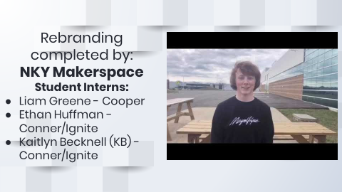

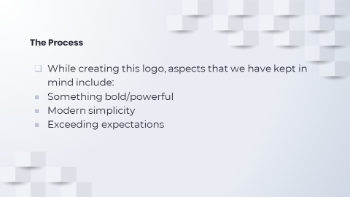

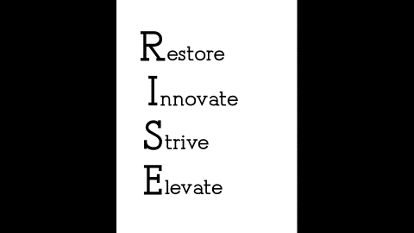

B. Allocation Addition Vice-Principal to Alternative School
Dr. Randy Poe, Superintendent, recommended the board approve the additional allocation of a Vice-Principal to the Alternative School, as presented.
- A motion was made by Karen Byrd, seconded by Try Fryman, to approve the additional allocation of a Vice-Principal to the Alternative School, as presented. Karen Byrd, Matt McIntire, Troy Fryman, Dr. Maria Brown, and Julia Pile voted, “aye” MOTION: The motion passed 5-0.

C. Revenue Bonds - Steeplechase Elementary
Dr. Randy Poe, Superintendent, recommended the board approve the resolution authorizing the Boone County School District Finance Corporation to issue revenue bonds, as presented.
- A motion was made by Dr. Maria Brown, seconded by Karen Byrd, to approve the resolution authorizing the Boone County School District Finance Corporation to issue revenue bonds, as presented. Karen Byrd, Matt McIntire, Troy Fryman, Dr. Maria Brown, and Julia Pile voted, “aye” MOTION: The motion passed 5-0.

RESOLUTION OF THE BOARD OF EDUCATION OF BOONE COUNTY SCHOOL DISTRICT, FLORENCE, KENTUCKY; AUTHORZING AND APPROVING CERTAIN ARCHITECTS' PLANS FOR THE CONSTRUCTION OF A CERTAIN SCHOOL BUILDING PROJECT (STEEPLECHASE ELEMENTARY PROJECT); APPROVING THE PLAN OF FINANCING THE COST OF SAID PROJECT; CONFIRMING THE ACCEPTANCE OF AN OFFER OF ASSISTANCE FROM THE KENTUCKY SCHOOL FACILITIES CONSTRUCTION COMMISSION; AUTHORIZING AND APPROVING THE EXECUTION OF A PARTICIPATION AGREEMENT WITH SAID COMMISSION; APPROVING THE EXECUTION OF CONTINUING DISCLOSURE PROCEDURES AND THE EXECUTION OF TAX COMPLIANCE PROCEDURES; AND AUTHORIZING THE EXECUTION OF A CONTRACT, LEASE AND OPTION WITH THE BOONE COUNTY SCHOOL DISTRICT FINANCE CORPORATION AND ANY FURTHER NECESSARY INSTRUMENTS;

D. Memorandum of Understanding Between Boone County School District and Kenton County School District Regarding the Ignite Institute
Dr. Randy Poe, Superintendent, recommended the board approve the Memorandum of Understanding Between Boone County School District and Kenton County School District Regarding the Ignite Institute, as presented.
- A motion was made by Karen Byrd, seconded by Dr. Maria Brown, to approve the Memorandum of Understanding Between Boone County School District and Kenton County School District regarding the Ignite Institute, as presented. Karen Byrd, Matt McIntire, Troy Fryman, Dr. Maria Brown, and Julia Pile voted, “aye” MOTION: The motion passed 5-0.

E. Memorandum of Understanding Between Boone County Schools and Walton-Verona School District
Dr. Randy Poe, Superintendent, recommended the board approve the Memorandum of Understanding Between Boone County Schools and Walton-Verona School District, as presented.
- A motion was made by Dr. Maria Brown, seconded by Troy Fryman, to approve the Memorandum of Understanding Between Boone County School District and Walton-Verona School District regarding the Ignite Institute, as presented. Karen Byrd, Matt McIntire, Troy Fryman, Dr. Maria Brown, and Julia Pile voted, “aye” MOTION: The motion passed 5-0.

F. NTI Days
Dr. Randy Poe, Superintendent, recommended the board approve the request to the Kentucky Board of Education for the Non-Traditional Instruction days, as presented.
- A motion was made by Julia Pile, seconded by Dr. Maria Brown, to approve the request Kentucky Board of Education fro the Non-Traditional Instruction days, as presented. Karen Byrd, Matt McIntire, Troy Fryman, Dr. Maria Brown, and Julia Pile voted, “aye” MOTION: The motion passed 5-0.

G. Non-Traditional Instruction Days Emergency Application Boone County Schools
Dr. Randy Poe, Superintendent, recommended the board approve the Non-Traditional Instruction Day Emergency Application for Boone County Schools, as presented.
- A motion was made by Julia Pile, seconded by Karen Byrd, to approve the Non-Traditional Instruction Day Emergency Application for Boone County Schools, as presented. Karen Byrd, Matt McIntire, Troy Fryman, Dr. Maria Brown, and Julia Pile voted, “aye” MOTION: The motion passed 5-0.

IX. SUPERINTENDENT'S REPORT
Dr. Michael Shires, Preschool Director, updated the board with a powerpoint presentation updating the board on the district Preschool program.

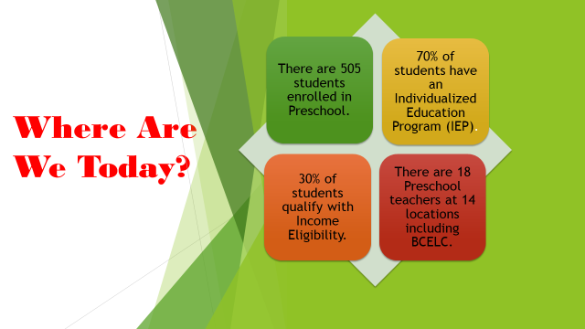

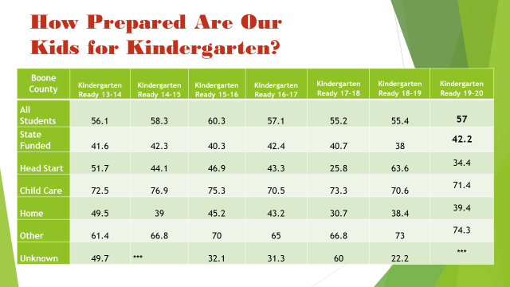

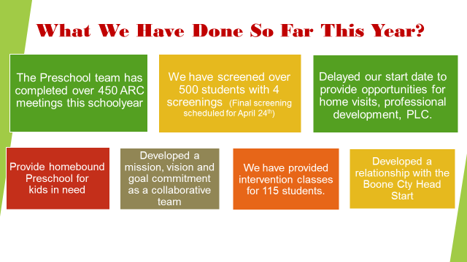

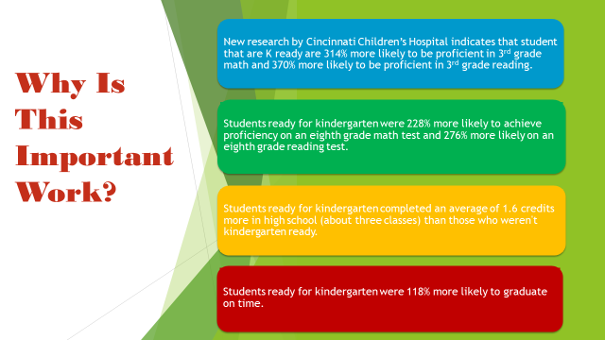

X. INFORMATION, PROPOSALS, COMMUNICATIONS
A. Human Resource Actions
B. Worker's Compensation Claims
C. Overtime Report
D. Construction Status Report
E. Energy Management Report
XI. AUDIENCE OF CITIZENS
Mrs. Olivia Cox, parent, discussed her students education and that she was not happy with the school system. She voiced several concerns about the district education system. Gerry Dusing, board attorney, did advise Mrs. Cox that the board is not legally allowed to discuss a matter that may be in litigation.

Mr. Cox, parent, asked the board about Jerome Bowles and the contract that the board has with him. He discussed Mr. Bowles being the president of NAACP and since he is the district consultant the Cox family cannot use him for their needs. Dr. Poe stated that if Mr. Bowles is working with other contracted jobs that is between Mr. Bowles and his company.

Mr. Bill Sanders, discussed the field trips that must now be rescheduled, will they need to resubmit field trip request? Dr. Poe said at this time, we just don’t know how long the NTI days will be in place.

XII. CLOSED EXECUTIVE SESSION PER KRS 61.810
A. No closed session
XIII. ADJOURN

- A motion was made by Karen Byrd, seconded by Julia Pile, to adjourn the meeting. Karen Byrd, Maria Brown, Julia Brown, Troy Fryman and Matt McIntire voted, “aye” MOTION: The motion passed 4-0.

Meeting was adjourned at approximately 8:51 pm.

____________________________________

Matt McIntire /Chairperson

_____________________________________
Karen Evans/Secretary

