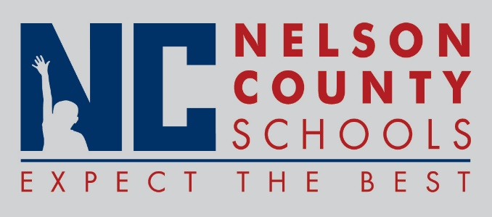

Decision Paper
To: | Nelson County Board of Education
From: | Tom Dekle
cc: | Dr. Anthony Orr, Superintendent
Date: | March 2, 2017
Re: | Fusion Youth Services Center grant application

Fusion Youth Services Center wishes to pursue a Heartland Trail KY-ASAP Funding Request for substance abuse prevention programs at TNHS and NCHS. KY-ASAP is the KY Agency for Substance Abuse Policy. This funding opportunity is for $250 for each school to help fund the Botvin Life Skills Training Program for high school. This life skills program is for 9th and 10th grades. This grant will pay most of the cost for 1 teaching manual and 30 student guides for each high school. Fusion coordinator Shannon Layman plans to incorporate the lessons in the freshman health classes. There are no matching funds required.

RECOMMENDATION: Approve request for grant application in the amount of $250 (x2) through the Heartland Trail ASAP grant program.

RECOMMENDED MOTION: I move that the Nelson County Board of Education ___________ as presented.

