THIS IS AN INFORMATION PAPER

TO: Hardin County Board Of Education

FROM: The PAC

DATE: June 1, 2022

SUBJECT: PAC NEWS
BART’S BLOG – JUNE 2022
Summer means vacation, right? Not at the PAC!
No, sir. You see, not only are we helping Youth Theatre with their production of Disney’s The Little Mermaid this summer, but we are also busy prepping Disney’s Beauty & the Beast to open the new PAC Season in September.
Just look at the puppets that arrived a couple of weeks back. Our North Carolina friends, Kevin and Kerrie, crafted these enchanted objects while our costumer Allison jumped in and built Babette. Hmmm, I better get busy and make Madame La Bouche and Chip, or they’ll feel left out.
We’re so excited to get our 21st season rolling that we’re inviting you to get a head start on auditions by joining us for our Audition Workshops on Monday, June 27, and Tuesday, June 28 at 8 PM.
These workshops are your chance for some one-on-one time with the director, choreographer, and music director to get the inside track on what we’ll be looking for at the July auditions. Please register NOW for this workshop so we can better focus on the needs of each workshop participant. CLICK HERE
Speaking of July auditions, in addition to Disney’s Beauty & the Beast, we’ll hold auditions for our non-musical – Thornton Wilder’s Pulitzer Prize-winning play, The Skin of Our Teeth. When it premiered on Broadway in 1942, this epic comedy-drama broke nearly every established theatrical convention of its time and paved the way for plays like Waiting for Godot and the meta-humor of folks like Mel Brooks and Monty Python. A revival of this classic is currently running at Lincoln Center with an all-black cast and has been nominated for six Tony Awards (see photos).
So in between catching some rays, you can catch us at the PAC this month at the Audition Workshop for Disney’s Beauty & the Beast on June 27 and the Audition Workshop for Thornton Wilder’s The Skin of Our Teeth on Tuesday, June 28. Pre-registration is required for both of these workshops, so go to the Auditions page on ThePAC.net and register NOW! CLICK HERE
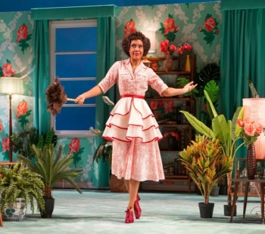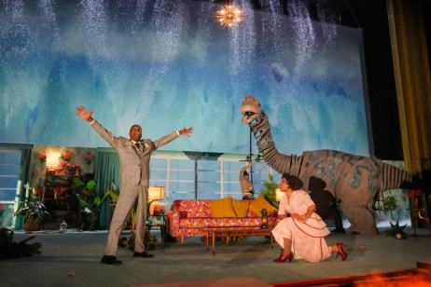

June Audience Survey Winners
Congratulations to STEPHANIE LARSON-RAIBOURN, MONICA LYNCH, BETHANY TIESMAN, TONIA LILLY, VERNAL JAYE BRAMLETT, SANDY NEWTON, HEATHER HACK & KRISTY STUECKER – each a lucky winner of a $20 PAC gift certificate for completing a May Audience Survey.

The PAC Spotlight
Sorry, we’re skipping June for our spotlight feature but will be back in July Spotlighting Youth Theatre’s 50th season and their production of Disney’s The Little Mermaid.
Learn more about all the PAC Spotlight Ambassadors we’ve recognized over the years.
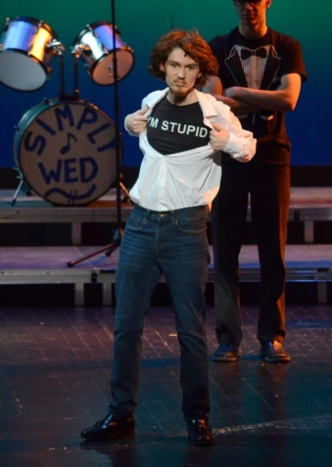 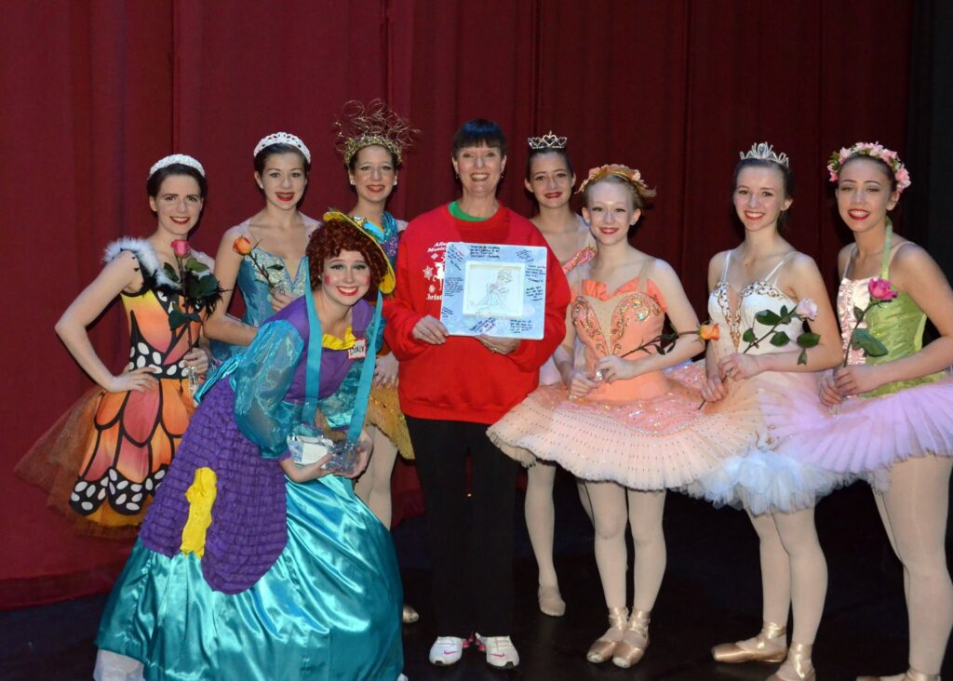

NOW SHOWING – JUNE 2022
June 1,3, 5 | Center Stage Dance Studio’s Spring Recitals. Wed, Friday at 7 PM & Sunday at 3 PM. POC Yvonne Groves 270-769-5505. All seats reserved through the PAC at www.thepac.net (Look for tickets to be available at least 2 weeks prior to event date.)
June 9 | Allegro Dance Theatre’s Musical Theatre Camp production. 7:30 PM. POC Carol Zagar 270-352-1333. All seats reserved through the PAC at www.thepac.net (Look for tickets to be available at least 2 weeks prior to event date.)
June 11, 12 | Dance Center of Elizabethtown Musical Theatre. Saturday at 2 PM, Sunday at 3 PM. POC Sherry Barnard 270–765-5464. All seats reserved through the PAC at www.thepac.net (Look for tickets to be available at least 2 weeks prior to event date.)
June 27, 28 | PAC Audition WORKSHOPS: For Disney’s Beauty & the Beast on Monday, June 27, and Thornton Wilder’s The Skin of Our Teeth on Tuesday, June 28. Pre-registration is required for both of these workshops, go to the Auditions page on ThePAC.net to register

COMING SOON – JULY 2022
July 8 -10, 15-17 | Youth Theatre of Hardin County summer production of THE LITTLE MERMAID. July 8, 9 15, 16 at 7 PM. Sun Matinees, July 10 & 17 at 3 PM, Sat Matinee, July 16, 2 PM. Tickets: Adults – $18.25, Seniors/Military/Students – $13, Children 10 & under, $7 (fees included). All seats reserved through the PAC at www.thepac.net or by calling 270-769-8837. Tickets will be available for purchase June 1
July 11,12 | PAC ProAm AUDITIONS for the ProAm BEAUTY & THE BEAST and THE SKIN OF OUR TEETH. Audition materials will be available at www.thepac.net prior to the auditions.
July 22 | Glen Rice/Buffalo Productions presents Glen Rice, Family & Friends Concert Series. Curtain, 7 PM. Tickets: $20 in advance, $25 at the door. Tickets are available by calling the PAC 270-769-8837 X 5 or Glen Rice 270-325-3256.

IN REVIEW – MAY 2022
On May 2, 135 student with Bluegrass Middle School Band under the direction of Joshua Mitchell performed a concert before an audience of 505.
On May 3, 122 students with West Hardin Middle School Band under the direction of Laura Hedges performed a concert before an audience of 575.
On May 5, 55 students of Studio One-Eleven Dance Studio under the direction of Katie Bennett presented a recital before an audience of 335.
On May 10, Abound Credit Union held is 71st Annual Meeting which included a Financial Education Expo before an audience of 303.
On May 11, 165 students with East Hardin Middle School Band under the direction of Vanessa Lee performed a concert before an audience of 468.
On May 12, 19 students with John Hardin High School Choir under the direction of Phyllis Westfall performed a concert before an audience of 70.
On May 14, 100 students with North Hardin High School Choir under the direction of Cassie Lucas performed a concert before an audience of 300.
On May 16, 90 students with Central Hardin High School Band under the direction of Trevor Ervin performed a concert before an audience of 250.
On May 19, Hardin County Board of Education held its monthly meeting at the PAC before an audience of 94 and recognized 84 students.
On May 21, 85 students with the Dance Centre of Elizabethtown under the direction of Sherry Barnard presented 2 recitals before audiences of 480.
On May 22, 46 students with Lawson School of Music under the direction of Heather Lawson presented a recital before an audience of 260.
On May 27-29, 116 students with Allegro Dance Studio under the direction of Carol Zagar presented 3 recitals and a production of Aladdin, Jr before audiences totaling nearly 800.
Total Served in May: 1,271 HCS Students, 343 Non-HCS Students, 94 Adults Participants,
4,533 Audience Members & 23 Live Streams.
Total Served to date: 13,550 Students (10,384 HCS, 3,166 Non-HCS) 1,553 Adult Participants & 17,749 Public Audiences and 139 Live Streams.

