Our center is located directly next to Davis Field:
999 Vine Street
Dayton, KY 41074
(859) 292-7485

Director: Heather Cook-Kiefer
Cell (859) 815-0567
Any other inquires can be directed to the Dayton Board of Education: (859) 491-6565
Superintendent- Jay Brewer -Jay.brewer@dayton.kyschools.us
Director of Special Education/Early Childhood Learning- Nicole Ponting­ Nicole.ponting@dayton.kyschools.us

Hours of Operation:

Monday thru Thursday: 7:15 am – 4:10 pm

Friday: 7:15 am – 4:00 pm

Parents will be charged $1.00 per minute, per child, for each minute they are late to pick up their child(ren) . The fee will be paid directly to the staff person who had to stay with you child(re n).

The center operates on the calendar of the Dayton Independent Schools. If the school is closed for any reason, the daycare center will also be closed.
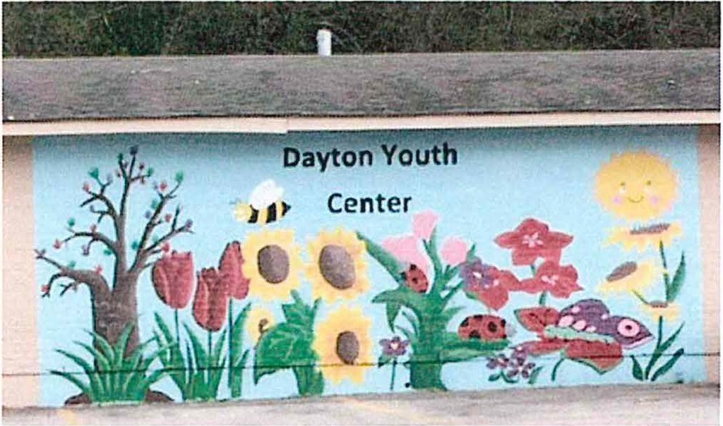

Daycare Services
Dayton Independent Youth Center

Parent and Staff
Handbook
DAYTON
INDEPENDENT

= S C H O O L S =

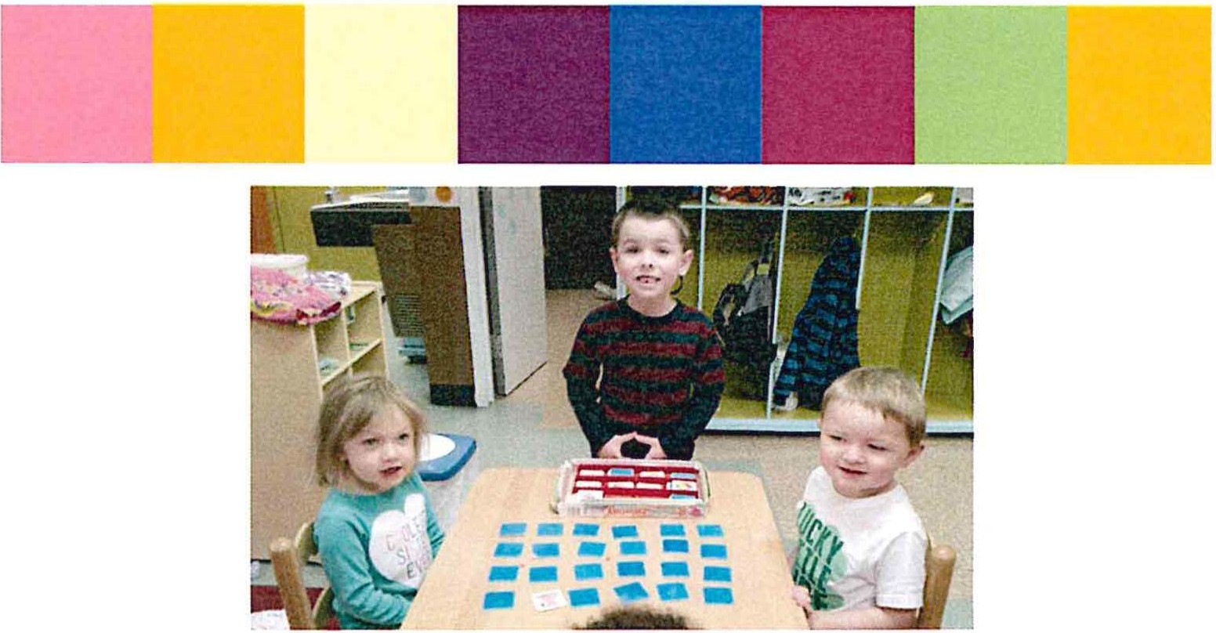

Parent and Staff Handbook
Our center is fully licensed by the State of Kentucky, Department of Human Resources, and meets or exceeds the guidelines for Division of Daycare Licensing and Regulations. We embrace the philosophy of the Dayton Independent Schools which is to Inspire, Engage, and Grow each of our students.
PHILOSOPHY
The Philosophy of the center is shaped by the idea that a young child’s growth will greatly benefit from the team of individuals who are concerned or each child’s growth and development. We believe that the parents are the most important people in the child’s life and they are viewed as the primary source to a child’s overall development. The center staff and other resource persons are all available and will serve as a support system for parents.
Communication between parents and center staff is essential. In addition to daily conversations, parents will receive information through a daily report. Conferences can be arranged when necessary. Each child will be involved activities, which strengthen and support the child’s physical, social-emotional, language, and cognitive development. The goal of working together is for each child to achieve his potential development while enrolled in the center.
ENROLLMENT INFORMATION
Our center accepts children from infancy through age 6 years old. Application for enrollment can be completed by picking up an application at our center. Please refer to the contact information on the back of the booklet if you have any questions. Prior to admission, the following information MUST be on file:
- Completed Enrollment Forms
- Emergency Medical Release
- Record of Birth
- KY Immunization Certificate
- Parent Schedule
Our center does not discriminate of the basis of race, color, nationality, gender, religion, or disability when considering a child for enrollment. If a child has special needs, enrollment status will be determined by the capability of the center staff to meet the needs of the child.
TUITION RATES
Full-Time
- $150 per week (Infants to 6 years of age)
Part-Time (3 days or less per week)
- $110 per week (Infants to 6 years of age)
Snack Fee
- $20 per quarter
We define part time as 3 days a week or less, on a pre-determined and agreed upon schedule. We do not offer part-time rates for students who also attend preschool.
We direct bill specific agencies for any childcare assistance funds or subsidies. Parents are in charge of enrolling and submitting the required paperwork to apply for these programs.
Tuition is due on each payday. IN ORDER TO MAKE THIS EASIER ON BOTH THE CENTER AND EMPLOYEES OF DAYTON INDEPENDENT SCHOOLS, TUITION WILL BE AUTOWITHDRAWN FROM EMPLOYEE’S PAYCHECK. Please contact the director I you have special arrangements or considerations. If your child is sick and will be out for a prolonged period of time, please contact the director to make arrangements.
Optional Food Fee (Sliding Scale)
$915/year ($91.50/month for 10 months) Full Fee Family
$208.32/year ($20.83/month for 10 months) Reduced Fee Family
$0 Free Families
Parents can elect or the Dayton Independent Schools to provide food, on a sliding scale based on income. The food fee includes breakfast and lunch. This can be decided on a month to month basis and parents will need to let the director know by the 15th day of the previous month in order for us to be prepared. Coast of food will be added to your weekly tuition.
Parent can elect to pack meals for the child(ren).
HEALTH POLICY
Center staff strives to help keep children healthy. In the daycare environment Illness transmits at a very fast pace. If your child becomes ill at the center, staff will notify you of your child's illness or symptoms.
Signs of illness that will result in notification of parents:
*fever of 101 degrees or more *more than two loose bowel movements
*vomiting *severe coughing* sore throat or difficulty swallowing *difficult or rapid breathing *redness and discharge from eyes *unidentified skin rash* evidence of lice or other parasitic infection * evidence of infection, such as green or yellow nasal or ear discharge.
You and center staff can determine at the time whether or not your child should remain at the Daycare. The other parents and staff understand that additional symptoms and the time of day will have a bearing on the decision. You must also take into consideration the fact that many illnesses can be passed quickly and easily among the other children with exposure. Be aware that children exhibiting signs of illness will be separated for the other children as much as possible to prevent the other children becoming sick. In the event that the center discharges a child from the center due to illness, the center may require a doctor's excuse which includes diagnosis for the child to return to the center. If your child has been sick at home and is still exhibiting symptoms that may spread to other children, then you should not bring your child to the center. In regards to fever, vomiting and diarrhea, the child must be symptom free for 24 hours to return to the center.

Medication

The center staff will administer medication in cooperation with the parent’s directions. Both prescription and over-the-counter medications mist be in the original container as required by state law. Containers must include written directions for administering the medication and expiration date of medication. Each day medication is to be given, you must fill out a Medicine Disbursement Form at the day care with specific instructions and your signature. When the medicine is given to your child, the staff person will note the time and sign the form. This medication will be given to you at the end of the day. No medication ca be left at the center. It will be kept in a safe, locked place while at the center.

SAFETY AND EMERGENCY POLICY

This policy has been developed to protect the best interest of the children enrolled at the Dayton Independent Youth Center. Children will be escorted into the building by parents/guardian or other authorized person each morning and will be greeted by the staff. Parents/guardian or other authorized person will sign in and out the children each day. Children will be escorted from the center each day by parent/guardian or authorized person each afternoon after notifying staff.
Monthly fire and tornado drills will be held on the last Wednesday of each month of operation. Maps of evacuation plans are posted in the center. In an emergency situation, if the center would need to be evacuated, the children would be transported to Lincoln Elementary School.
If your child is involved in a minor accident, it will be noted on the child’s daily care report form. In the case of an accident, injury, or evidence of medical emergency, the center will make an immediate attempt to contact a parent. If the parent or other designated emergency contact cannot be reached, the child's physician will be contacted. If necessary, the center will call emergency medical personnel and supervise the transportation of the child to hospital (transportation of a child to the hospital will be by an ambulance). The emergency medical release form will be submitted to hospital personnel if the absence of the parent would delay the child in receiving immediate medical care. In case of an accident, an accident report form will be completed (at staff discretion in terms of the nature of accident or nature of illness) and be available to parents in accordance with licensing regulations. Parents, upon enrollment of their child in the center, will be required to fill out and Emergency Contact Form to be kept on file at the center. There will be no smoking allowed in the center.
CHILD ABUSE
According to Statute KRSG00.020 “child abuse or neglect” means a child whose health or welfare is harmed or threatened with harm when his/her parent, guardian, or any other person exercising custodial control or supervision of the child. Any child has the fundamental right to a safe and nurturing environment.
Anytime you suspect child abuse or neglect, you are required by law to report it regardless of whether or not you have proof. The Child Protection Hotline Number is 1-877-597-2331.
At the center, if a staff member suspects child abuse, they will discuss their concerns with the director. The Daycare Center is required by law to report the incident if it is deemed necessary.

DISCIPLINE POLICY

The discipline policy set forth for the Dayton Youth Center was designed to help your child develop socially and in a mature way and ls in accordance with the guidelines set forth by the licensing regulations. Corporal (physical) punishment will not be used with your child. All staff shall use positive guidance, which helps the child develop self-control and assume responsibility for his/her actions. In the event that a child behaves in a manner which is disruptive to the other children, or disregards a set rule of the daycare, the child will be given a verbal notification that the behavior Is Inappropriate. At this time staff may find it helpful to redirect the child's attention elsewhere· and/or provide the child with acceptable, appropriate alternative behaviors. If the action continues, the child will be reminded of what he/she is doing wrong and reminded of appropriate behavior then asked to sit in time out for a period of no more than a minute for each year of age. When a child must be put in "time out" two or more times a day, it will be the responsibility of the staff to notify parents of the problem at the end of the day. In addition we ask parents to reinforce appropriate behavior by discussing the rules for behavior of the center at home.

In the event that a child exhibits repeated behaviors that cause injury or emotional anguish to other children in the Day Care it will be necessary to ask the parent to make arrangements for child care until the child discontinues the behaviors

ARRIVAL AND DEPARTURE

Upon arrival, parents must sign their child in. This information is used for attendance, lunch, and in case of an emergency evacuation.
A child will only be released to the parent or persons authorized to pick-up the child. (Specified on the enrollment form) if any person other than the parent or authorized person picks the child up, this must be given to staff in writing. Any person picking up the child, other than parent, will be required to show picture identification or the child will not be released.

CENTER STAFF

There is a person that serves as the administrator of the center. Persons working directly with the children are referred to as teachers. The center will employ adequate staff to maintain at least the following ratios which is In compliance with the Cabinet for Human Resources regulation:

Age of Children | Ratio | Max Group Size
Birth to 1 year | 1 staff to 5 children | 10
1 to 2 | 1 staff to 6 children | 12
2 to 3 | 1 staff to 10 children | 20
3 to 4 | 1 staff to 12 children | 24
4 to 5 | 1 staff to 14 children | 28
5 to 6 | 1 staff to 15 children | 30

PARENT RESPONSIBILITIES
We are glad that you have chosen to use the school system Day Care to provide care for your child throughout the school year. The Dayton Independent Board of Education is very proud to be able to offer this service to you. This is, however, a private, non-profit childcare facility so as a parent using the center, the responsibility of seeing that the center runs smoothly is yours in part. We will meet approximately 2 times a year or when warranted. It is necessary that we have your participation in these meeting. This is where many decisions will be made that may affect your child regarding the program in which they will participate throughout the day.
There will be an open house before each school year for parents using the center. Rules, regulations, and expectations will be outlined and discussed. It is mandatory that parents attend the open house.
The following is a list of items that will be necessary for you to bring to the center to ensure appropriate comfort for you child throughout the day:

- DAILY
  - Bottles of prepared formula (must be labeled with your child’s first and last name)
  - Cereal and/or baby food (containers must be labeled with your child’s first and last name)
- MUST BE KEPT AT THE CENTER AT ALL TIMES
  - Diapers and wipes
  - A change of clothing (several changes when child is potty-training)
  - A blanket and pillow for nap time labeled with the child’s first and last name
The Center will provide breakfast, lunch and snacks (see page 2 for pricing). Packing is welcomed, but please be sure that the packed lunch meets state requirements of protein, bread, fruit, vegetables, and milk or juice.
Please send your child to the center in comfortable, play clothes. Children may be going outside to play, so they will need to be dresses according to the weather. When picking up your child, please check their cubby for art, teacher notes alerting you to items your child may need or upcoming events.
Snacks are welcomed for holidays and birthdays, but please ask the teacher what is permitted. Please be advised that if a toy is brought into the center, your child is expected to share that item. We are not responsible for the toy in any way, and will NOT replace it should it get broken. We will remove any toy, item that becomes a problem with the children (fighting, choking hazard, etc.), and it will be given to the parents at the end of the day.
CHILDCARE STAFF RESPONSIBILITIES
The following responsibilities are assigned to all childcare staff as they may work with all age groups at one time or another. Each worker will become familiar with the different responsibilities as they related to each particular age group. Each staff person will be required to complete any in-service training hours required by state licensing.
PHYSICAL CARE
Each staff person shall be responsible for the safety of all children during the day. This includes but is not limited to, play time, rest time, activity time, meal time, and travel time between the daycare and pre-school. At NO time will a child be left unattended. Any staff needing to leave their area will inform another staff member to cover for him/her. Each staff member shall see that all children are comfortable in their area. Infant’s diaper will be changed regularly, or when necessary. Toddlers will be asked/reminded to use the bathroom on a regular basis. Clothing will be changed when necessary. A staff person shall to minor accident immediately and will report to parents when they arrive. If a serious accident occurs, parents will be notified immediately and an accident form will be completed and kept on file. Each staff person will help prepare food and/or bottles for the children at mealtime or snack time. A report will be made to the parent if the child refuses meals. It will also be reported if there is a noticeable change in the child’s eating habits. Each worker shall see that the children receive a reasonable amount of rest throughout the day. If a child does not nap, there will still be a quiet time where the child must rest. Infant naps will vary. Toddlers and preschoolers will have a quiet time for a least 30 minutes after lunch. A report will be made to the parent if there is a noticeable change in sleeping patterns. Each staff person shall see that the child is given the opportunity to exercise and play. This may be outdoors in good weather.

SOCIAL/EMOTIONAL CARE
Each staff person shall respect, be considerate and fair to all children so that the children may model the behavior of the staff person. Each staff person shall be polite and use manners toward the children and other staff to ensure that appropriate behavior is being modeled for the children. Each staff person shall be alert to things that may cause the children fear, anxiety, embarrassment, etc. A staff person shall be alert to disagreements between children and help them work the disagreements out. Each staff person shall use fair and consistent disciplinary action when discipline is necessary. (Discipline policy is in the Discipline Section) Each staff person shall supervise children’s free play and encourage sharing and cooperation.

DEVELOPMENTAL
Each staff person shall be knowledgeable about developmental stages and provide the appropriate developmental activities for each age group. (Infants) For toddlers through six year old, a staff person will develop activities that stimulate the child to reach their potential. Each staff will plan their own activities, but there will be some consistency and routine built into overall schedule.
The following responsibilities are for staff that are working on a part time basis or working through the high school vocational education program. These responsibilities are very important because they assist the full time staff in the normal daily operation of the center. Each staff person will be required to complete any in-service training hours required by state licensing.

HOUSEKEEPING
In order for the day care to run efficiently and be kept clean and neat, certain chores must be done on a regular basis. This includes, but it not limited to: washing and disinfecting high chairs, chairs, tables, shelves, toys, play pens, beds and cots, swings, changing tables, and riding toys. The floor just be swept and mopped. Children are to be helped in cleaning up after themselves it this is necessary

