Regular Meeting Boone County Board of Education
September 8, 2016 7:30 PM
Ralph Rush Professional Development Center
99 Center Street
Florence, Kentucky 41042

I. CALL TO ORDER

The Regular meeting of the Boone County Schools Board of Education September 8, 2016 was called to order by Chairperson Maria Brown at the Ralph Rush Staff Development Center.
Attendance Taken at 7:30 PM:

Present Board Members:
Dr. Maria Brown
Ms. Karen Byrd
Mr. Ed Massey
Ms. Bonnie Rickert
Mr. Steve Templeton

Updated Attendance:
Mr. Ed Massey was updated to present at: 8:15 PM
Gerry Dusing attended as Board Attorney
Karen Evans, Board Secretary, recorded the minutes.

II. NATIONAL ANTHEM
II.A. The National Anthem was presented by members of the Boone County High School Choir under the direction of Ms. Lauren Barnhill, Choir Director.

III. PLEDGE TO THE FLAG
III.A. The Pledge to the Flag was led by students of Stephens Elementary School.

IV. STUDENT BOARD MEMBER REPRESENTATIVE REPORT
IV.A. Bradley Rodriguez reported the first Student Advisory meeting took place this week and they are off to a successful start.

V. GOOD NEWS
V.A. The board recognized the September 2016 Break the Mold Award recipient, Ms. Debbie Zegarra, Special Education Teacher at North Pointe Elementary.
V.B. Representatives of Duke Energy including Ms. Rhonda Whitaker presented a $10,000 check to the Board of Education for STEM/Energy Teams.
V.C. Ms. Joy Tarleton, Chick-fil-A Stuff the Bus program presented a check for $500.00 for winning the challenge. The funds will go directly to the Family Resource Centers.
V.D. The board recognized September 2016 Parent Power Awards

Congratulations to the following parents:
September Boone County Schools Parent Power Award Recipients are:

Stephens Elementary Nick Gruen
Candy Gruen
Kimberly Presser
Camp Ernst Middle School Becky Quigley
V.E. The board congratulated and recognized the Boone County Schools Retirees.

Congratulations and Thank YOU! for your Service!
AMBROSE | NEENA |  | BURLINGTON ELEMENTARY
BAKER | SARAH |  | INSTRUCT COACH M.S & H.S.
BERBERICH | VICKI |  | INSTRUCT COACH M.S & H.S.
BREITHOLLE | PATRICIA |  | GOODRIDGE ELEMENTARY
DUNCAN | BONNIE |  | STEPHENS ELEMENTARY
FLOYD | GEORGE |  | BOONE COUNTY HIGH SCHOOL
HAYDEN | MARTHA |  | CAMP ERNST MIDDLE SCHOOL
HENAGE | KATHY |  | SHIRLEY MANN ELEMENTARY
HENSON | RICHARD |  | CONNER HIGH SCHOOL
HERRINGTON | JACQUELINE |  | CONNER MIDDLE SCHOOL
LOHR | DONNA |  | YEALEY ELEMENTARY
MARSH | GLENN |  | COOPER HIGH SCHOOL
MARTIN | WILLIAM |  | RYLE HIGH SCHOOL
MILLS | PAT |  | COOPER HIGH SCHOOL
PFALZGRAF | CINDY |  | BURLINGTON ELEMENTARY
REED | JUDY |  | YEALEY ELEMENTARY
SIPPLE | AMELIA |  | DISTRICT WIDE
THOMAS | SCOTT |  | CONNER HIGH SCHOOL
VAN LANINGHAM | JANETTE |  | ERPENBECK ELEMENTARY SCHOOL
WESTPHAL | PATTI |  | BURLINGTON ELEMENTARY
ALEXANDER | DAVID |  | TRANS - STEPHENS DISTRICT 1
BRANDENBURG | RHONDA |  | BOONE COUNTY HIGH SCHOOL
BROSMORE | SHEILA |  | OCKERMAN ELEMENTARY
COOMES | DENISE |  | FOOD SERVICE DEPARTMENT
GILBERT | MARIA |  | OCKERMAN ELEMENTARY
GOBER | FRED |  | TRANSPORTATION - UNION DISTR 3
HIBNER | JUDY |  | FLORENCE ELEMENTARY
HUFF | CHARLOTTE |  | SHIRLEY MANN ELEMENTARY
HUMBERT | WILLIAM |  | GOODRIDGE ELEMENTARY
JOHNSON | DORA |  | ERPENBECK ELEMENTARY SCHOOL
RISHEBERGER | PATRICIA |  | YEALEY ELEMENTARY
SCHMENK RYMERS | KAREN |  | ERPENBECK ELEMENTARY SCHOOL
SIPPLE | SONDRA |  | TRANSPORTATION-BURLINGTON 4
TRAPP | LINDA |  | KELLY ELEMENTARY
TURNER | KATHERINE |  | GOODRIDGE ELEMENTARY
UPCHURCH | JAMES |  | TRANSPORTATION - CONNER DIST 2
BARRETT | TONI |  | STUDENT SERVICES
BOARD | KATHLEEN |  | DISTRICT WIDE
CONLEY | ILAH |  | FLORENCE ELEMENTARY
FORMAN | SUSAN |  | DISTRICT WIDE
KELLY | AMY |  | COOPER HIGH SCHOOL
OVERMANN | HARRIET |  | RYLE HIGH SCHOOL
POWELL | CARLEEN |  | FLORENCE ELEMENTARY
RADFORD | VIRGINIA |  | OCKERMAN ELEMENTARY
REEVES | ANN |  | FLORENCE ELEMENTARY
RYLE | SHONDA |  | CONNER HIGH SCHOOL
SHAFER | BRENDA |  | GRAY MIDDLE SCHOOL
STELLMAN | THOMAS |  | CONNER HIGH SCHOOL
UTZ | MICHAELYN |  | FLORENCE ELEMENTARY
WEHMEYER | MARY |  | FLORENCE ELEMENTARY
WILSON | BARBARA |  | YEALEY ELEMENTARY
PENICK | SANDRA |  | NEW HAVEN ELEMENTARY
ROBINSON | MARY JANE |  | TRANSPORTATION AIDES - DIST 4
SCUDDER | BETTY |  | NEW HAVEN ELEMENTARY
WIESMANN | DONALD |  | TRANSPORTATION-BURLINGTON 4
HARWOOD | JEROME |  | TRANS - STEPHENS DISTRICT 1
HAMMERLE | MICHAEL |  | TECHNOLOGY DEPARTMENT
CADDELL | VICKY |  | TRANSPORTATION AIDES - DIST 4
FREDERICK | BOBBY |  | MAINTENANCE DEPARTMENT
NELSON | WANDA |  | CAMP ERNST MIDDLE SCHOOL
WRIGHT | MARTHA |  | TRANSPORTATION AIDES - DIST 4
ROBERTS | CHARLES |  | TRANSPORTATION - CONNER DIST 2
DORSEY | KAREN |  | GOODRIDGE ELEMENTARY
TALLARIGO | KATHRYN |  | STEPHENS ELEMENTARY
STRICKLAND | HENRY |  | OPERATIONS - HVAC
HADDIX | CONNIE |  | CONNER HIGH SCHOOL
FLANNERY | CAROLYN |  | OCKERMAN ELEMENTARY
PARHAM | RONALD |  | TRANSPORTATION - UNION DISTR 3
MERCHANT | RITA |  | NEW HAVEN ELEMENTARY
ZELLER | PAMELA |  | CONNER HIGH SCHOOL
JAHNKE | LARRY |  | OCKERMAN ELEMENTARY
HAARBERG | MARY |  | COLLINS ELEMENTARY
STURNIOLO | ELISABETH |  | R.A. JONES MIDDLE SCHOOL
BOWMAN | VICKI |  | TRANSPORTATION-BURLINGTON 4
HACKER | MARY |  | STEPHENS ELEMENTARY
JESENSKY | ANDREW |  | MAINTENANCE WAREHOUSE
CRIDER | BARBARA |  | TRANSPORTATION - DIRECTOR'S

VI. AUDIENCE OF CITIZENS
No one spoke.

VII. RECOMMENDED ACTION - CONSENT AGENDA
Dr. Randy Poe, Superintendent, recommended the board approve the consent agenda items A-JJ for board approval, as presented.

- A motion was made by Karen Byrd, seconded by, Bonnie Rickert to approve the consent agenda items A-JJ as presented. Steve Templeton, Karen Byrd, Maria Brown, and Bonne Rickert voted, “aye” MOTION: The motion passed 4-0.
VII.A. Minutes of the regular board meeting of August 11, 2016 Regular Board Meeting
The board approved the minutes of the regular board meeting of August 11, 2016, as presented.
VII.B. Bill List
VII.C. Treasurer's Report - Report given by Mrs. Linda Schild, Finance Director.
VII.D. Leaves of Absence
The board approved following persons submitted leave of absence requests:
Recommended by Principal/Supervisor for approval:
Drake, Regina, Café & Bus Aide @ Yealey Elem, 8/17/2016 – 9/30/2016
Garnick, Rebecca, Speech Pathologist @ Spec Ed, 8/15/2016 – 9/30/2016
Hahn, Levonne, Teacher @ Mann Elem, 8/15/2016 – EOY
Higgins, John, Custodian @ North Pointe Elem, 8/12/2016 – 8/26/2016
Hons, Michelle, Teacher @ Ockerman Middle, 11/2/2016 – 1/4/2017
Quinn, Cheryl, Teacher @ Burlington Elem, 8/15/2016 - EOY
Ratcliff, Dawn, Café Wkr @ RA Jones, 8/17/2016 – 9/2/2016
Walker, Amanda, Teacher @ Cooper High School, 8/31/2016 – 10/27/2016
Not Recommended by Principal/Supervisor for approval:
Nothing to Report
Amended Leaves:
Blum-Ficke, Melanie, Teacher @ Boone County High, 8/16/2016 – 12/21/2016
Hall, Roberta, Bus Driver @ Transportation, 8/17/2016 – 9/19/2016
Messmer, Kim, Teacher @ Ockerman Elem, 9/8/2016 – 10/14/2016
Ratliff, Linda, Custodian @ Goodridge Elem, 6/22/2016 – 9/2/2016
Cancelled Leaves:
Nothing to Report

VII.E. Northern Kentucky University MOA with Boone County Schools- Dual Credit Program 2016-2017
The board approved the NKU MOA with Boone County Schools regarding Gov. Bevin's Executive Order 2016-378 establishing KY Dual-Credit Scholarship Program Academic Year 16-17, as presented
VII.F. MOA between Children's Inc. and Boone County Schools for the Extended Education, Before/After School Care/Early Learning Centers: Preschool
The board approved the MOA between Children's Inc. and Boone County Schools for the Extended Education, Before/After School Care/Early Learning Centers: Preschool, as presented.
VII.G. Annual Clinical Affiliation Agreement between Beckfield College and Boone County Schools
The board approved the Annual Clinical Affiliation Agreement between Beckfield College and Boone County Schools, as presented.
VII.H. Memorandum of Agreement Kentucky Educational Collaborative State Agency Fund (KECSAC)
The board approved the Memorandum of Agreement Kentucky Educational Collaborative State Agency Fund (KECSAC), as presented.
VII.I. MOA between Children Inc. and Boone County Schools for the Early Learning Center
The board approved the MOA between Children Inc. and Boone county Schools for the Early Learning Center, as presented.
VII.J. Annual Collaborative Services Agreement between Children's Home of Northern Kentucky and Boone County Schools
The board approved the Annual Collaborative Services Agreement between Children's Home of Northern Kentucky and Boone County Schools, as presented.
VII.K. NCERT Fall 2016 Conference
The board approved the NCERT Fall 2016 Leadership Conference for Randy Poe, as presented.
VII.L. Schlechty Fall 2016 Leadership Conference
The board approved the SLN Fall 2016 Leadership Conference in Atlanta Georgia on October 26-28, 2016 for Randy Poe, as presented.
VII.M. Surplus Equipment
The board approved old equipment stored in the warehouse as surplus and dispose of, as presented.
VII.N. Online Auction Services
The board approved The Public Group, as a resource for auctioning surplus property for the Boone County Schools, as presented
VII.O. Schlechty Leadership Network Membership 16-17
The board approved the Schlechty Leadership Network Membership 16-17, as presented.

VII.P. Change Order #2 New Haven Elementary Renovations BG# 15-303
The board approved the Change Order #1 New Haven Elementary Renovations BG# 15-303, as presented.
VII.Q. BG-1 Application Minor Paving Improvements 2016
The board approved the BG-1 Application Minor Paving Improvements 2016, as presented.
VII.R. Conner High School Mobile Classroom BG#16-160 AIA Standard Form of Agreement
The board approved the Conner High School Mobile Classroom BG#16-160 AIA Standard Form of Agreement, as presented.
VII.S. Collins Elementary Mobile Classroom BG#16-205 AIA Standard Form of Agreement
The board approved the Collins Elementary Mobile Classroom BG#16-205 AIA Standard Form of Agreement, as presented.
VII.T. Maintenance Building Renovations AIA Standard Form of Agreement
The board approved the Maintenance Building Renovations AIA Standard Form of Agreement, as presented.
VII.U. School Resource Officer Agreement 2016-2017
The board approved the School Resource Officer Agreement, as presented.
VII.V. Bid Award and Revised BG-1 for Florence Elementary School Parking Lot Expansion Phase 2 BG#15-304
The board approved the Bid Award and Revised BG-1 for Florence Elementary School Parking Lot Expansion Phase 2 Bg#15-304 to Century Construction with the bid of $72,000.00 , as presented.
VII.W. Bid Award and Revised BG-1 for Ballyshannon Middle School Phase I BG#15-279
This item was removed from the agenda board meeting on Thursday, September 8, 2016. Kahn Construction decided it was in their best interest to not proceed with this project due to the fact that they could not meet the requirements set forth by the Kentucky Department of Education. The complete project will be bid at another time, as presented.
VII.X. Change Order #2 Ryle High School Additions/Renovations BF#15-281
The board approved the Change Order #2 Ryle High School Additions/Renovations BF#15-281 with the addition of $61,393.00, as presented.
VII.Y. Bidding Documents for Paving 2016
The board approved the Bidding Documents for the Paving 2016 project, as presented.
VII.Z. Boone County Schools Paving 2016 AIA Standard Form of Agreement
The board approved the Boone County Schools Paving 2016 AIA Standard Form of Agreement, as presented.
VII.AA. Sales Campaign Approvals
The board approved the Sales Campaign Approvals, as presented.
VII.BB. Revised BG-1 for Collins Elementary Portable Classroom BG#16-205
The board approved the Revised BG-1 for Collins Elementary Portable Classroom BG#16-205, as presented.
VII.CC. Revised BG-1 for Conner High School Portables BG#16-160
The board approved the Revised BG-1 for Conner High School Portables BG#16-160, as presented.
VII.DD. National Center for Education Research and Technology NCERT Membership 16-17
The board approved the NCERT Membership 2016-2017 of $6950.00, as presented.
VII.EE. AASA Conference 2017 Ed Massey
The board approved Ed Massey to attend the AASA 2017 Conference in New Orleans on March 2-4, 2017, as presented.
VII.FF. ARC/504 Chairs Approval
The board approved the ARC/504 school personnel meeting chairs for the 2016-2017 school year, as presented.
VII.GG. American Association of School Administrators AASA 2017 Leadership Conference Randy Poe
The board approved the American Association of School Administrators AASA 2017 Leadership Conference in New Orleans on March 2-4, 2017 for Randy Poe with estimated travel expenses $2500.00, as presented.
VII.HH. Field Trips
The board approved the Field Trips, as presented.

School | Date Of Trip | Location | Reason
Boone County High School | February 23-25, 2017 | Louisville, KY | KHSAA State Swim/Dive Meet
Conner High School | October 19-21, 2016 | Indianapolis, IN | National FFA Convention
Cooper High School | October 19-21, 2016 | Indianapolis, IN | National FFA Convention
Cooper High School | February 9-13, 2017 | Orlando, FL | National Cheerleading Competition
Goodridge Elementary | April 6, 2017 | Frankfort | Educational
Goodridge Elementary | October 4, 2016 | Conner Prairie | Educational
Gray Middle School | April 27-29, 2017 | Chicago, IL | Educational
Longbranch Elementary | October 27, 2016 | Conner Prairie | Educational
Ryle High School | October 12, 2016 | Lexington & Frankfort | Educational
Ryle High School | October 26, 2016 | Shaker Village | Educational
Ryle High School | October 17, 2016 | Mammoth Cave | Educational
Ryle High School | September 9-10, 2016 | Hardinsburg, KY | FFA Leadership Training

VII.II. Appointment of School Board Attorney
The board approved the contract and appointment of Adams, Stepner, Woltermann and Dusing as school board attorney to Boone County for continued legal representation from August 2016 thru August 2017 as presented.
VII.JJ. Revised BG-1 for Conner Middle School HVAC Upgrades Phase 2
The board approved the Revised BG-1 for Conner Middle School HVAC Upgrades Phase 2, as presented.

- Dr. Poe commented the change order for the Ryle storage building was changed when the decision the structure needed to be moved for future expansion and esthetics to the grounds. It was best to move it now than the cost of moving it later. Mr. Templeton stated he agreed it was a good decision to change the location of the building for future expansion that will likely come to the grounds.
- Dr. Poe discussed the consent agenda item concerning the Management Company at Ballyshannon. This was a mutual agreement with the School, State and Management Company to not proceed with the waiver seeked from the state to secure a Management Company for the new building.
- Discussion on Portable Classrooms in the district by Ms. Byrd. The count is at 9 at this time with the growing attendance.

VIII. RECOMMENDED ACTION - OLD BUSINESS
VIII.A. No Old Business

IX. RECOMMENDED ACTION - NEW BUSINESS
IX.A. Amendment of 2016-2017 School Calendar
Dr. Randy Poe, Superintendent, recommended the board to approve the Amendment of the 2016-2017 School Calendar concerning November 8th election day, as presented.

- A motion was made by Steve Templeton, seconded by, Karen Byrd to approve the Amendment of the 2016-2017 School Calendar concerning November 8th election day, as presented.
Steve Templeton, Karen Byrd, Maria Brown, and Bonne Rickert voted, “aye” MOTION: The motion passed 4-0.

- Dr. Poe discussed Human Resources recognized in our calendar day the shortage for the contractual pay day concerning the closure on Presidential Election day of November 8th. . This will be a paid day, this year only and is not a president, but to only modify this year because of the shortage of work day.

IX.B. Working Budget for Fiscal Year 2016-2017
Dr. Randy Poe, Superintendent, recommended the board to approve the working budget for the Fiscal Year 2016-2017, as presented.

- A motion was made by Karen Byrd, seconded by, Steve Templeton to approve the the working budget for the Fiscal Year 2016-2017, as presented. Steve Templeton, Karen Byrd, Maria Brown, and Bonne Rickert voted, “aye” MOTION: The motion passed 4-0.

- Dr. Poe discussed the work of the budget committee and the many hours that went into this budget and thanked all for the work. This year the district was able to take the compensating rate even with the addition of the Chrome Books and World Language staff in the budget.

Dr. Maira Brown, chairperson added for the record, Mr. Ed Massey joined the meeting at 8:15 pm.

X. SUPERINTENDENT'S REPORT
X.A. Casey Jaynes, Director of Secondary Learning Support Services, provided a handout of the detailed report and presented a powerpoint presentation to the board on the Middle School/High School and District Summer School programs. Presentation below:

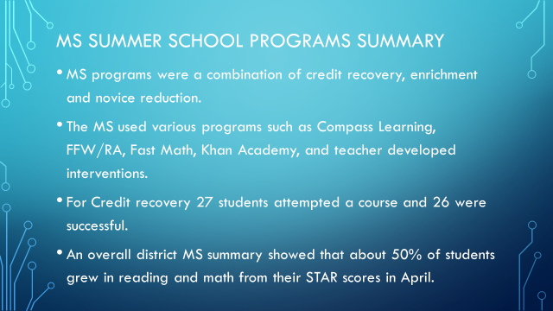

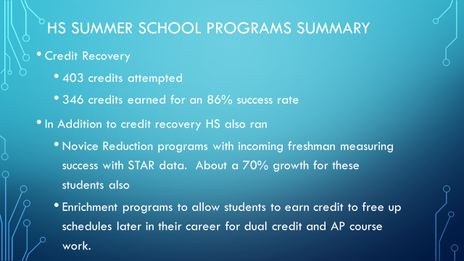

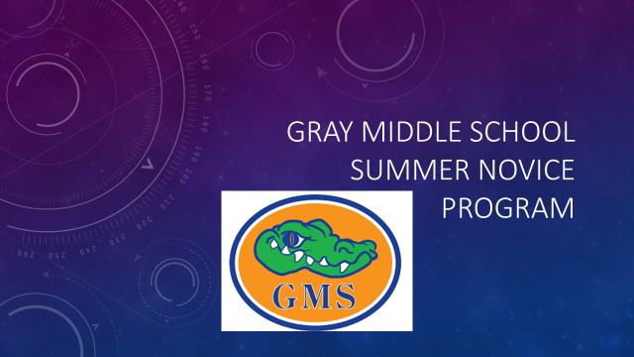

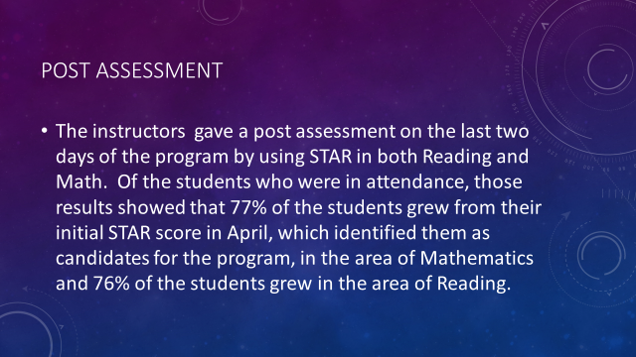

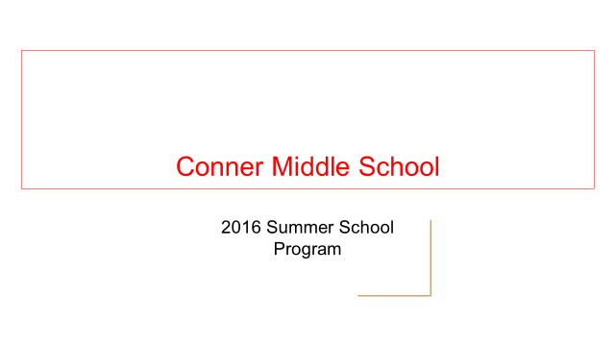
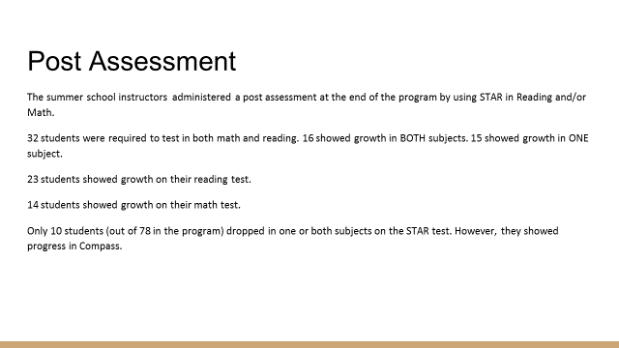

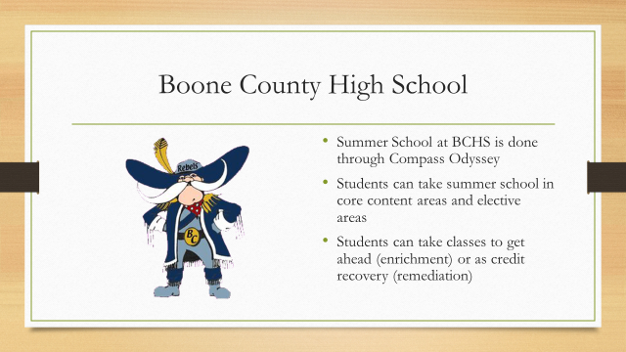

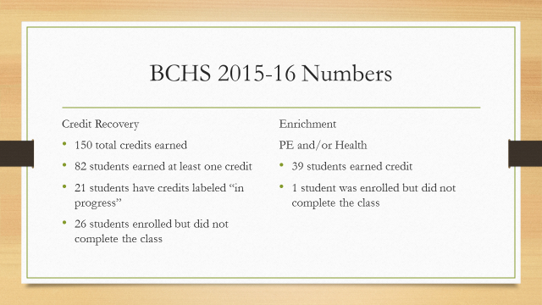

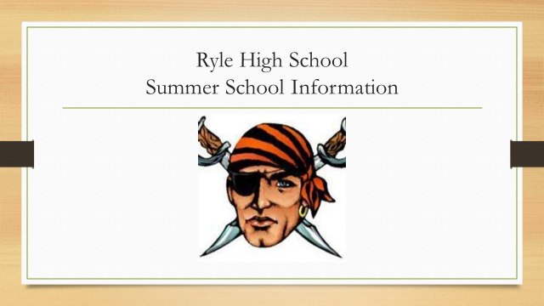

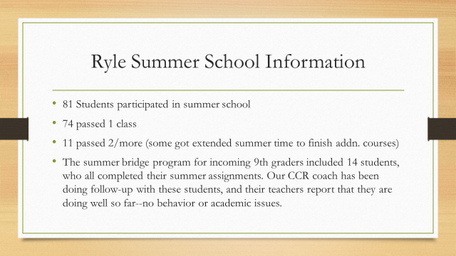

X.B. Linda Black, Elementary Director of Teaching and Learning, provided the board with a detailed report on Summer School results for Elementary Schools. Powerpoint following:

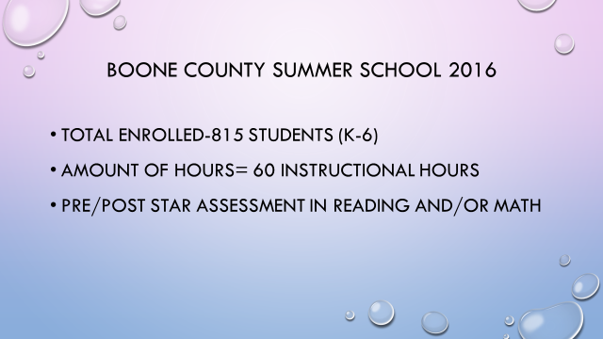

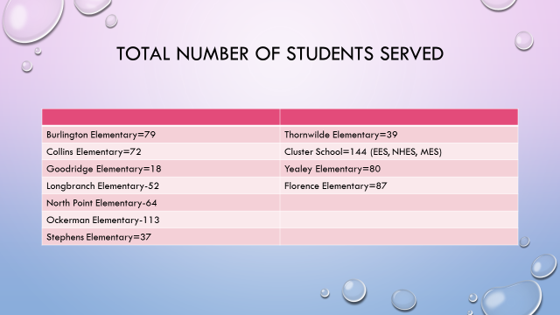

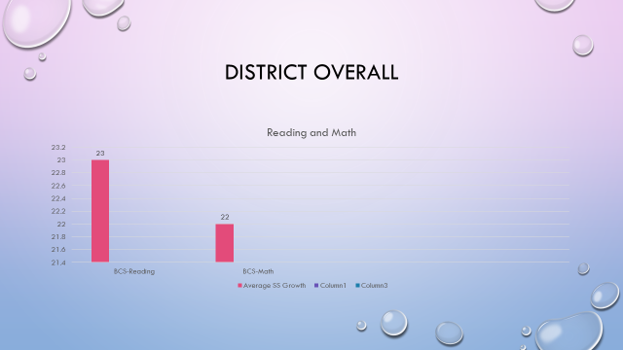
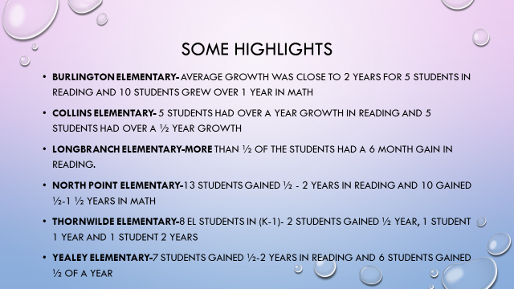

XI. INFORMATION, PROPOSALS, COMMUNICATIONS
XI.A. Human Resource Actions
XI.B. Worker's Compensation Claims
XI.C. Overtime Report
XI.D. Construction Status Report
XI.E. Energy Management Report
XI.F. Certification for the 2016-2017 School Year Constitutionally Protected Prayer in Public Schools
XI.G. Preschool Partnership Grant Application Information

- Dr. Poe discussed potential dates with the board members for the Professional Development board workshop on the Poverty book study. The date was discussed and will be at 6:30 pm on November 3rd at the Ralph Rush Development Center.
- Dr. Poe announced students from our district would be joining together at the Freedom Center 911 Remembrance event on Friday, Sept. 9th. This event educates are students on the importance of patriotism and there will be 50 states participating at the same time. Mr. Massey will be a guest speaker at the event.
- Steve Templeton stated the Boone County Business Association raised over $5500.00 in the recent annual golf outing that directly benefits our students. Mr. Templeton discussed the Business Association desire to volunteer and help in the schools were needed. Recently a group volunteered at Mann Elementary during popcorn day and if any principals have a need for any community volunteers such as reading to student events etc., please get in touch with Mr. Templeton and he will arrange.
- Karen Byrd announced the KSBA NKY Regional Dinner will be held on Sept. 20th and our district is the host for the event.

XII. AUDIENCE OF CITIZENS
Jennifer Combs, education student at NKU, introduced herself to the board.

XIII. CLOSED EXECUTIVE SESSION PER KRS 61.810
XIII.A. No closed session

XIV. ADJOURN

- A motion was made by Steve Templeton, seconded by Karen Byrd, to adjourn the meeting. Bonnie Rickert, Maria Brown, Karen Byrd, Ed Massey and Steve Templeton voted, “aye” MOTION: The motion passed 5-0.

Meeting was adjourned at approximately 8:44 pm

_____________________________________
Maria Brown/Chairperson

_____________________________________
Karen Evans/Secretary

