Communication Updates- August 2021
Candace Gibson- Communication and Outreach Coordinator

Newsletter Update
Transition to S’more newsletters is on hold while new parents and students sign up in our current form. Once the influx of new sign-ups slows down, I will transition over to the new platform. In the meantime, the header for the Bellevue Bulletin has been updated for the new school year! Fun fact: the first newsletter of the 2021-2022 school year is our 81st edition of the Bulletin.
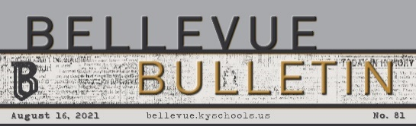

Social Media
Our social media engagement always ramps up right before back to school, and this year was even more successful with huge gains in reach and engagement! Despite the ongoing debates over masking, any pushback and/or negativity was miniscule in comparison to the outpouring of support from our community. Our photos of the Block Party and Open house reached upward of four thousand people, and over five hundred engagements (likes, shares, comments, or clicks). Bellevue is reaching a much larger audience, with a large thanks in part to our community members who proudly share out our posts. Facebook analytics also shows that we have had a 62% increase in views from people in neighboring communities.
FACEBOOK MONTHLY IMPACT
Average post reach per month | 15,081 (+99%)
Average post engagement per month | 6,023 (+476%)
New followers | 25 (+317%)

MAILCHIMP- NEWSLETTER IMPACT (based on numbers from the latest edition)
Total Subscribers | 281 (5 new subscribers, before beginning of year push)
Avg. % of subscribers who engage via email | 50% (+5%)
Social media impressions per week | 577 (Facebook), 563 (Twitter)
As our Twitter base continues to grow, so do our impressions and engagements with the newsletter. We saw a 319% increase in viewership via Twitter last week!

Website
Details on potential new website options through the SchoolPointe/Finalsite merger are on hold until later in the school year.

The current website goal is to continue redirecting our community from social media to the website as our single source of truth. A new Back To School Info Hub was added to the home page to create a centralized location for Covid-related procedures and other necessary Back to School information. Our Food Service team is now partnering with MySchoolMenus to create more detailed online school menus. Athletic events will also be more prominently displayed on our district calendar and “upcoming events” section of the homepage, to encourage more attendance.

One of my favorite new features is the Construction Updates blog, hosted on our website. Updates will be posted a minimum of twice weekly by Candace Gibson, Robb Smith, or Jim Hicks to keep the community in the know about all the exciting projects happening at both schools. We wanted to be as transparent as possible about where we are in the construction process and how it may affect the school day. So far, we have received very positive feedback on the blog, and families were happy to be informed prior to the start of the school year.

In an effort to streamline processes for our Director of Facilities, new digital forms have been created to allow staff to request field trip transportation or submit a maintenance/custodial request. They are located in the Staff Links section of our Forms & Links page, and will allow for a simpler, more organized method of submitting requests.

