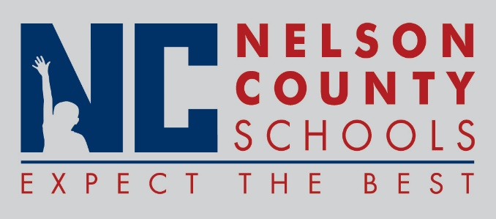

Decision Paper
To: | Nelson County Board of Education
From: | Kimberly Brown and Ann Marie Williams
cc: | Dr. Anthony Orr, Superintendent
Date: | May 17, 2016
Re: | Nelson County Schools Non-Traditional Instruction (NTI) Application

RECOMMENDATION: I recommend that the Nelson County Board of Education approve the 2016 - 2017 Non-Traditional Instruction (NTI) Application.

RECOMMENDED MOTION: I move that the Nelson County Board of Education approve the Nelson County Schools 2016 – 2017 Non-Traditional Instruction (NTI) Application as presented by the Directors of Instruction.

