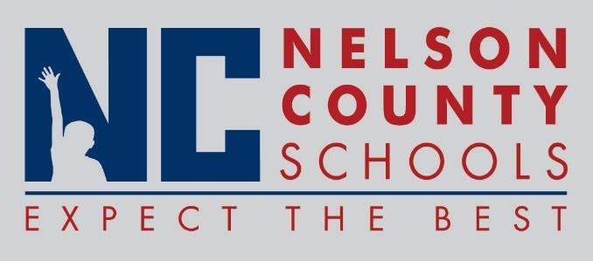

Information Paper
To: | Nelson County Board of Education
From: | Bob Morris, Director of Student Support
cc: | Dr. Anthony Orr, Superintendent
Date: | May 4, 2017
Re: | New Procedure and Updated Policies and Procedures

03.13251 Certified Drug Free Schools Policy: Updated
03.13251 AP.1 Certified Drug Free Workplace Notice: Updated
03.23251 Classified Drug Free Schools Policy: Updated
03.23251 AP.1 Classified Drug Free Workplace Notice: Updated
09.423 Students Drug Free Schools Policy: Updated
09.423 AP1 Students Drug Testing Procedures: Updated
09.423 AP 21 Student Drug Testing Consent Form; Updated
S08.1114 Pre School: New

