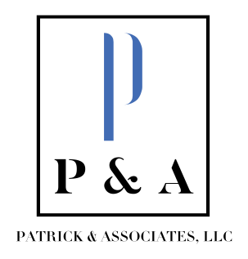
Tammy Patrick, CPA Beth Francis
tammy@patrickassoc.com beth@patrickassoc.com
(859) 808-1329 (859) 333-2360

November 6. 2023

Superintendent Stull and Members of the Board of Education of the Garrard County School District:
We have completed the independent audit of the Garrard County School District for the fiscal year that ended June 30, 2023 and have issued an unmodified opinion, which is a clean opinion (please see the audit report page 1). Our audit work found no evidence of fraud of misappropriation of funds in examining the school district’s finances. We also found no issues related to compliance or internal control related to the District’s major federal programs or school activity funds.
We greatly appreciate the courtesy extended to our staff during the audit. Mrs. Coffey and her staff were cooperative and professional during the audit and did an excellent job of providing information as it was requested throughout the audit.
Financial Highlights:
The District’s governmental fund balances increased by $30,899,697 (please see the audit report page 16), resulting in ending fund balances of $36,921,290. This large increase is due to bonds issued in June 2023 for construction of Garrard County High School athletic projects.
The District’s business type activities (school food services and community education services) fund balances increased by $439,016 resulting in ending fund balances of $1,069,654 (please see the audit report page 22).
The District’s ending net position also increased by $2,814,493 (please see the audit report page 13). This is primarily due to the increases in total assets, deferred outflows of resources, and total liabilities, offset by decreases in the deferred inflow amounts related to pension and OPEB.
Overall revenues for the FYE in comparison to the prior FYE increased by $3,763,864 and expenditures increased by $3,568,450 (please see audit report page 8)
Again, we want to thank and commend Mrs. Coffey and her staff for the excellent work they have done.
Please feel free to contact us if you have any questions.
Sincerely,
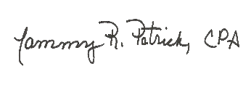
Tammy R. Patrick, CPA
Patrick & Associates, LLC

