Communication Updates- March 2023
Candace Gibson- Communications and Outreach Coordinator

NEWSLETTER
Based on changes to the free MailChimp newsletter service, we have moved the Bellevue Bulletin over to Smore. The first edition of the Smore newsletter will be published on Friday, March 17. There will be a few new features, such as an event RSVP option embedded within the newsletter. Every current subscriber will be migrated over to the new system, and a social media campaign will take place to encourage additional subscribers.

MAILCHIMP- NEWSLETTER IMPACT (based on the latest edition)
Total Subscribers | 318
Number of subscribers who engage via email | 149 opens, 4 link clicks
Social media impressions per week | Facebook- 446 (6 engagements)  Twitter- 253 (16 engagements)

SOCIAL MEDIA
Our social media presence continues to expand, with a monthly post reach nearing 20,000. Of those connections, 63% of our audience actively engaged with a post. This increase took place despite having fewer posts than the previous months, indicating that our Word of Mouth marketing is strong. Below are the top performing posts of the month.
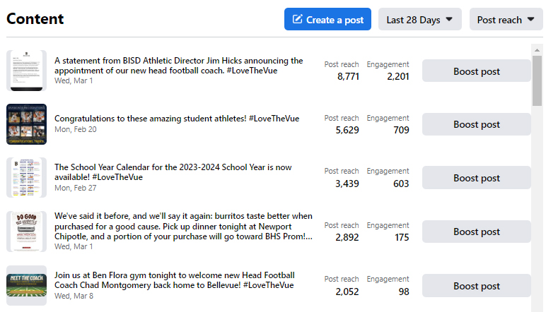
FACEBOOK MONTHLY IMPACT
Total post reach this month | 19,849
Total post engagement (likes, comments, etc) | 12,590
Number of posts this month | 54
New followers; new page likes | +36; +18
Total shares | 211

Fun Fact: The BISD Facebook page has gone global, with subscribers located in nine other countries! Among those are Vietnam, Italy, Belgium, Brazil, and Nigeria.

NEW DESIGN PROJECTS
Based upon the board’s feedback from the March working meeting, changes to the new Mission & Vision, Strategic Plan, and Portrait of a Graduate designs are currently underway. Additional design projects slated for the month of March are as follows:
- New marketing for the Bellevue Classroom
- A retractable banner to be used to promote BISD at job fairs and other community events.
- Updated trifold for teacher recruitment
- “Enchanted Forest” designs for Prom
- GES Summer Camp marketing and t-shirt designs

