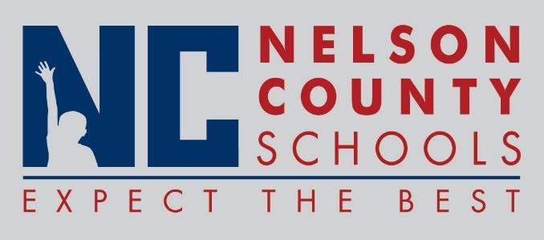

Information Paper
To: | Nelson County Board of Education
From: | Bob Morris Executive Director of Student Support
cc: | Dr. Anthony Orr, Superintendent
Date: | March 21, 2017
Re: | Personnel Notifications

New Hires: Kaye Theford Teacher OKH
Darren Morris IAI TNHS
Lemondra Williams IAII HOR

Transfers: None Reinstatements: None

One Year Certification: None

Classified Subs: Jessica Comes, John Smith, Tosha Neace, Stephanie Calhoun, Allysa Johnston,

Certified Substitute: Marcy Singer, Darcy Gillock, Ashley, WImsett, Christine Futch, Tim Waldorf

Student Workers: None Non-Renewals: None

Resignation: April Peach Food Service Director CO
Gavin Walls Teacher OKH

Retirements: None
201
Reprimands/Terminations: None

