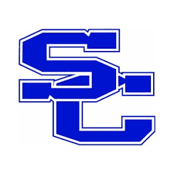
SPENCER COUNTY PUBLIC SCHOOLS
Board of Education Agenda Item

Meeting Date 8/22/2022

Topic/Title ____SCMS FEE REQUESTS_____

Presenter(s) Chuck Abell

Type of Information/Board Action
☐ Information only. No Board action required.
☐ Action requested at a future meeting: Click or tap to enter a date.
☒ Consent agenda for approval at this meeting.
☐ Action requested at this meeting.

Board review is a result of:
☐ State or federal law or regulation.
☐ Board of Education policy.
☐ Past practice.
☐ Other:

Previous Review, Discussion, or Action
☐ No previous Board review, discussion, or action.
☐ Previous review/action on: Click or tap to enter a date. Action: Click or tap here to enter text.

Background/Summary of Presented Information

Jr. Beta | $30 (State) and $50 (National) | National Beta Club Convention Registrations
Jr. Beta | $30 | New Member Fee
Cross Country | $100 | Entry fees, Uniforms, Apparel, Awards, Pizza Party and Banquet
Academic Team | $25 | Registration for KAAC
Art Club | $25 | Art Club Membership – Supplies for Club

Financial Considerations
☐ There is NO financial impact on resources.
☐ There is a financial impact on Board resources. Chief Financial Officer must review.
Click or tap here to enter text. Chief Financial Officer’s initials, if required

Superintendent’s Recommendation
Recommend as presented

