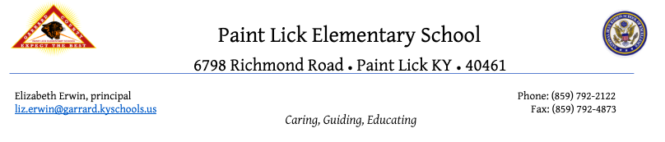

SBDM Meeting March 17, 2021
Special Called Meeting
3:15 - Virtual - Streamed at https://bit.ly/plewebsite

Opening Business
3:22 Liz called the meeting
Present- Amy Jennings, Liz Erwin, Andrea Brin, Tammy Fain, Lisa Middleton-special guest

- Approval of the Agenda -Amy Jennings makes motion, Tammy Fain seconds, consensus met.
- Approval of previous meeting’s minutes -Andrea Brin makes motion to approve, Amy Jennings seconds
- Good News Report
- Public Comment

Student Achievement Report/Data

a. Spring Testing
Social Studies will be a field test. SS is optional this year, but Garrard County has chosen to participate. Testing will be shorter, and all students receive additional time. The results from this school year won’t be representative data. We will look at prior data to form improvement plans.
School Improvement Planning
Needs Assessment
- https://docs.google.com/document/d/12KDhHZVpfZKBjHcknFFc359RFnxMagksWn42AyylG5w/edit?usp=sharing
- Learning Loss Survey
- Teacher Survey-10 responses
-Most people agree math is a growth area.
-Amy Jennings thinks there should be a focus on SEL on continuing basis, even though it was not a priority on the teacher survey
-Tammy Fain-since testing will be online, students need more training on typing and technology tools.
-Councils three subject priorities-Math, Technology, Reading
- iready Data

- Iready Grade Level Comparison Data
- Iready Below Grade Level Co
- Iready Longitudinal Data

List of Needs and Priorities
Math-one of our lower rankings
Science- the lowest percent of P/D
Something to think about: Practice items on KPREP practice test are more difficult. Social Studies standards are changing. When standards and testing change, there can be some “catch up” time.
Budget Report
Social Emotional need to continue to be a focus (forever)
Focus more on Technology (Students need to learn presentation tools, how to take tests on the computer) Our students are behind other schools in the use of tech tools. GMS uses Chromebooks for everything.

- February Budget Report
- Draft of the 2021-22 staffing allocation plan- (Hold harmless) One teacher is considering retiring; if that happens, we will not lose a physical person, but we will lose the highly structured program and one assistant (the positions).
Section 6 money-$140 per student times average daily attendance. Budget is roughly $36, 000
Committee Reports
- None
Policy Review -(Tabled until next meeting)
  - 1.13 Selection of Instructional Materials

  - 1.11 Professional Development
Old Business
Communication with parents through Remind
Communication about SBDM
Calendar and Newsletters include standards and how we remediate

New Business-No new business

Adjournment-Andrea Brin makes motion, Tammy Fain seconds. Consensus met.

