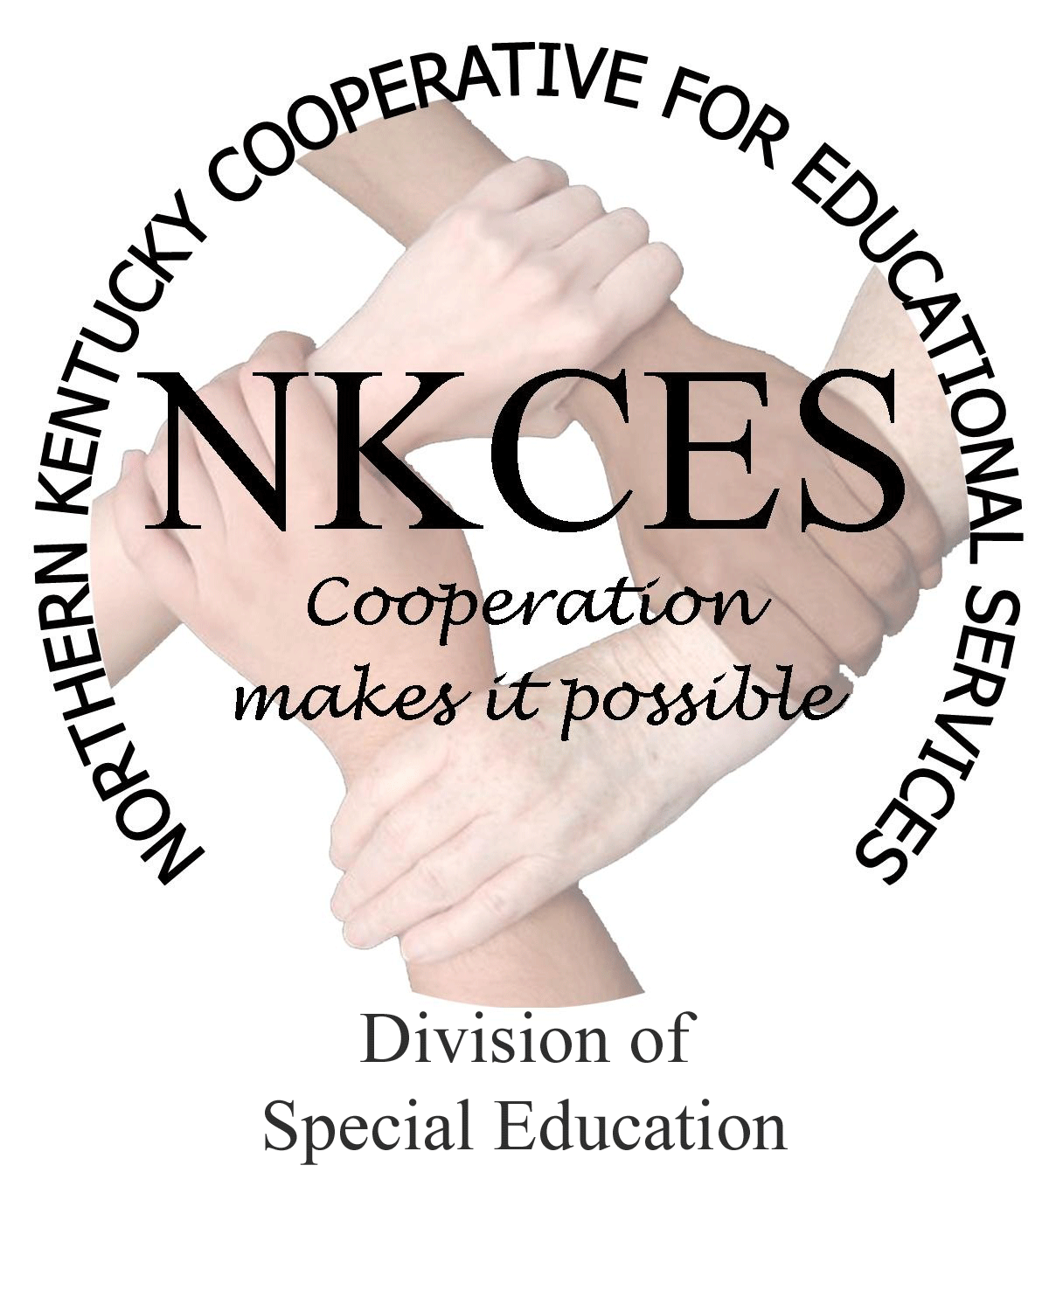
Northern Kentucky Cooperative for Educational Services, Inc.

Member Districts

Beechwood Independent • Bellevue Independent • Boone County • Campbell County

Covington Independent • Dayton Independent • Erlanger-Elsmere Independent

Ft. Thomas Independent • Kenton County • Ludlow Independent • Newport Independent

Pendleton County • Silver Grove Independent • Southgate Independent

Walton-Verona Independent • Williamstown Independent

January 5, 2015

Curtis Hall, Executive Director
NKCES
5516 E. Alexandria Dr.
Cold Spring, KY 4-176

Re: Superintendents Report

Dear Curtis:

It is hard to believe that we have alaready completed half of the 2014 – 2015 school year. With that in mind, we thought it would be beneficial to provide you with our six month report regarding the activity we provided to the N KY region. Upon your review, we believe you will agree that our team has effectively produced trainings, coaching, consultations, walk throughs, and meetings that will assist our school’s staff in “Closing The Gap.”

The month of December was busy as we closed out meetings, assessments, and trainings in preparation for the holiday break. Highlights included regional training for CBB Math trainings, Instructional Coaching Follow-up, and the annual Transitions Forum held at the Gateway Community and Technical College.

Looking forward, we have secured the following dates for upcoming regional trainings:

WISC-V &KTEA-3  January 22, 2015  8:00 – 3:00 PM  Indiana Wesleyan  Presenter: Dr. Gloria Maccow | High Impact Training  March 9, 2015  8:00 – 4:00 PM  Gateway Community & Tech College  Presenter: Tricia Sklyes | Parent Professional Conference  May - TBD  8:00 – 3:00 PM  Location: TBD  Presenters: TBD
Orton Gillingham Advanced Continuum Training  June 22 – 25, 2015  8:00 – 3:30 PM  Location: TBD  Presenter: Michele Wenger | Para ED Professional Conference  June 22 – 24, 2015  8:00 – 3:00 PM  Ralph Rush Center  Presenter: Mina Hammons | Standard Based Training  July 27, 2015  8:00 – 3:00 PM  Dietz Center  Presenters: Dr. Thomas Guskey  Dr. Leann Jung

Online Registrations are now available for the January – March trainings. For those conferences and trainings remaining, online registrations will be forth coming upon completion of reservations regarding locations.

We are excited to begin the New Year in anticipation as we move forward with the District’s Plans, as well as finalizing plans for additional conferences and trainings. We will keep you abreast with our progress and will provide you with any and all new conferences to be provided.

It is always a pleasure to bring this report as I believe I speak not only for myself, but also for our staff’s team who undertake what we can do in an excellent fashion. There are no prizes for average performance. As a matter of fact, the only prize we seek to realize is the smiling faces upon the children within our region for having met success in the classroom. Ultimately, the Gap is closed.

Sincerely,

Linda Alford, Regional Director of Special Education

