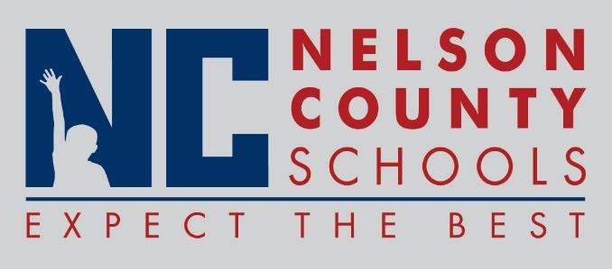

Information Paper
To: | Nelson County Board of Education
From: | Bob Morris Executive Director of Student Support
cc: | Dr. Anthony Orr, Superintendent
Date: | June 19, 2017
Re: | Personnel Notifications

New Hires: Nancy Barnett Teacher BMS
Ashleigh Morgan FRYSC BMS
Amanda Skees Acct Clerk BOS
Kari Reckart Teacher CC
Sheryl Figg Teacher CC
Emily Kelly Teacher CC
Traci Wethington Teacher CC
Troy Thomas Teacher CC
Chelsey Ritchie Teacher ELC
Mandy McGrew IAII ELC
Julie Bixler IAII ELC
Ann Bell Teacher FH
Jessica Rice Teacher Hor
Denise Taylor IAII Hor
Teresa Henderson Teacher NCHS
Tanya Jury Principal NCHS
Michael Ehrler Teacher NH
Katie Kerr Teacher NH
Mary Newton Teacher NH
Neal Wells Teacher OKH
Amy Deaton Teacher NCHS
Jennifer Johnson Teacher NCHS
Larry Williams Teacher NCHS
Lauren Herth Teacher TNHS

Transfers: Randi Jury Teacher OKH to Curriculum Coach Dis

Reinstatements: None

One Year Certification:

Classified Subs:
Certified Substitute:

Student Workers: None

Non-Renewals: Larry Adamson IAII HOR

Resignation: Todd Payne Teacher BMS
Alex Edwards Teacher NCHS
Tiffney Deopere PT District
Jeffery Neagle Teacher OKH
Beverly Parrish Account Clerk BOS
Trevor Mason Teacher NCHS
Alan Vales Teacher New Haven
Josh Bartley Mechanic Trans
Robin McCoy Counselor NCHS to (KDE)
Stefanie Bryan Teacher New Haven

Retirements: Regina Davis Cook/Baker BMS
Cindy Chesser Account Clerk TNHS
Donna Neal Teacher NCHS

Reprimands/Terminations: None

