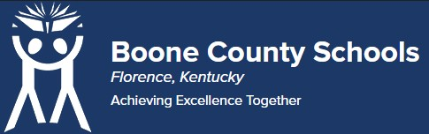
Boone County Board of Education Members
Dr. Maria Brown, Board Chair Mrs. Julia Pile, Vice Chair
Ms. Karen Byrd Mr. Jesse Parks
Mr. Keith Collins Mr. Matthew Turner, Superintendent

Board Memo

DATE: 11/16/2021

AGENDA ITEM DETAILS:
School/Department
LSS

Product Vendor or Grant Issuer
Kagan

Product or Grant Name
Kagan Professional Development Date/Term (Beginning and End Dates/Year) June 13-17, 2022

APPLICABLE BOARD POLICY:
N/A

DESCRIBE USE OF CONTRACT/PURCHASE/AGREEMENT
Professional development for Pre K - 12 educators on cooperative learning structures which promote engagement, collaboration and builds social-emotional learning for students.

FUNDING FOR PURCHASES AND OTHER REQUESTS:
Total Cost
$749 for approx. 75
Funding Source Title II

*If more than one funding source, list below along with amount or percent for each source
N/A.

IF THIS IS A GRANT, ENTER AMOUNT TO BE AWARDED:
n/a

RECOMMENDATION:
I, Jenny Watson, Assistant Superintendent Learning Support Services recommend to the Board approval of this Letter of Agreement as presented.

CONTACT PERSON: (submitter)
Kim Thomson/Jenny Watson

