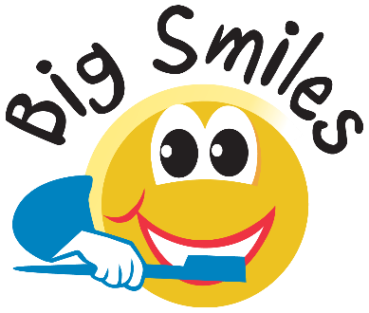

MEMORANDUM OF UNDERSTANDING

The mission of Big Smiles Kentucky PSC (dba “Big Smiles Kentucky”) is to improve the quality of children’s lives by providing preventive and, where appropriate, restorative dental services to children often left without care. With a signed permission form, Big Smiles Kentucky can provide a dental exam, cleaning, fluoride treatment, x-rays and sealants, where applicable. In addition, restorative services such as simple fillings, pulpotomies (a root canal on baby teeth), extractions of baby teeth and pulp caps are offered. We generously provide donated care to children-in-need which includes a cleaning, screening and fluoride treatment. No child is ever turned away for lack of resources.

The purpose of this memorandum is to establish an understanding between:

Big Smiles Kentucky

And

Boone County School District

Big Smiles Kentucky agrees:

- At a date to be mutually agreed upon, to provide preventive and restorative dental services, including: exams, cleanings, fluoride treatments, as well as x-rays and sealants where applicable, in addition to simple fillings, pulpotomies on baby teeth, baby teeth extractions and pulp caps. Such care shall be offered to the children with parental/guardian consent.

- All children ages 18 months -18 years are eligible.

- Each site will be served by our licensed Kentucky dentist(s) and hygienist(s) and/or dental assistants.

- There is no charge to the schools or District. .

- When available, Medicaid covers 100% of treatment. Most insurances are accepted. For those without insurance, self-pay options are available.

- When children-in-need without insurance, Public Aid or the ability to self-pay receive grant funding, a dental screening, cleaning and fluoride treatment will be provided at no expense once per school year, with parental signature and completion of our grant form confirming eligibility.

- Restorative dental care, including services listed above, is available only to those children with Medicaid, CHIP or applicable private insurance coverage.

- In the end, no child is turned away based on his/her ability to pay.

- All children will be given a “report card” for their parents’ review. Copies of x-rays are available to the family and dental offices.

Boone County School District agrees to:
- Distribute Permission Forms to students in the fall and spring semesters of each school year and at other times upon request, as well as to collect the Permission Forms from the students in advance of the dental visit, and to send the completed Permission Forms to Big Smiles Kentucky as far in advance of the dental visit as reasonably possible.

- Communicate directly with parents via electronic medium (i.e. text, email) and/or robo-calls, as well as posting to the school/district website to make them aware that the in-school dentist is coming to school and provide parents with the online sign-up option, available at www.myschooldentist.com

- Provide a space that is a minimum of 14 feet x 14 feet including 2 standard power outlets and access to water, suitable for the staff of Big Smiles Kentucky to set up its “dental office”.

- Provide a minimum of 25 children per site to be treated. If minimum is not reached, the visit may be rescheduled or cancelled.

This agreement is non-financial in nature. It shall run for a period of one year and, shall be renewed automatically on an annual basis for additional one year terms, unless notified by either party in writing with 30 days notice. If necessary to fulfill its responsibilities under this agreement, Big Smiles may assign this agreement to another dental practice.

Big Smiles Kentucky PSC
2333 Alexandria Drive
Lexington, KY 40504

By: |  |  |  | Date:
 | Signature
 | Print Name
 | Title

Boone County School District
8330 US Highway 42
Florence, KY 41042

By: |  |  |  | Date:
 | Signature
 | Print Name
 | Title

