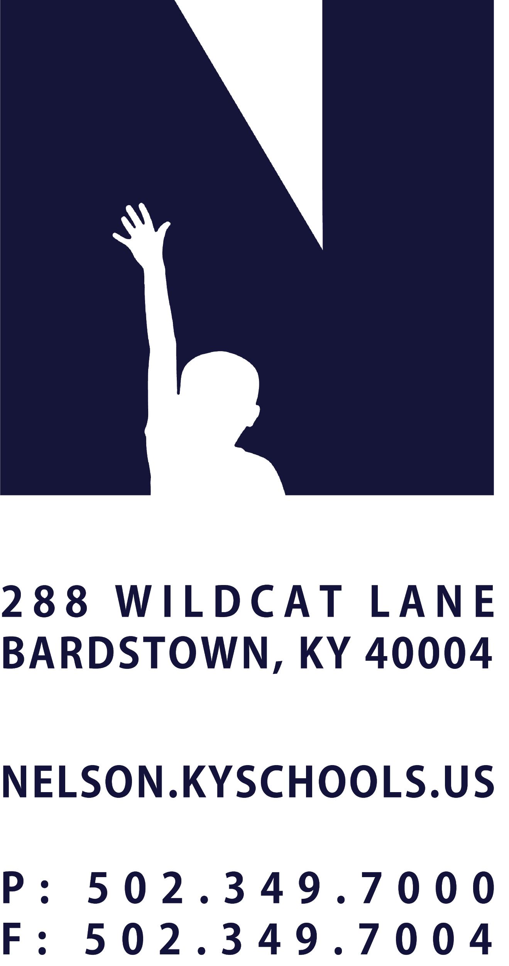 | JOB TITLE | STUDENT LEADERSHIP DIRECTOR
 | REPORTS TO | DIRECTOR OF STUDENT LEADERSHIP & LEARNING/PRINCIPAL
 | SALARY SCHEDULE/GRADE | CERTIFIED (15 YEAR BASE SALARY)
 | CONTRACTED DAYS AND/OR HOURS | 186 DAYS + EXTENDED DAYS PER EXTENDED EMPLOYMENT SCHEDULE
 | EXEMPT STATUS | EXEMPT
 | JOB CLASS CODE | 7344
 | POSITION CLASSIFICATION | CLASSIFIED PROFESSIONAL
 | DATE APPROVED

QUALIFICATIONS
Bachelor’s degree required.

POSITION SUMMARY
Student leadership coordinators create opportunities to honor and celebrate our student leaders, their accomplishments, and their future story. Build leadership opportunities to ensure all students can showcase their leadership abilities through a variety of experiences and create intentional structures to recruit, empower, retain, and evaluate leaders in our student leadership positions through a value driven process.

DISTRICT AND SCHOOL PRIORITY ALIGNMENT
Align actions with district and school values and core priorities.
Evaluated based on the efficacy of aligned actions.

PERFORMANCE RESPONSIBILITIES
Provide visionary direction for athletic program building across the district.
Align monetary and scheduling resources to school & district priorities.
Building a culture of Nelson County PRIDE focused on annual rituals and traditions that honor and celebrate past and present.
Facilitate student organization classes to build capacity in student voice.
Ensure student data & recruiting process allows for access for all students to engage in leadership.
Share powerful student leadership experiences with our community.
Share and monitor implementation of a vision for community centered schools in alignment with athletic and student organizations K-12.
Monitor service partners with student leadership organizations across the district.
Provide ongoing vision for academic success and work ethic standards.
Support, monitor, and celebrate academic progress of participating students.
Collaborate with coaches to ensure high standards for academic & work-based experiences.
Demonstrate a commitment to professional growth.
Demonstrate effective interpersonal and communication skills.
Demonstrate punctuality and regular attendance.
Maintain appropriate professional appearance.
Adhere to the Professional Code of Ethics for Kentucky Certified Personnel 16 KAR 1:020
Perform other duties consistent with the position assigned as may be requested by the Principal or Director of Student Leadership and Learning.

KNOWLEDGE AND ABILITIES
Knowledge of athletic management and student leadership co-curricular involvement.
Knowledge of policies, regulations, and bylaws from the Kentucky High School Athletic Association

PHYSICAL DEMANDS
Work is performed while standing, sitting and/or walking.
Communicate effectively using speech, vision and hearing.
Use of hands for simple grasping and fine manipulations.
Bending, squatting, crawling, climbing, reaching.
Bending, squatting, reaching, with the ability to lift, carry, push or pull light weights.

