Communication Updates- November 2022
Candace Gibson- Communication and Outreach Coordinator

NEWSLETTER
After listening to some feedback from a few subscribers, I have turned our BMHS and GES news sections into downloadable, printable one-sheets of information for the coming week. Additionally, we can now print copies to keep on-hand for those families who do not have access to the internet. GES’s newsletter features upcoming events and the next week’s lunch menu, and BMHS features the upcoming events and the most recent daily announcements and reminders.
MAILCHIMP- NEWSLETTER IMPACT (based on the latest edition)
Total Subscribers | 313
Number of subscribers who engage via email | 142 opens, 24 link clicks
Social media impressions per week | 636 (Facebook), 135 (Twitter)

SOCIAL MEDIA
Social media engagement numbers remain at never before seen numbers, largely due to the response to the community football game, Halloween, and Veterans Day photos. It is interesting to note that the last 28 days have seen fewer overall posts, but higher numbers of views and engagements. Our regular audience grew by another 41 followers. The top performing post is shown below:
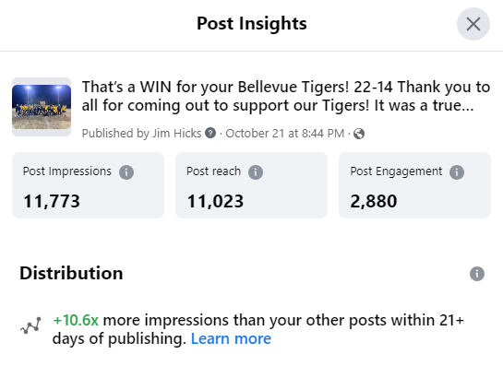
FACEBOOK MONTHLY IMPACT
Total post reach this month | 26,262 (up from 23,805)
Total post engagement (likes, comments, etc) | 22,436 (down from 24,741)
Number of posts this month | 65 (down from 72)
New followers; new page likes | +18; +41
Total shares | 298 (down from 330)

Over the last few months, have had a handful of encounters around town of parents expressing their gratitude for the photos that allow them to see a glimpse of their child’s school day. As one stated, “now, when I ask my children how their day was, I get more of a response because I can ask about specifics based on what I see on Facebook!”

NEW OUTREACH PROJECTS
Feedback from the October Community Forum was arranged into a series of spreadsheets to allow us to look for trends and determine what participants most valued in our school district. Full results can be found at http://bit.ly/3UXfpAX, and a snapshot of the most common answers can be found below:
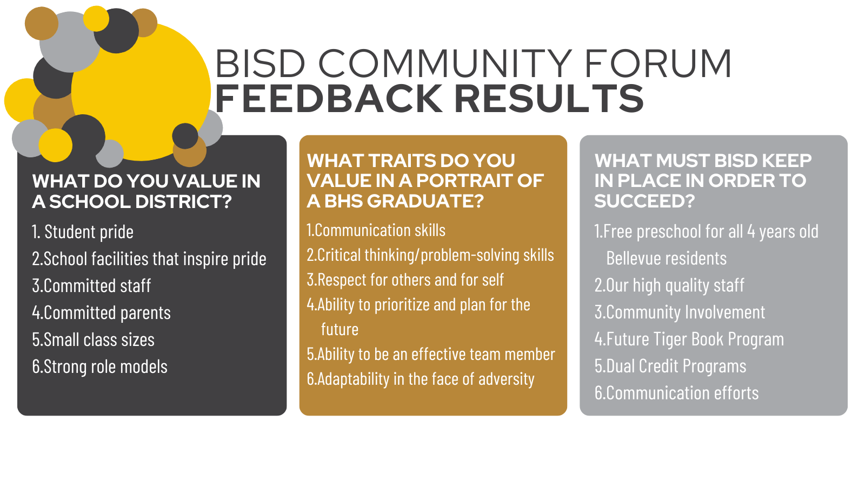
Our first “Vue at the Brew” was a big success! Five community members, including new-to-the district families and an alumnus who was eager to find out what the district needs to succeed. It was a great group for the size of the room, and everyone was very engaged in the conversation. Other community members were in Avenue Brew during the event, and while they were unable to attend our first event, they expressed an interest in future chats! The event was very casual, which made for a very welcoming environment for questions and comments. Future dates will feature additional members of BISD staff, and we look forward to continuing these chats with the community! Future dates can be found below:
