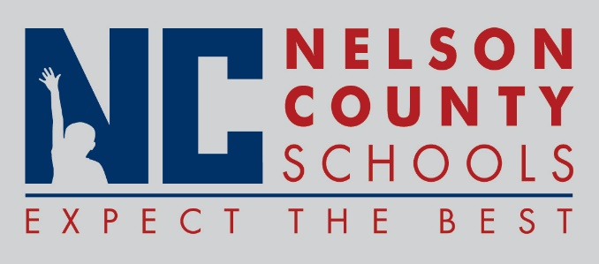

Decision Paper
To: | Nelson County Board of Education
From: | Kimberly Brown, Director of Secondary Education
cc: | Dr. Anthony Orr, Superintendent
Date: | April 25, 2017
Re: | Perkins Grant 2017 – 2018 School Year

RECOMMENDATION: I recommend that the Nelson County Board of Education approve the 2017/2018 Perkins Grant as presented by the Directors of Education.

RECOMMENDED MOTION: I move that the Nelson County Board of Education approve the Perkins Grant for the 2017/2018 School Year as presented.

