North Hardin High School – Phase 7

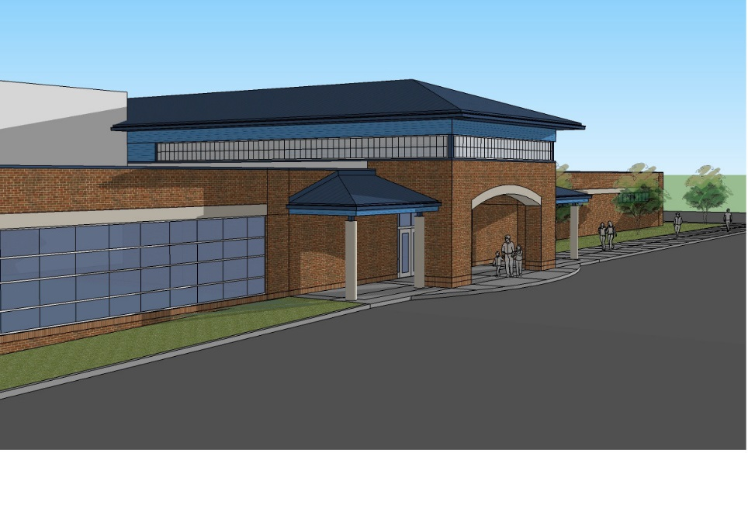
Construction Update

July 7, 2017

Original Construction Cost: $13,380,000.00
Present Construction Cost: $13,636,865.00 (Revised by Change Order No. 9)

Original Completion Dates
Substantial Completion: July 1, 2016
Final Completion: August 1, 2016

Anticipated Completion Dates (Revised by Change Order No. 1)
Substantial Completion: Substantial Completion Achieved
Final Completion: January 24, 2017

Change Order Summary
Change Order Amount Status Rvsd. Contract Amount
CO No. 001 $11,196.00 Fully Executed $13,391,196.00
CO No. 002 $5,534.00 KDE Approved $13,396,730.00
CO No. 003 $57,407.00 KDE Approved $13,454,137.00
CO No. 004 $23,578.00 BOE Approved $13,477,715.00
CO No. 005 $35,162.00 BOE Approved $13,512,877.00
CO No. 006 $6,462.00 BOE Approved $13,519,339.00
CO No. 007 $20,753.00 BOE Approved $13,540,092.00
CO No. 008 $110,692.00 BOE Approved $13,650,784.00
CO No. 009 ($13,919.00) BOE Approved $13,636,865.00

Potential Change Orders
Proposed change | Reason | Projected Price / Quote from contractor
Credit for steel not required at existing locker room area. | Existing structure can remain. | Estimated ($8,000.00)
Credit for unused unsuitable soil allowance | Actual costs less than anticipated. | Estimated ($19,219.00)

Progress Report

Work Completed

- Small Gymnasium Insulation Correction.
  - Insulation correction was completed. SCB met with John Stith and Morel Construction to review the corrective work on Wednesday, June 28th.
  - A punch list was issued by SCB on Friday, June 30th outlining all items that require the contractor’s attention. Those items include general clean-up work, wall cleaning, floor cleaning and possible refinishing.
  - Per phone conversation with Rick Clauson on July 7th, the gym has currently been repainted, floor has been cleaned, overspray has been corrected, and all puch list items have been addressed.
  - $21,250.00 is being withheld for this corrective work until all repairs are satisfactory. SCB will schedule a walk through with John Stith for early the week of July 10th to review completion. Upon satisfactory completion, SCB will forward closeout documentation and recommendation for final payment.

The following warranty items have also been identified and forwarded to Morel Construction for correction.

- VET tile glue at Cafeteria 162

