Regular Meeting Boone County Board of Education
October 13, 2016 7:30 PM
Ralph Rush Professional Development Center
99 Center Street
Florence, Kentucky 41042

I. CALL TO ORDER
The Regular meeting of the Boone County Schools Board of Education October 13, 2016 was called to order by Chairperson Maria Brown at the Ralph Rush Staff Development Center.
Attendance Taken at 7:30 PM:

Present Board Members:
Dr. Maria Brown
Ms. Karen Byrd
Mr. Ed Massey updated to arrive at 7:35 pm due to traffic.
Ms. Bonnie Rickert
Mr. Steve Templeton

Lewis Kelly attended as Board Attorney
Karen Evans, Board Secretary, recorded the minutes.

II. NATIONAL ANTHEM
II.A. The National Anthem was presented by members of the Conner Middle School Orchestra.

III. PLEDGE TO THE FLAG
III.A. The Pledge to the Flag was led by Student Council members from Thornwilde Elementary.

IV. STUDENT BOARD MEMBER REPRESENTATIVE REPORT
IV.A. Bradley Rodriquez was unable to attend due to an athletic school event.

V. GOOD NEWS
V.A. The board recognized the October 2016 Break the Mold Award recipient, Ms. Emily Martin, Conner High School Art Teacher. The BCEA president, Tom Haddock, presented Ms. Martin with a carry bag as a member appreciation recognition.
V.B. The Boone County Business Association representatives, Mr. Steve Templeton, Mr. Roger Babik, Mr. Bill McCarty and Ms. Karen Byrd presented the Board of Education with a $5000.00 check from the July Golf Outing benefiting the students of Boone County Schools.
V.C. 2015-2016 Transportation Safety Awards was presented by Ms. Virginia Lainhart.
2015-2016 Transportation Safety Awards-The Boone County Schools have 67 bus drivers who have qualified for the Safe Driver Award for the 2015-2016 school year. Ms. Virginia Lainhart, representing The Woodsmen Association, presented awards to drivers present. The Board recognized and thanked the bus drivers that were present and the following is the full list of safe driver awards:

1 year:
Joe Adkins, Terri Beardsley
Debbie Black
Donna Breetz
Shane Burch
Jason Burris
John Burt
Linda Carter
Jerry Cook
Mark Danks
James Delp
Richard Fannin
William Gamble
David Gilligan
Joe Hamelin
Danny Harlow
Scott Harper
Kathy Hart
Sally Hodges
Robin Hoffman
Renee Hooks
Mike Hoppenjans
Rosemary Kaminsky
April Massingale
Paul O'Daniel
Gary Owens
Bob Perrone
Lori Phillips
Paula Rayburn
Sean Riley
Kimberly Rose
Richard Rothweiler
Mark Scanapieco Heather Schultz
William Sullender
Joe Szybisty
Crystal Tarvin
Charles Vickers
Mark Wade
Stacey Walden
Jeff Wege
Ted Wingrove
Timothy Witschey
Ron Zembrodt.
5 year:
Barb Adams
Norman Belt
Daryl Buckler
Glenna Chamblin
Pam Dickman
Tanhya Handorf
Cheri Herald
Martha Kelly
Terri Kendig
Ray Kolodziejski
Kari Mahan
John Schickel
Terri Schlictmann
Mike Shields
Betty Stickrod
Greg Stottman
Marva Walters
10 year:
Wayne Badida
Les Good
Elaine Robinson
Jerry Stamper
15 year:
Tim Carrier
Pat Roesel
20 year:
Pam Duncan.

V.D. Presentation of the 2016 Bus Garage All-Star Awards.
Boone County Transportation recognized the 2016 Bus Garage All-star Awards recipient:

Ronnie Daniel
Charlie Utz
Jimmy Joe Rudicill
Mike Grout
V.E. The board recognized the 2016 Project Lead the Way Teacher of the Year, Mr. Todd Hanley, RA Jones Middle School
V.F. The board recognized the ten Boone County Schools honored as the 2015-2016 Schools of Contribution.

First Time Recipients: Erpenbeck and Mann and Continuing Recipients: Collins, Florence, Goodridge, Longbranch, New Haven, North Pointe, Ockerman, and Yealey.

V.G. Dr. Poe announced Boone County Schools was recognized by Children Inc. for dreaming and achieving with innovation in education at the recent Children’s Inc. luncheon and award event.
V.H. The board recognized the 2016 October Sportsmanship Award recipients.
Victoria Nash, Boone County High School
Nick Craddock, Conner High School
Dante Hendrix, Cooper High School
Cole Burch, Ryle High School

V.I. Boone County Schools participated in the September 9, 2016 Day of Remembrance at the National Underground Railroad Freedom Center with over 1500 students in attendance. Educational program was presented and the students joined the National Anthem Sing along across America. Ed Massey was a speaker at the event and stated he was proud of Boone County for participating and it was a moving day for all in attendance.

VI. AUDIENCE OF CITIZENS
No one spoke.

VII. RECOMMENDED ACTION - CONSENT AGENDA
Dr. Randy Poe, Superintendent, recommended the board approve the consent agenda items A-CC for board approval, as presented.

- A motion was made by Ed Massey, seconded by, Karen Byrd to approve the consent agenda items A-CC as presented. Steve Templeton, Karen Byrd, Maria Brown, Ed Massey and Bonne Rickert voted, “aye” MOTION: The motion passed 5-0.

VII.A. Minutes of the regular board meeting of the September 8, 2016 meeting.
The board approved the minutes of the regular board meeting of September 8, 2016, as presented.
VII.B. Bill List
VII.C. Treasurer's Report was given by Mrs. Linda Schild.
VII.D. Leaves of Absence
The following persons submitted leave of absence requests was approved:
Recommended by Principal/Supervisor for approval:
Baumgartner, Margaret, Teacher @ Kelly Elem, 9/27/2016 – 10/6/2016
Cahill, Rose Ann, Café Worker @ Cooper High School, 9/7/2016 – 11/18/2016
Cobb, Mark, Bus Driver @ Transportation, 9/29/2016 – 10/14/2016
Collier, Carla, Café Aide @ Thornwilde Elem, 9/14/2016 – 10/14/2016
Cooper, Susan, Café Aide @ Ockerman Elem, 9/6/2016 – 10/28/2016
Cunningham, Sheila, Para Ed @ Ockerman Elementary, 11/2/2016 – 11/9/2016
Haubner, Michelle, Teacher @ Cooper High School. 12/5/2016 – 1/13/2017
Hutson, Kimberly, Staff Support @ Pupil Personnel, 10/3/2016 – 11/1/2016
Lehn, Ashley, Teacher @ Burlington Elem, 10/14/2016 – 12/21/2016
Leistner, Michael, Bus Driver @ Transportation, 10/21/2016 – 10/28/2016
Longland, Jessica, Teacher @ Kelly Elem, 10/12/2016 – 12/9/2016
Morris, Megan, Teacher @ Erpenbeck Elem, 10/12/2016 - EOY
Not Recommended by Principal/Supervisor for approval:
Nothing to Report
Amended Leaves:
Blum-Ficke, Melanie, Teacher @ Boone County High, 8/16/2016 - EOY
Case, Stephanie, Teacher @ North Pointe Elem, 8/15/2016 – 9/6/2016
Drake, Regina, Café/Bus Aide @ Yealey Elem, 8/17/2016 – 11/4/2016
Garnick, Rebecca, Speech Pathologist @ Conner Middle School, 8/15/2016 – 11/1/2016
Harvey, Sarah, Teacher @ Long Branch Elem, 10/24/2016 – 12/21/2016
Higgins, John, Custodian @ North Pointe Elem, 8/12/2016 – 10/14/2016
Hon, Michelle, Teacher @ Ockerman Middle School, 11/11/2016 – 12/7/2016
Messmer, Kimberly, Teacher @ Ockerman Elem, 9/8/2016 – 10/11/2016
Ratcliff, Dawn, Café Worker @ RA Jones Middle, 8/17/2016 – 9/9/2016
Ratliff, Linda, Custodian @ Goodridge Elem, 6/22/2016 – 10/17/2016
Schnurr, Paula, Café Worker @ RA Jones Middle, 8/15/2016 – 9/9/2016
Skidmore, Jillian, Teacher @ Collins Elem, 9/13/2016 – 10/21/2016
Cancelled Leaves:
Nothing to Report

VII.E. Beyond Accountability District Service Agreement 2016-2017
The board approved the Beyond Accountability District Service Agreement 2016-2017 with American Institutes for Research, as presented.
VII.F. Gateway Community and Technical College Dual Credit Memorandum of Agreement
The board approved the Gateway Community and Technical College Dual Credit Memorandum of Agreement, as presented.
VII.G. Instruction Transformation Project Contract- Commonwealth of Kentucky
The board approved the Instruction Transformation Project Contract with the Commonwealth of Kentucky, as presented.
VII.H. St. Elizabeth Healthcare Honor Run Bus Request
The board approved the St. Elizabeth Healthcare Honor Run Bus Request for November 13, 2016, as presented.
VII.I. National School Board Association Conference March 24-27, 2017 Denver CO
The board approved the National School Board Association Conference March 24-27, 2016 Denver CO travel expenses for the board members and the superintendent, as presented.
VII.J. Bid Award and Revised BG-1 for Ballyshannon Middle School BG#15-278
The board approved the Bid Award and Revised BG-1 for Ballyshannon Middle School BG#15-278, to Century Construction with the lowest bid of $25,498,800.00, as presented.
VII.K. Extension of the 2016-2017 Collaborative Agreement between Children Home of Northern KY and Boone County Schools
The board approved the Extension of the 2016-2017 Collaborative Agreement between Children Home of Northern KY and Boone County Schools, as presented.
VII.L. Approval of Final Project Closeout BG-5 (Revised) Erpenbeck Elementary Controls Upgrades BG #15-065
The board approved the Final Project Closeout BG-5 (Revised) Erpenbeck Elementary Controls Upgrades BG #15-065, as presented.
VII.M. Approval of Schematic Design Documents Maintenance Building Renovations BG#17-017
The board approved the Schematic Design Documents Maintenance Building Renovations BG#17-017, as presented.
VII.N. Change Order #2 Conner Middle School HVAC Upgrades BG#16-087
The board approved the Change Order #2 Conner Middle School HVAC Upgrades BG#16-087, adding $10,846.00, as presented.
VII.O. Bidding Documents and BG-3 for Conner Middle School HVAC Upgrades Phase 2 BG#16-172
The board approved the Bidding Documents and BG-3 for Conner Middle School HVAC Upgrades Phase 2 BG#16-172, as presented.
VII.P. Change Order #1 Stephens Elementary Chiller BG# 15-278
The board approved the Change Order #1 Stephens Elementary Chiller BG# 15-278, adding $2,157.00, as presented.
VII.Q. Sales Campaigns
The board approved the sales campaigns, as presented.
VII.R. BG-1 Application Paving 2017
The board approved the BG-1 Application Paving 2017, as presented.
VII.S. BG-1 Application Conner High School Reroof
The board approved the BG-1 Application Conner High School Reroof, as presented.

VII.T. Field Trips Requested
The board approved field trips, as presented.
School |  | Date Of Trip | Location | Reason
Burlington Elementary |  | May 4, 2017 | COSI | Educational
Collins Elementary |  | October 25, 2016 | Frankfort | Educational
Conner High School |  | June 6-10, 2017 | New Your | Choir Performance Tour
Conner High School |  | October 28, 2016 | Immanuel United Methodist Church | KMEA All-State auditions
Cooper High School |  | November 17-20, 2016 | Orlando, FL | FCCLA National Cluster Meeting
Mann Elementary |  | April 21, 2017 | Fishers, IN | Educational
North Pointe Elementary |  | November 7, 2016 | Sharon Woods Park | Educational
Ryle High School |  | November 17-20, 2016 | Orlando, FL | FCCLA National Cluster Meeting
Ryle High School |  | November 10-12, 2016 | Daytona, FL | FBLA National Fall Leadership Conference
Ryle High School |  | November – December | TBD | Possible Football Playoff Games
Ryle High School |  | November 4-6, 2016 | Louisville | Possible Volleyball State Tournament
Ryle High School |  | October-November | TBD | Possible Boys and Girls Soccer Playoff Games
Ryle High School |  | October 19, 2016 | Indianapolis, IN | FFA National Convention

VII.U. ID Card Printer System Bid - Fusion ID Technology
The board approved the ID Card Printer System bid award to Fusion ID Technology, as presented.
VII.V. Cooper High Equipment Maintenance Agreement
The board approved the Cooper High Equipment Maintenance Agreement with Millennium Business Systems, as presented.
VII.W. Cafeteria Small Wares Bid
The board approved the Cafeteria Small Wares bid award to Tri-Mark/SS Kemp, as presented.
VII.X. Surplus Kiln Sale
The board approved the surplus kiln sale be awarded to Karla Hall, as presented.
VII.Y. Cooper High Dell Instrument Lease
The board approved the Cooper High Dell Instrument lease, as presented.
VII.Z. Fresh Produce Bid Renewal to Refresh Produce
The board approved the Fresh Produce Bid Renewal to Refresh Produce through Nov. 30, 2017, as presented.
VII.AA. Surplus Equipment-Various Cafeteria Equipment
The board approved and declared various cafeteria equipment items no longer in use as surplus and dispose of in accordance with Board Policy, as presented.
VII.BB. Night Deposit Agreement for Gray Middle School
The board approved the night deposit agreement for Gray Middle school with BB& T Bank, as presented.
VII.CC. Assistant Director Transportation Modification of Job Description
The board approved the Assistant Director Transportation Modification of Job Description, as presented.

VIII. RECOMMENDED ACTION - OLD BUSINESS
VIII.A. No Old Business

IX. RECOMMENDED ACTION - NEW BUSINESS
IX.A. Annual District Funding Assurance Statement
Dr. Randy Poe, Superintendent, recommended the board to approve the Annual District Funding Assurance Statement, as presented.

- A motion was made by Steve Templeton, seconded by, Ed Massey to approve the Annual District Funding Assurance Statement, as presented. Steve Templeton, Karen Byrd, Maria Brown, Ed Massey, and Bonne Rickert voted, “aye” MOTION: The motion passed 5-0.

IX.B. Adopt a Resolution authorizing the Boone County School District Finance Corporation to issue revenue bonds for New Middle School at Ballyshannon location.

Dr. Randy Poe, Superintendent, recommended the board to approve and adopt a Resolution authorizing the Bonne County school District Finance Corporation to issue revenue bonds to finance the new Middle School at the Ballyshannon location , as presented.

BOONE COUNTY BOARD OF EDUCATION RESOLUTION

RESOLUTION OF THE BOARD OF EDUCATION OF BOONE COUNTY SCHOOL DISTRICT, FLORENCE, KENTUCKY; AUTHORZING AND APPROVING CERTAIN ARCHITECTS' PLANS FOR THE CONSTRUCTION OF A CERTAIN SCHOOL BUILDING PROJECT; APPROVING THE PLAN OF FINANCING THE COST OF SAID PROJECT; CONFIRMING THE ACCEPTANCE OF AN OFFER OF ASSISTANCE FROM THE KENTUCKY SCHOOL FACILITIES CONSTRUCTION COMMISSION; AUTHORIZING AND APPROVING THE EXECUTION OF A PARTICIPATION AGREEMENT WITH SAID COMMISSION; AUTHORIZING THE EXECUTION OF A CONTRACT, LEASE AND OPTION WITH THE BOONE COUNTY SCHOOL DISTRICT FINANCE CORPORATION AND ANY FURTHER NECESSARY INSTRUMENTS;

- A motion was made by Steve Templeton, seconded by, Karen Bryd to approve and adopt a Resolution authorizing the Bonne County school District Finance Corporation to issue revenue bonds to finance the new Middle School at the Ballyshannon location , as presented. Steve Templeton, Karen Byrd, Maria Brown, Ed Massey, and Bonne Rickert voted, “aye” MOTION: The motion passed 5-0.

X. SUPERINTENDENT'S REPORT
X.A. Mrs. Krista Decker, LSS Director of Assessment, reported to the board on the on the 2016 KPREP results and GAP Analysis report. Mrs. Decker explained in detail and congratulated Boone County for being named a Distinguished/Progressing District, the District Overall has risen from 69.7 in 2014-2015 to 71.1 in 2015-2016. Boone County continues to score the highest of the large, diverse districts in the state. Mrs. Decker gave a handout to all board members and presented the following Powerpoint presentation.

Dr. Jim Detwiler, Assistant Superintendent of LSS, also reported on the GAP and Novice Reduction. Dr. Detwiler reported on the Elementary, Middle and High School Growth numbers of 64.6, 63.3 and 61.9, above the State growth point. See below: GAP Reports & Novice Reduction slide.

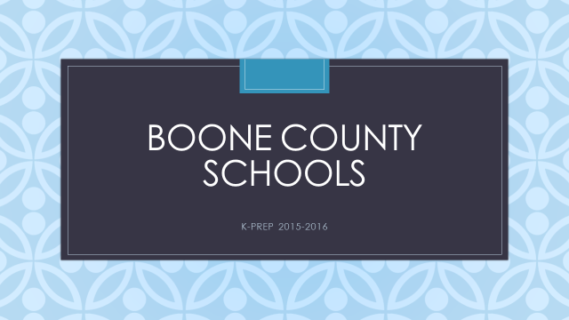

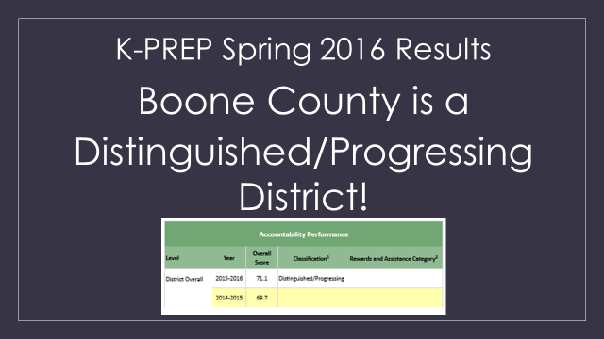

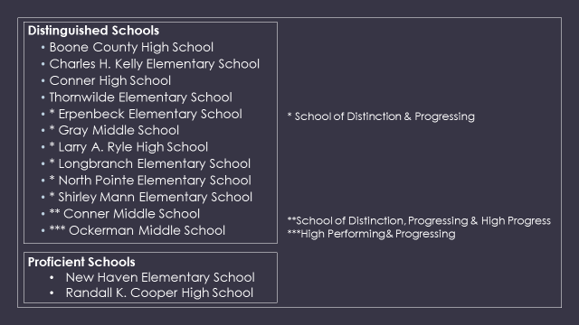

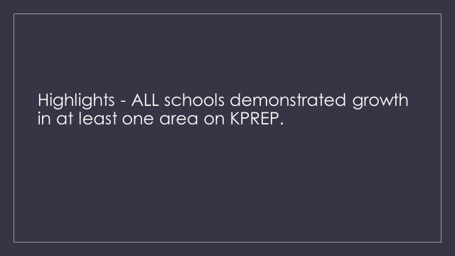

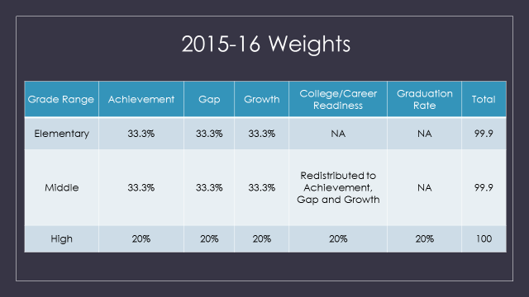

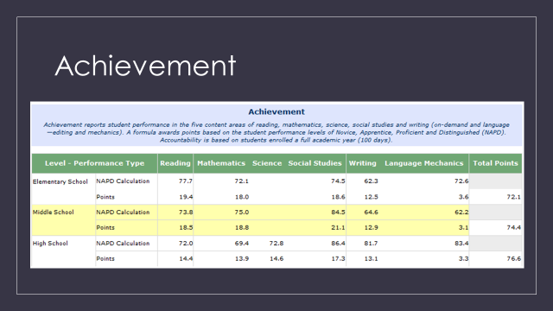

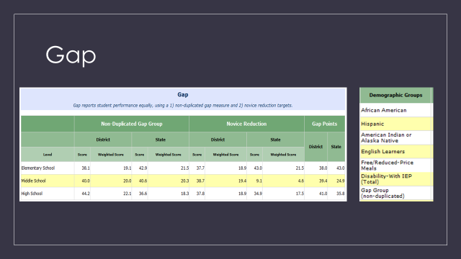

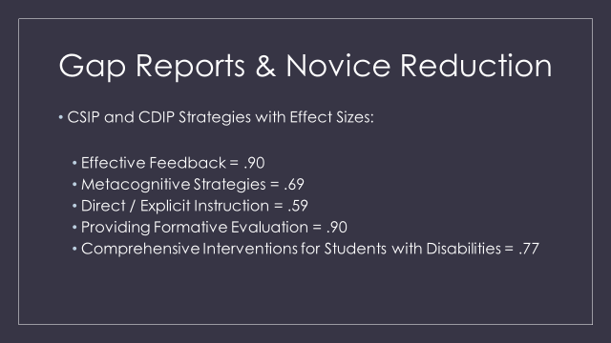

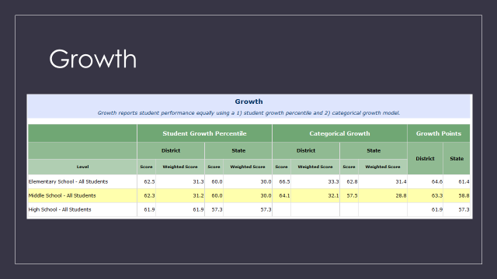

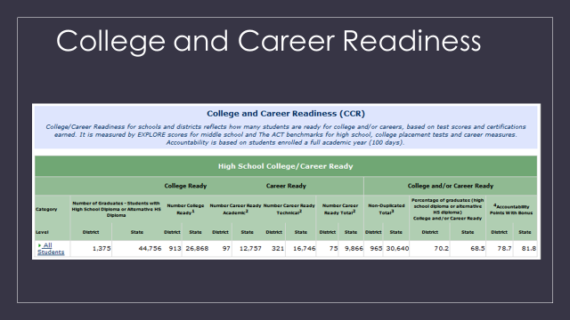

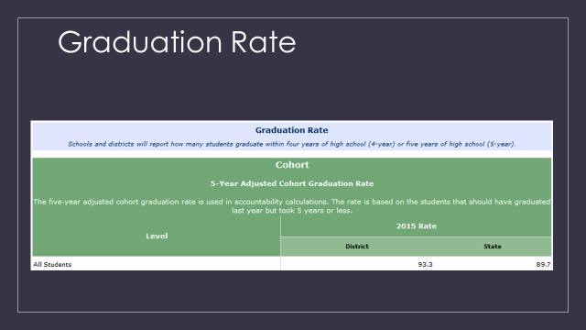

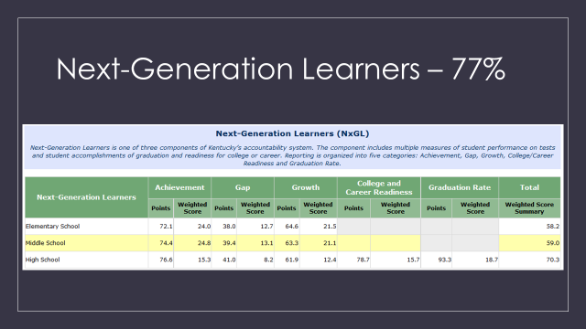
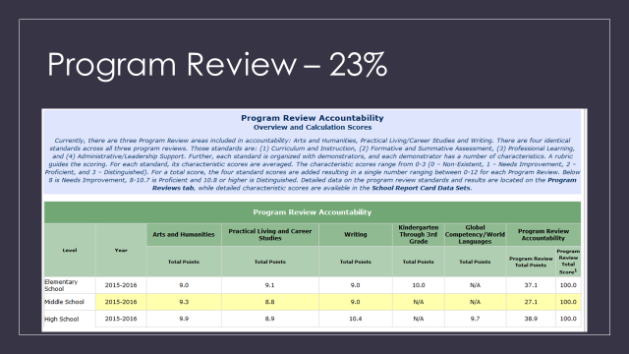

X.B. Lisa Resing, Florence Elementary Principal, will report on the FES and NKU Collaboration Project. Florence Elementary program partnership is with practicum students from Northern Kentucky University. This spring the partnership got underway with the goal of the project to have NKU teacher candidates involved in the classrooms more frequently to assist K-5 student and teachers. NKU students utilize a classroom on site at Florence to continue their required coursework. The program has proven to be a winning combination for the students, teachers, and gives the elementary students more one-on-one time with a teacher. The positive impact of the program was displayed in a video of the partnership shown at the board meeting,

- Dr. Poe announced the November 2, 2016 Special Board Workshop of Professional Development. The workshop will be held at 6:30 pm at Ralph Rush and will review the Poor Students Rich Teaching Book Study.
- Dr. Poe relayed a thank you message from the District Office employees to Tom Haddock and Joe Hamline for providing a very nice appreciation lunch from BCCEA and BCEA to the office employees for all their hard work for the district.
.

XI. INFORMATION, PROPOSALS, COMMUNICATIONS
XI.A. Human Resource Actions
XI.B. Worker's Compensation Claims
XI.C. Overtime Report
XI.D. Construction Status Report
XI.E. Energy Management Report
XI.F. 2016 Closing the Achievement Gap Report
- Ed Massey reported Erin Gurwell, Freedom Writer, will be at the Freedom Center on October 26, 2016 at 5:00 pm for a presentation. Mr. Massey announced the event for any teachers that would be interested and discussed the Freedom Writer Institute and a future partnership for our teachers.
- Bonnie Rickert discussed the Kindergarten age change and how this is being disseminated to parents. Dr. Poe explained this is on the website, newsletter, and has been sent to the paper to spread the word. ‘
- Bonnie Rickert discussed the Summit Program at Conner Middle School. She thanked Principal Brewer for her recent tour of the program and encouraged anyone that was interested in learning about the program to reach out to Conner Middle for a tour.

XII. AUDIENCE OF CITIZENS
The following education college students introduced themselves to the board: Gateway College - Stephanie Dunery, Kelsey Webb, Christina Tayor, Viviane Johnson, Joanne Luper, Abbey Owens, Kathryn Crupper; NKU College – Gabby Herman, Sam Steek, Sandra Steiber, Caitlyn Roberts; University of the Cumberlands – Peggy Houston Nienaber.

XIII. CLOSED EXECUTIVE SESSION PER KRS 61.810
XIII.A. No closed session

XIV. ADJOURN

- A motion was made by Karen Byrd, seconded by Steve Templeton, to adjourn the meeting. Bonnie Rickert, Maria Brown, Karen Byrd, Ed Massey and Steve Templeton voted, “aye” MOTION: The motion passed 5-0.

Meeting was adjourned at approximately 9:05 pm

_____________________________________
Maria Brown/Chairperson

_____________________________________
Karen Evans/Secretary

