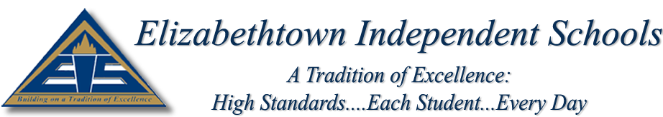

MEMORANDUM

To: Mr. Jon Ballard, Superintendent

From: Kristin Froedge, Director of Special Programs

Re: Approval of Personnel to Serve as ARC Chairpersons for the 2015-2016 School Year

Date: June 1, 2015

Please approve the positions/individuals listed below to serve as chairperson(s) for ARC committees for the 2015-2016 school year:

Kristin Froedge Director of Special Programs
Carole Brown District Special Education Consultant
Kelli Bush Assistant Superintendent for Student Learning
Steve Smallwood Principal, Elizabethtown High School
B.J. Henry Assistant Principal, Elizabethtown High School
Dawne Swank Assistant Principal, Elizabethtown High School
Melissa Butler Guidance Counselor, Elizabethtown High School
Rex Hanson Guidance Counselor, Elizabethtown High School
Jennifer Burnham Principal, T.K. Stone Middle School
Joe Nepi Assistant Principal, T.K. Stone Middle School
Karen Appelman Guidance Counselor, T.K. Stone Middle School
Michelle Hart Principal, Helmwood Heights Elementary School
Carole Ann Christian Guidance Counselor, Helmwood Heights Elementary School
Karla Buckingham Principal, Morningside Elementary School
Jack Breunig Guidance Counselor, Morningside Elementary School
Kelly Graham Principal, Panther Academy
Amy Truitt RTI Coach, Panther Academy
Marci Kauffeld Special Education Teacher, Panther Academy

