Dayton High School
November 28th, 2018
Board Report from Principal Ryan Kellinghaus
- Veteran’s Day assembly on Nov 9th
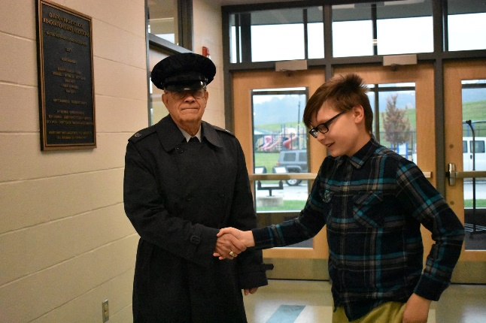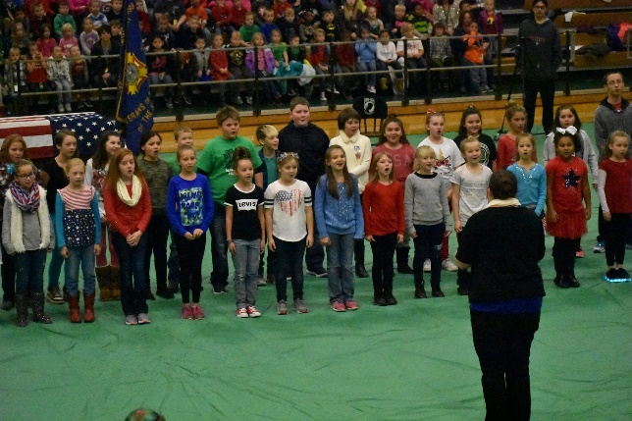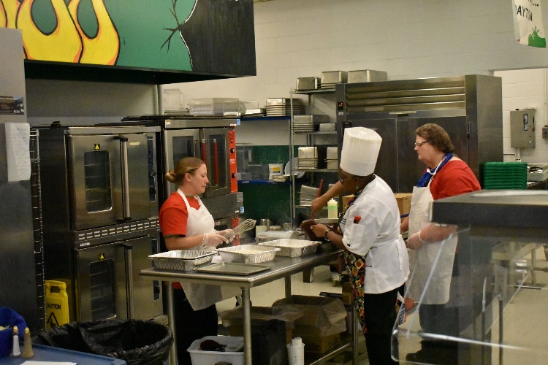
- We had an attendance of 151 during our Family Fun Night of Enchantment on Nov 15th! Last year’s attendance was 113.
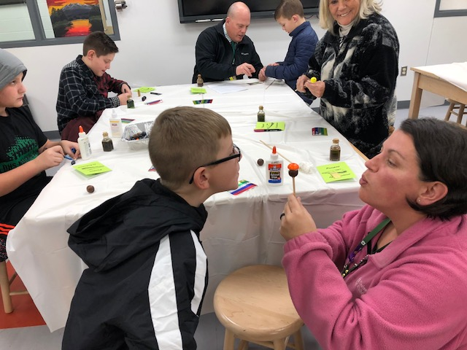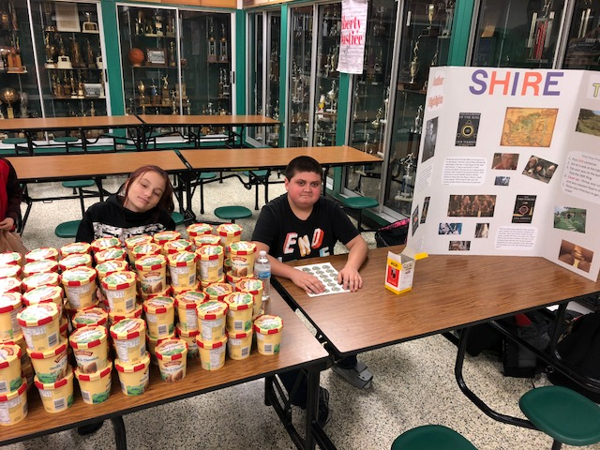
- We officially kicked off our eSports season with one loss and one win on Nov 13th!
- We collected 918 canned goods for the needy and celebrated with our Student vs faculty game on Nov 21st.
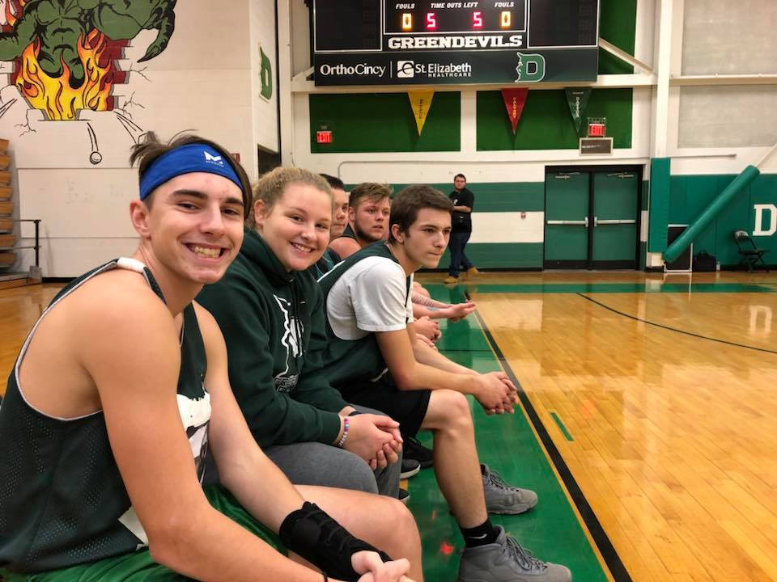
- We are gearing up for winter CERT and CASE testing.

